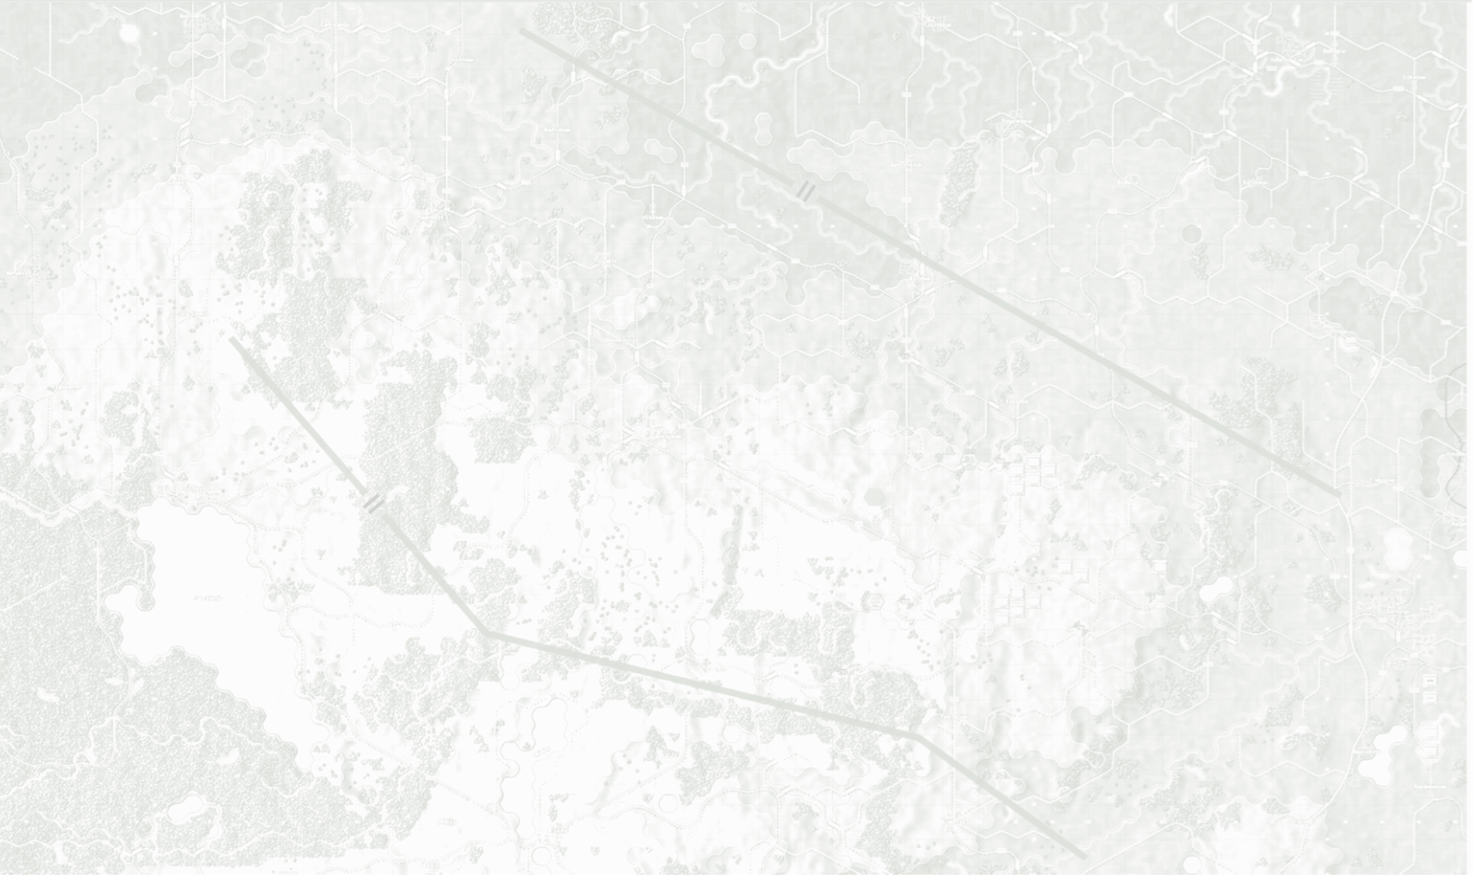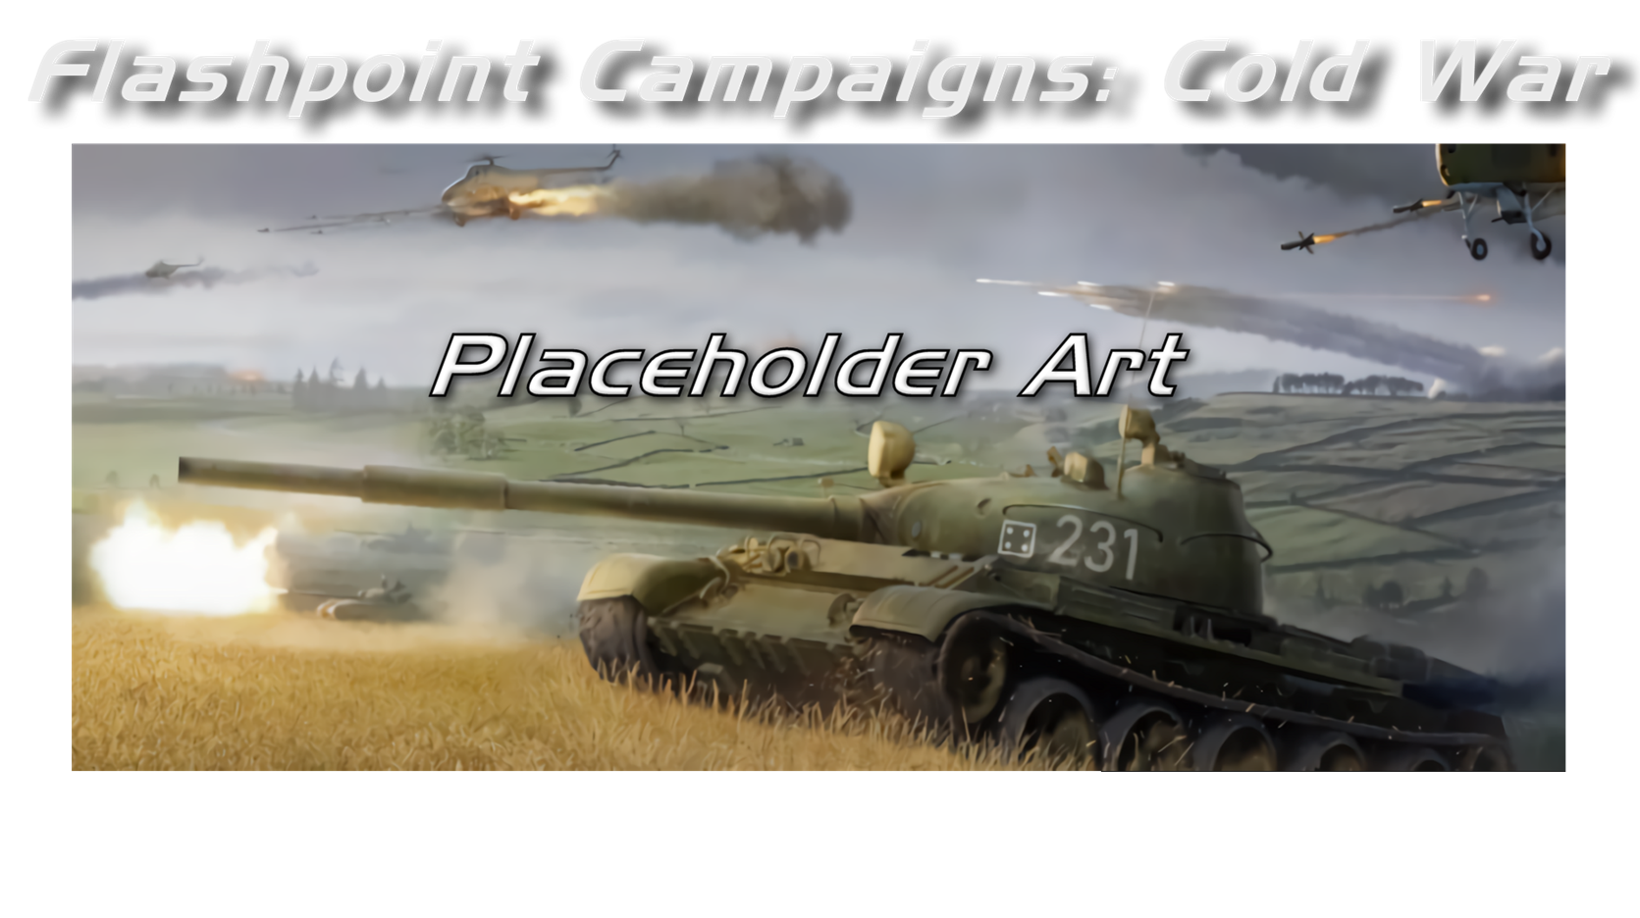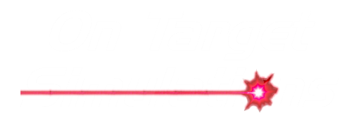

Map Construction

Field Manual FCCW-07/R1

**© 2025 On Target Simulations (OTS), LTD. All Rights Reserved. The images used and OTS Logo are property of On Target Simulations, LTD. All other marks and trademarks are the property of their respective owners.**

Table of Contents

1 Introduction 5

1.1 What's in This Document 5

1.2 Manuals 6

1.2.1 The Field Manuals (FM) 6

1.2.2 What’s New 6

1.2.3 FPC Hotkeys 6

1.2.4 Flashpoint Campaigns: Cold War FAQ 6

1.3 Gender Pronouns and Inclusion 6

2 Map Making 7

2.1 Game Map 7

2.2 Map Creation Process 8

2.3 QGis 9

3 Example Map Area and Example QGis Project 9

3.1 The Example Map Area: Minden, West-Germany 9

3.2 The Example Project ‘Minden area.qgs’ 9

4 Getting Started 9

4.1 Online: Downloading and Installing QGis 10

4.2 Online: Installing in QGis 10

4.3 Two Essential Plug-ins 10

4.4 Creating a Folder for Our Map Project and Extracting FC Presets 11

4.5 Setting Up Our QGis Project and Coordinate System 11

4.6 Downloading and Adding Digital Elevation Model (DEM) Data 12

4.7 Finding Minden 15

5 Defining Our Map 16

5.1 Decorative Grid 5km 16

5.2 Creating an Area Box 16

5.3 Styling and Positioning the Area Box 18

5.4 Positioning Our 500m Hex Grid 20

5.5 Rendering the Elevation in FC's Color Palette 21

6 Exporting Our 'Elevation Only' Map for Map Values Scanning 23

7 Intermezzo: The Terrain per OTS Render Tool 31

8 Drawing Our Map: Water and Roads 31

8.1 Creating Layers for Our Manual Annotations 31

8.2 Defining Short-Cuts for Quickly Selecting and Moving Features 33

8.3 Adding a Satellite Layer to Drawn On 34

8.4 Drawing Rivers, Highways, Primary Roads, and Air Strips 35

8.5 Intermezzo: OTS Render 37

9 Drawing on Our Map: Towns, Minor Roads, and Railroads 38

9.1 Built-up Areas and Crisp, Clear Maps 38

9.2 Drawing Built-up Areas 38

9.3 Drawing Railroads 38

9.4 Drawing Secondary Roads 39

9.5 A Critical Review of Our Results and a Few Fixes 39

9.6 Intermezzo: OTS Render of Our Works-in-progress 40

10 Drawing on Our Map: Minor Rivers, Streams, Forests and Fields 41

10.1 Identifying Minor Rivers and Streams 41

10.2 Enabling Snap to Grid for Drawing Tight Polylines and Polygons 41

10.3 Drawing Forests and Vineyards/Orchards 43

10.4 Drawing Fields 43

10.5 Drawing Banks 44

10.6 Inspection Time: Fixing Road Flow and Elevation 45

11 Prettying up Our Map with Labels 46

12 Creating Our Second Map 47

13 Appendix A. Example Project 48

14 Appendix B. Default FCSS Map Data Types 49

14.1 Elevation 49

14.2 Hex Visibility / Cover / Mobility 50

14.3 Road Connections 50

14.4 Slope Hex Sides 50

14.5 Edges (Hex Sides) 50

14.6 How to Define an Additional Type of Terrain? 50

15 Appendix C. UTM zones 51

16 Appendix D. Representing Water Obstacles 52

17 Appendix E. Creating a New Elevation Correction Layer 52

18 Flashpoint Campaigns Credits 53

18.1 On Target Simulations 53

18.2 On Target Simulations Content Team 53

18.3 Cold War Beta Testers 53

18.4 Matrix Production Support 53

19 OTS on the Web 54

# Introduction

Welcome to FLASHPOINT CAMPAIGNS: COLD WAR

This is a grand tactical combat simulation on the Cold War battlefield. As the force Commander, you will plan and then issue orders and Standard Operating Procedures to your battalion, brigade, or regimental forces, shaping the fight by maneuver and your intent. Your forces will engage the enemy on rendered real-world map locations. Each hex is 500m of militarily significant terrain. Each battle can last 4 to 24 hours of in-game time. Your troops will meet their foes any time of day and in any environment.

The game engine is based on asynchronous WEGO turns. This means you will issue orders and then watch a variable amount of time unfold on the battlefield. Then, issue or adjust orders to react to what has happened as you execute your battle plan.

***Flashpoint Campaigns: Cold War*** is a deep simulation of combat operations where your forces are arranged in maneuver units of companies, platoons, and sections of tanks, infantry fighting vehicles, infantry squads and teams, recon forces, engineers, air-defense and anti-tank systems, helicopters and more. As the Commander, you must use available off-map assets like long-range artillery, rockets, or airstrikes.

Your efforts in this complex battlespace will be constantly challenged by modeled features like Electronic Warfare, Air Superiority, Realistic Weather, Line of Sight and Fire, Terrain and Elevation, Smoke and Mines, and Human Factors like training, morale, and readiness. All these elements must be considered if you are to be victorious on the battlefield.

The game is packed with information dialogs, map overlays, and range rings to aid you as Commander, master the situation, and understand your force’s capabilities.

***Flashpoint Campaigns: Cold War*** is a data-rich simulation where each nation has information on National Characteristics, Command Parameters, and Orders of Battle. Data Tables are packed with era-specific equipment and troops. Weapon Systems of the time, such as guns, missiles, precision munitions, small arms, and much more, are comprehensively modeled.

As a toolkit, you can create your own scenarios and campaigns. You can also dive deeper and create or modify game data, artwork, and sound effects as you see fit. All these modding capabilities are supported by detailed documentation.

## What's in This Document

We created this document to help Users understand how to create Maps and Map Values with QGis. This guide uses the QGis GIS tool as the editor to create a map values bitmap defining the terrain for the Flashpoint Campaigns game engine.

**WARNING: There are no supplied tools for rendering the art portion of the map. You will need to use your own tools and style to make the visual part for the game based on the work here to setup the values used in game.**

**NOTE:** Areas of interest or buttons on form pictures are outlined in red.

**NOTE:** Some images in this manual are from other versions of the game. While your maps and units may be different, all the information and how it is used and displayed will match the information seen in this manual.

* 1. Manuals

We have chosen to go with many living manuals to cover game interface/play, learning the game, basic tactics, Content Creation, and Game Modding for the Cold War game engine. We also have guides that cover that area of operations. The affected manuals and guides will be updated as the game is updated, and PDFs of these changes will be included with the new patches.

### The Field Manuals (FM)

These are the core manuals on how to play, create content for, and modify data for the Cold War game engine. Before jumping into Content Creation, we strongly recommend you review the first three manuals, **Game Operations**, **Battlefield Primer**, and **Tutorial Operations,** if you are new to this type of game and warfare. Returning Flashpoint Campaigns players should review **Game Operations** to get details on new features, as there are many.

These documents are found in the Documents\FMs folder.

* FM01: Game Operations – Detailed information on the game, its interface, and how to use it
* FM02: Battlefield Primer – Fighting in the Cold War
* FM03: Tutorial Operations – How to learn and play the game
* FM04: Scenario Design – How to make or edit scenarios
* FM05: Battle Planning – How to create or edit battle plans. Battle Planning is a unique topic of Scenario Design.
* FM06: Campaign Design –How to make or edit campaigns
* FM07: Map Construction –***This Manual*** - How to make simple maps for the game
* FM08: Game Engine Modifications - How to Mod elements of the game engine
* FM09: Data Structures and Editing– How to edit or build data sets
* FM10: Weather Setup – How to add in weather from other locales
  + 1. What’s New

The What’s New PDFs summarize any changes and fixes when updates are released.

These can be found in the Documents\WhatsNew folder.

* + 1. FPC Hotkeys

This PDF document lists all the unique game key presses for Function keys and all hotkey definitions. Due to the large number of functions in the game, rebinding is not possible.

This document is in \Documents folder.

* + 1. Flashpoint Campaigns: Cold War FAQ

To stave off forum-clogging threads on various topics we either don't control or can't support, we created this FAQ document with the answers to those specific topics.

Please review the FAQ for answers to several game topics related to the game but not on how to play the game.

This document is in the \Documents folder.

* 1. Gender Pronouns and Inclusion

We understand that users of all genders will play our simulation. We try to keep language in the game and manuals gender-neutral, when possible, but sometimes use the pronoun “he” to refer to the user. This is merely to streamline the writing, not to exclude anyone or note a specific gender.

The On Target Simulations team supports the inclusion of all people in the field of wargaming.

# Map Making

Welcome to the Flashpoint Campaigns Guide to creating Maps and Map Values with QGis. This guide is using the QGis GIS tool as the editor to create a map values bitmap defining the terrain for the Flashpoint Campaigns game.

## Game Map

The game map in Flashpoint Campaigns defines the terrain for the game, and for the players (be it a computer player or human player).

Flashpoint Campaigns uses hexagon-based maps, where the terrain partitioned into 500m hexagons (hexes). Each hex defines the local mobility, local visibility / occlusion at ground level, and the local cover. Each hex also defines its altitude (above sea level), and the height to which its contents (fields, forests, high-rise buildings) extend from the ground.

In addition, each of the hex’ six sides can have special properties:

* Having a road (and great mobility) into the adjacent hex,
* Being a barrier to the adjacent hex, blocking or delaying movement across the hex side as a wet or dry obstacle, and enabling bridges to be placed to reduce the barrier
* Representing a height difference, with large height differences (steep slopes) being impassable to vehicles
* Beach lines, enabling landing craft to unload its cargo from the water hex across the hex side into a dry hex

This is illustrated in the figure below, where a piece of field terrain is crossed by a secondary road and a railroad, and bordered by a wide water obstacle (North, Northwest) and a minor water obstacle (Northeast, Southeast).

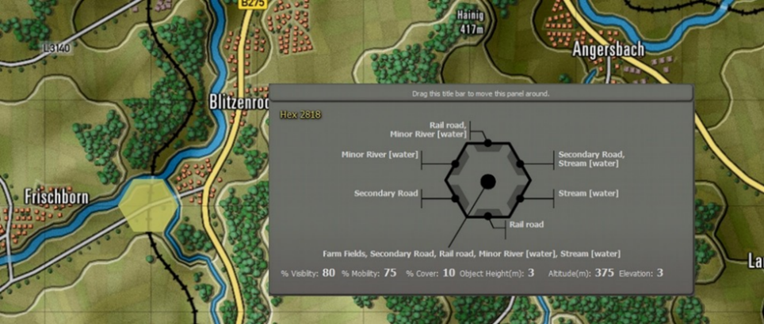

Figure 1: A game map hex (see the yellow highlight), with its properties for the central terrain and for the six hex sides in the gray panel

The Flashpoint Campaigns game uses the terrain to perform path-planning (on the ground, and in the air), to pick positions for observations, concealment, interdiction, and for line-of-sight/line-of-fire calculations.

For line-of-sight calculations, the terrain is treated as several plateaus, each containing objects on their terrain, and atmosphere above them. The objects and the atmosphere above it both have different properties with respect to blocking / attenuating the (optical, thermal, RADAR) line of sight. See Figure 2.

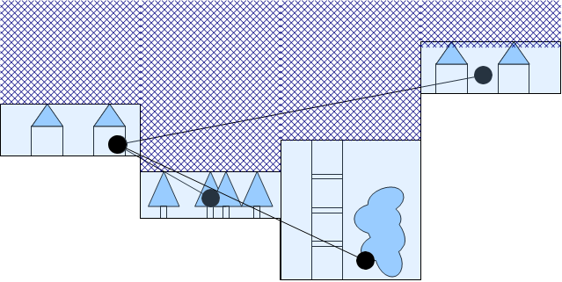

Figure 2: Lines-of-sight, taking into account the atmosphere (hatched) above hexes, and the objects in the hex

## Map Creation Process

The aim of map creation is to define terrain such that the Flashpoint Campaigns game, the Flashpoint Campaigns computer player, and the human player all understand it.

This guide focuses on creating maps for the Flashpoint Campaigns game and Flashpoint Campaigns computer player; creating a pretty map for the human player is more an ‘art’ and does not need to be restricted by this guide. See Figure 3.

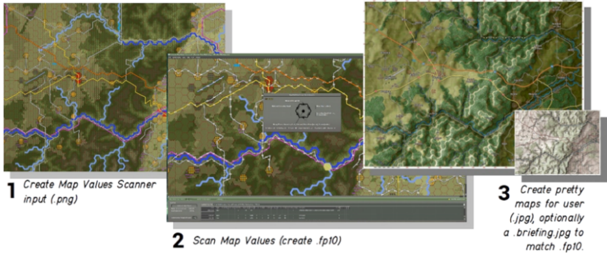

Figure 3: The map making process

The Flashpoint Campaigns game includes the ‘Map Values Scanner’ to scan a bitmap to generate a terrain description (*.fp10) file.

The Map Values Scanner requires as input a bitmap (*.png file) with 128 pixels per kilometer, with pixels having colors defined by the Map Data Types file. This Map Data Types is a spreadsheet telling the scanner which colors represent elevation, fields, forests, roads, and streams. See Figure 4 and see Appendix B. Default FCSS Map Data Types for a more complete description.

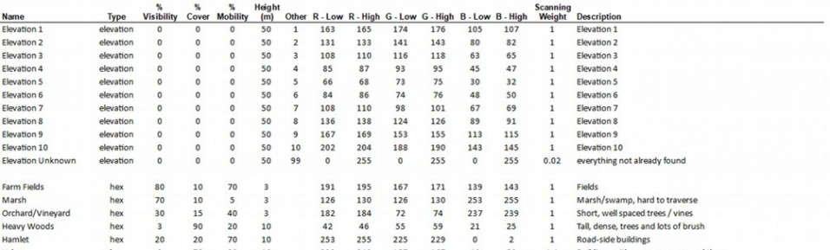

Figure 4: Part of the FCSS Map Data Types file, defining the interpretation of the map values bitmap

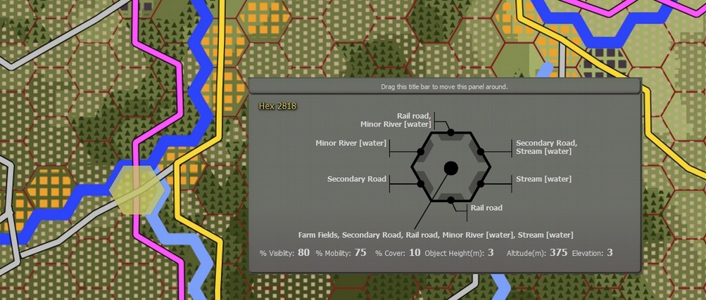 *Figure 5: The map values bitmap input for the terrain described in the first figure*

Scanning the map values bitmap is a fully automatic process. The effort of creating the map is in creating the input for the Map Values Scanner, the so-called Map Values Bitmap. For this, we recommend using a third-party tool dedicated to creating maps: QGis.

## QGis

This guide is using the QGis GIS tool as the editor to create a map values bitmap.

QGis is an attractive editor because it is free, it handles digital elevation data (DEM) well, it allows you to draw quickly to a hexagon grid, and it offers nice overlays of tile maps from OpenStreetMap / Google and Bing.

QGis also comes with two disadvantages: it is a complex tool designed for manipulating map data in general, not just hex game maps. And it doesn't automatically create pretty maps. However, it allows you to create mashups blending your annotations with OpenStreetMap / Google / Bing maps or generated relief data.

This guide (and the corresponding example project) describes how to configure QGis and create a first map. The corresponding example project includes a set of QGis styles and templates tuned for creating a map values bitmap for the Flashpoint Campaigns 2.x engine (see Appendix A).

**NOTE:** To get the most out of QGis, notably out of the OpenStreetMap / Google / Bing layers, QGis is best run from a computer connected to the internet.

# Example Map Area and Example QGis Project

## The Example Map Area: Minden, West-Germany

As a map example, I've chosen to recreate the area around the Porta Westfalica area, near Minden and Bad Oeyenhausen, the Weser River and the Mittelandkanal, and the former, Cold War, boundary between the West German I Corps and British I Corps in NORTHAG, West-Germany.

It is a good example location since it involves considerable elevation, a river, highway and major roads, lakes, industry, and urban areas, covering many of the terrain types supported by the Flashpoint Campaigns game.

This area also plays a key role in Ralph Peter’s ‘Red Army’ cold war fiction book.

## The Example Project ‘Minden area.qgs’

The example QGis project ‘Minden area’ is made available along with this manual. You can follow this manual closely to create a similar QGis project from scratch. Alternatively, you can skim this manual while checking the example project. Or even use the manual and project to create your own map without having to do a lot of set-up work.

# Getting Started

To create the map, we are going to need the following tools and assets (in addition to the Flashpoint Campaigns game):

* QGis, version 2.x, x64 for Windows (*not the version 3.x series*). 2.18 is the latest 2.x version.
* QGis style presets files for elevation, map elements and print composition; they preset match the colors, thickness and resolution expected by the Flashpoint Map Values Scanner.

When using a computer connected to the Internet, it is recommended to download QGis and download and install the plug-ins the ‘normal way’. See sections 3.1 and 3.2.

When using a computer that is not connected to the Internet, please install QGis and the plug-ins from the installer files made available. See sections

## Online: Downloading and Installing QGis

The QGis 2.18 downloads are available from the QGis download folders:  
<https://download.qgis.org/downloads/>

Pick the installer most suitable for your system. Typically, this will be Windows stand-alone installer 64-bit ( QGIS-OSGeo4W-2.18.28-2-Setup-x86_64.exe ).  
<https://download.qgis.org/downloads/QGIS-OSGeo4W-2.18.28-2-Setup-x86_64.exe>

After downloading, install QGis. After installing QGis, launch the QGis Desktop app.

## Online: Installing in QGis

Our next step is to install, from within QGis, three plug-ins which will help us create maps:

1. MMQGis plug-in, which adds the ability to create 500m hexagon grids to align with / snap to
2. OpenLayers plug-in, which adds the ability to add a layer from Google Maps (terrain or satellite), Bing Maps (terrain or satellite) or OpenStreetMaps (various) in the editor, to guide our drawing.
3. GeoSearch plug-in, which will help us find and navigate to named locations

## Two Essential Plug-ins

Install the plug-ins by choosing the "Plugins" menu, "Manage and Install Plugins". A dialog will pop up, enabling us to search and install plug-ins.

Enter "mmqgis" in the search box, select it in the search results, and press "Install Plugin".

Next, enter "openlayers" in the search box, select the "OpenLayers Plugin" from the search results, and install it.

Close the "Manage and Install Plugins" dialog.

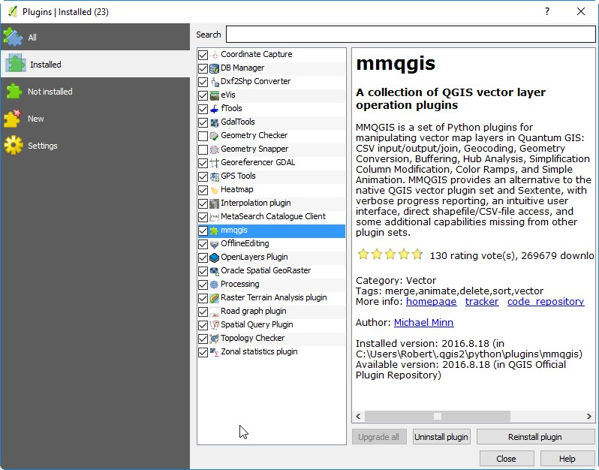

*Figure 6. QGis Manage and Install Plugins dialog with MMQGis and OpenLayers plug-ins installed*

## Creating a Folder for Our Map Project and Extracting FC Presets

Switch to Windows explorer and create a new folder for this map creation project. We’ll use it to store our QGis map data.

For this project, I’ve created a “Minden area” folder somewhere under my Documents.

From the example project, copy the three subfolders ‘_qgis_elevation_styles’, ‘_qgis_print_composer_templates’ and ‘_qgis_vector_styles’:

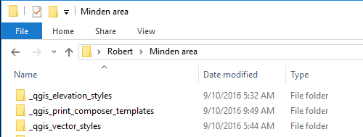

Figure 5 Our new map project folder ‘Minden area’ with the qgis_fcrs_styles_and_templates.zip extracted there

## Setting Up Our QGis Project and Coordinate System

Let's set up our first QGis project. It might be a bit of work, but the good news we can (re)use the project for multiple maps.

Switch to or launch QGis Desktop

Use "Project" Menu, New to create a new project.

Use "Project" Menu, Project Properties to open the Properties dialog.

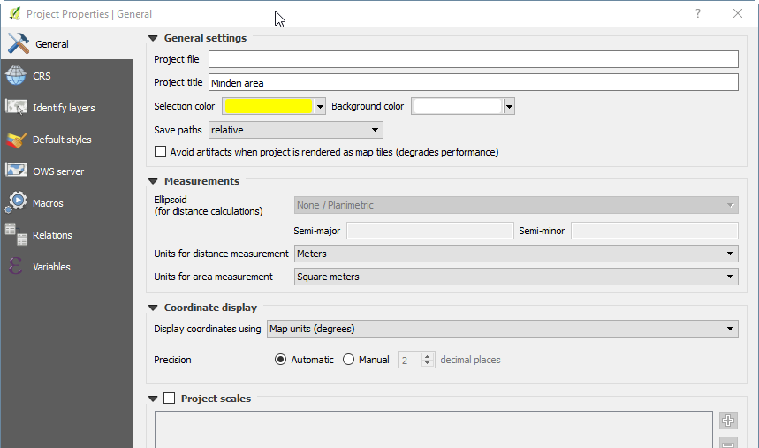

Figure 6 Enter project title in project properties

Enter a project title, then change to the CRS tab.

**WARNING:** In the CRS tab, setting the right coordinate reference system for the project is essential to achieve the correct map scale; (I have had to redo over 20 maps after getting it wrong here).

We need the CRS associated with the right UTM zone (out of 60 UTM zones) for the location at hand.

See the Appendix C for which UTM zone to use. For this map, in former West-Germany, the CRS to use is UTM32N (since UTM32U is north (N) of the equator). Normandy, France would be UTM30N, Kursk, Russia would be UTM37N, Korea would be UTM52N, and the Falklands/Malvinas would be UTM21S.

In the Filter box, enter WGS UTM followed by the UTM column, and select the corresponding WGS84/ UTM zone. For this map, it will be WGS 84/ UTM zone 32N. Select it and press OK.

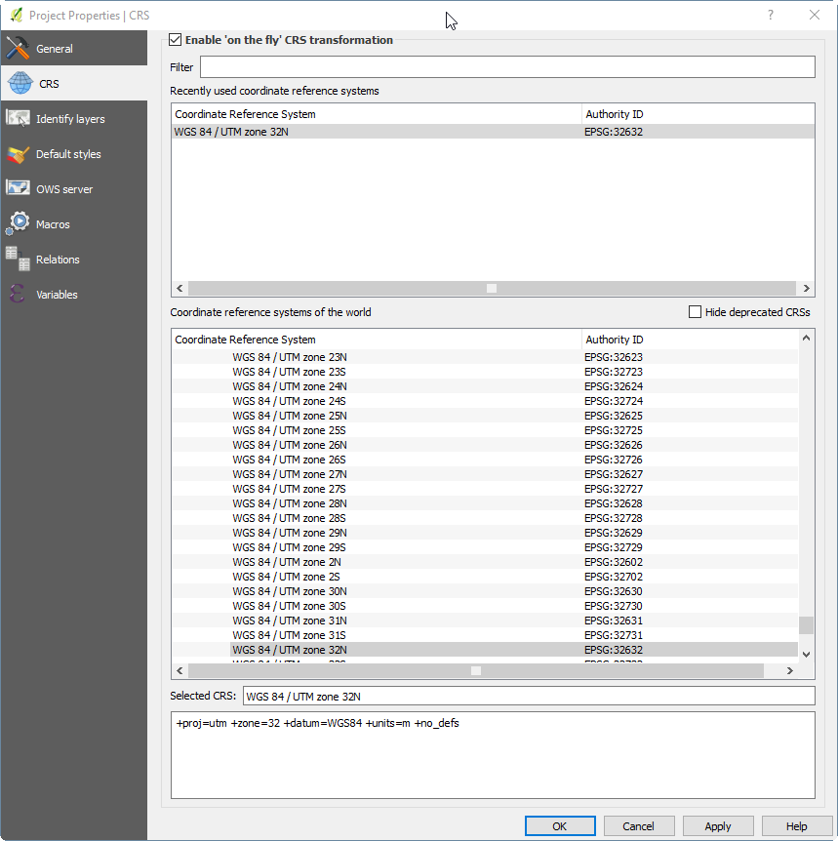

Figure 7 Selecting UTM 32N (for West-Germany maps), and enable 'on-the-fly' CRS transformation

Enable automatic 'on the fly' CRS conversion. This is necessary for QGis to adapt its projection towards tiles from Google / Bing/ OpenStreetmap overlays. Press OK.

Now it is time to save our project. Make sure to save the project in the folder we already created.

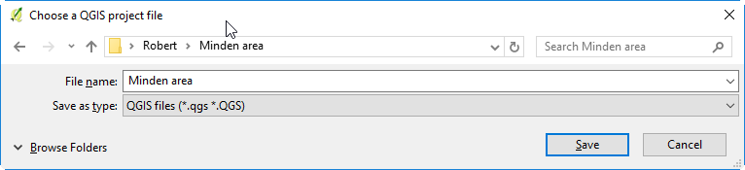

Figure 8 Saving the project in a dedicated folder

## Downloading and Adding Digital Elevation Model (DEM) Data

For our map, we need (digital) elevation data. This elevation data can be downloaded for free from, for example, Google’s EarthEngine:  
<https://earthengine.google.com/>.

Sign-up for the Earth Explorer and then enter the Earth Explorer.

The elevation data is available via:

<https://developers.google.com/earth-engine/datasets/catalog/CGIAR_SRTM90_V4>

Pan and zoom towards the area in which the map is situated. Next, add a geometry layer (called ‘geometry’) with a single rectangle using the drawing tools. Make the rectangle large enough (I’ve covered most of West-Germany and East-Germany).

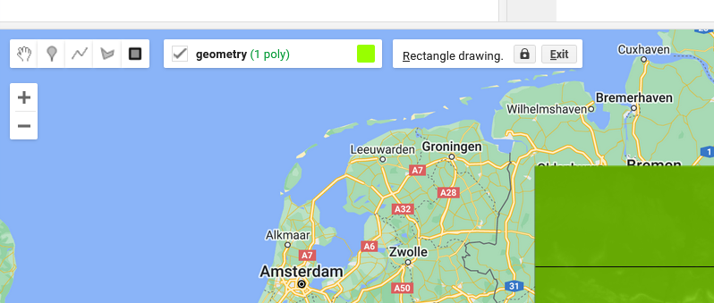

Figure 9

In the scripts panel, add code to read and export SRTM elevation data for the rectangular area we’ve drawn, as shown below.

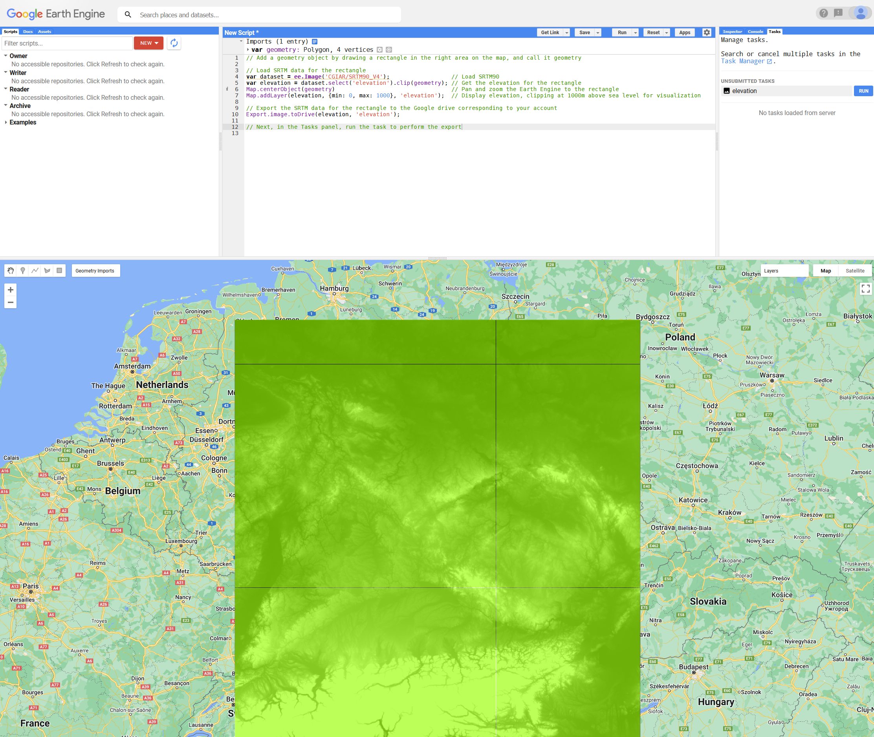

Figure 10

Script:  
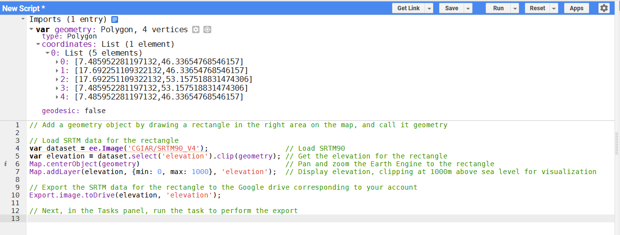

Figure 11

// Add a geometry object by drawing a rectangle in the right area on the map, and call it geometry

// Load SRTM data for the rectangle

var dataset = ee.Image('CGIAR/SRTM90_V4'); // Load SRTM90

var elevation = dataset.select('elevation').clip(geometry); // Get the elevation for the rectangle

Map.centerObject(geometry) // Pan and zoom the Earth Engine to the rectangle

Map.addLayer(elevation, {min: 0, max: 1000}, 'elevation'); // Display elevation, clipping at 1000m above sea level for visualization

// Export the SRTM data for the rectangle to the Google drive corresponding to your account

Export.image.toDrive(elevation, 'elevation');

// Next, in the Tasks panel, run the task to perform the export

Figure 12 The script as copy-able text

Next, run the script, which will result in a task in the Tasks tab on the right side of Earth Explorer. Select and Run the task to export the elevation data to your Google Drive. Make sure to select the GEO_TIFF format and a Scale (resolution) of 128m per pixel.

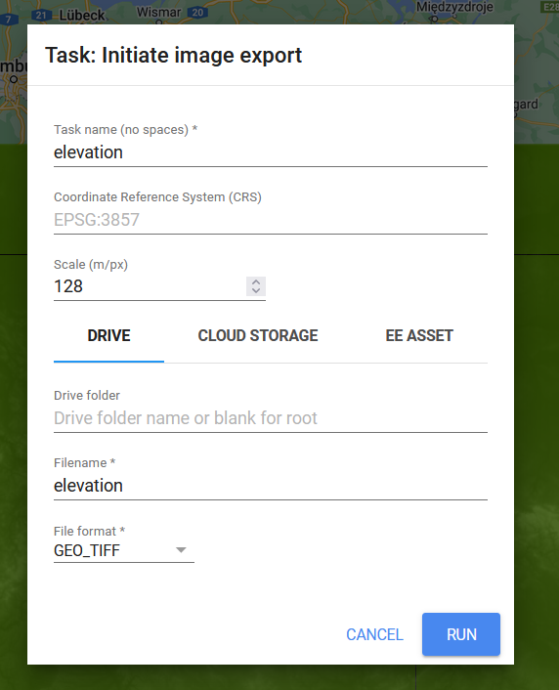

Figure 13

Finally, run the task, wait for it to be completed, and download the generated .tif file from from Google drive. Place it in the project’s folder.

Then switch to QGis and our project.

In QGis, we'll add a new raster layer to our project. Choose the "Layer" menu, Add Layer, "Add Raster Layer", and select the .tif file:

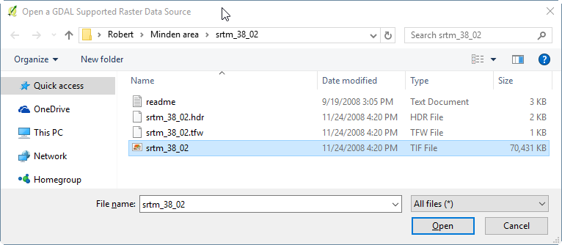

Figure 14 Adding a Raster Layer containing the SRTM elevation data

After adding the layer, we'll see the layer displayed in our project in gray scale:

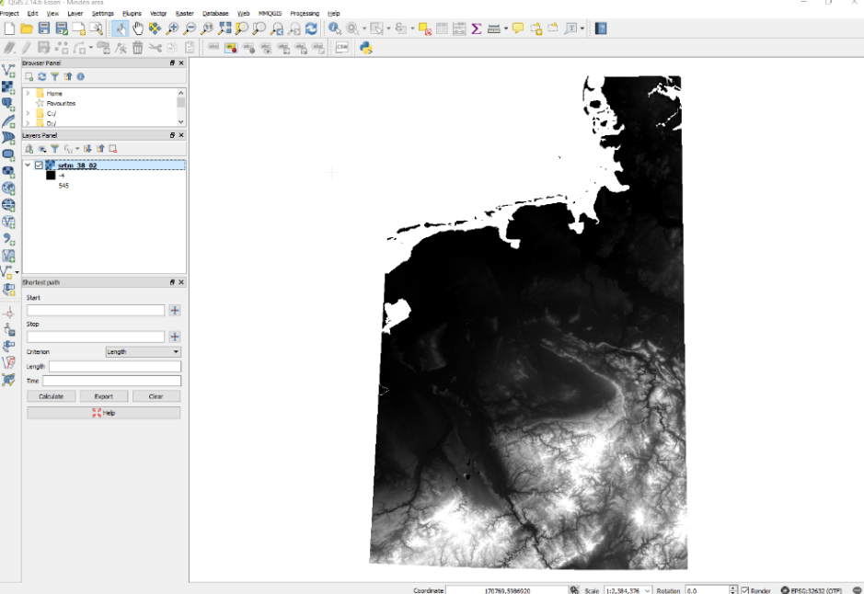

Figure 15 Our project with the DEM raster layer

Before we save the project, let's close some QGis' UI panels which we won't need: the Browser panel and the Shortest path panel.

Save the project.

## Finding Minden

To find Minden’s location, we first look it up on the web outside QGis, and, using the OpenStreetMap layer pan and zoom to the same area.

(Yes, QGis 2.x used to have a working GeoSearch plug-in, but that plug-in is no longer functional).

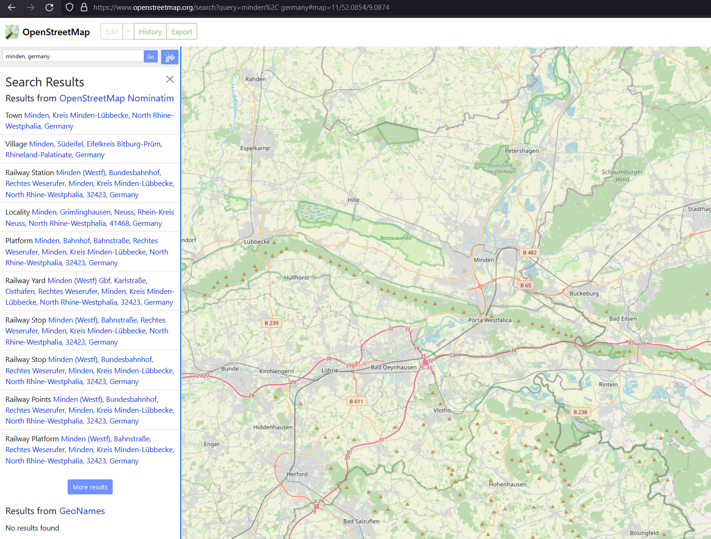

Figure 16 Looking up Minden on the web.

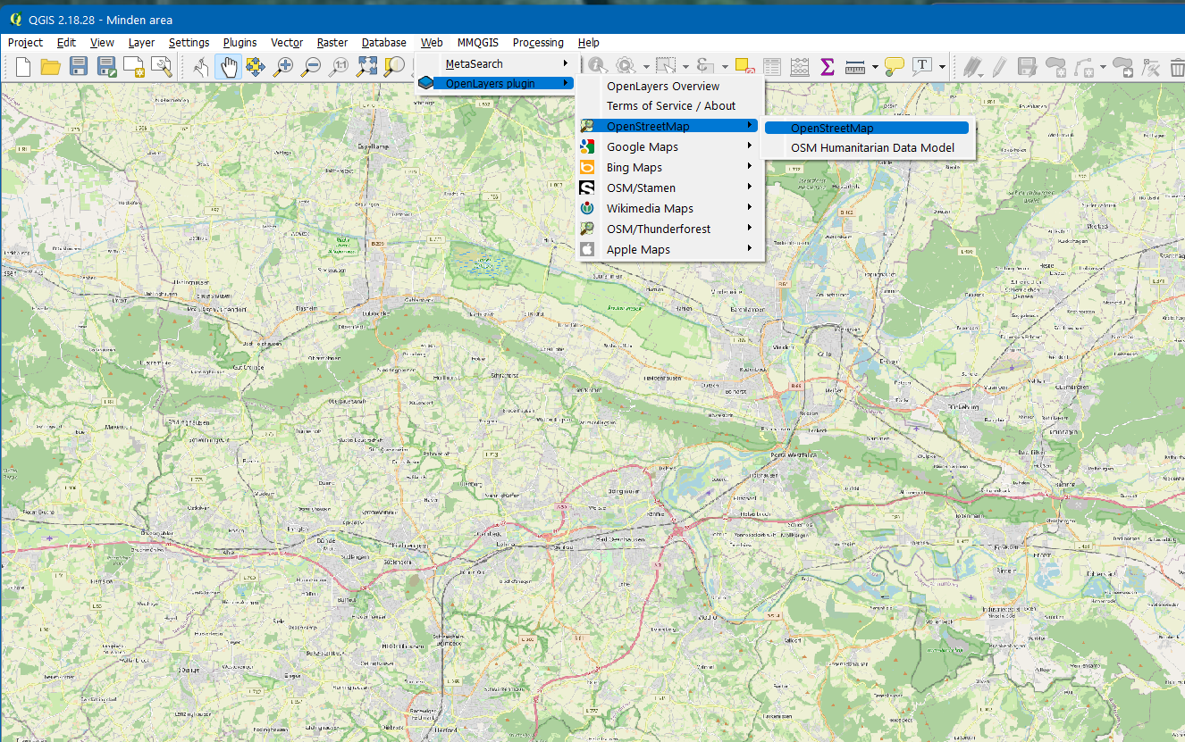

Figure 17 And having found the same area, using an OpenStreetMap layer in QGis

# Defining Our Map

**WARNING:** Here's comes a tricky bit, since getting this wrong may cause us to end up with a map at the wrong scale, and effort wasted. If you use the example project to create your own map, make sure to follow the instructions related to the coordinate system.

Make sure QGis is now using our UTM coordinate system again (since measurements on other coordinate systems might result in the wrong scale). Check "Project", "Project Properties", "CRS" tab and re-select our WGS 84 / UTM zone entry again. Press Apply, OK.

## Decorative Grid 5km

Next, enable a decorative square grid at 5km scale. This will help us draw a box reflecting the intended map size. To display the decorative grid, use the "View" menu, Decorations, Grid. In the Grid properties dialog, select Enable grid, and set the Interval X and Interval Y to 5000 (meters). Press Apply and OK.

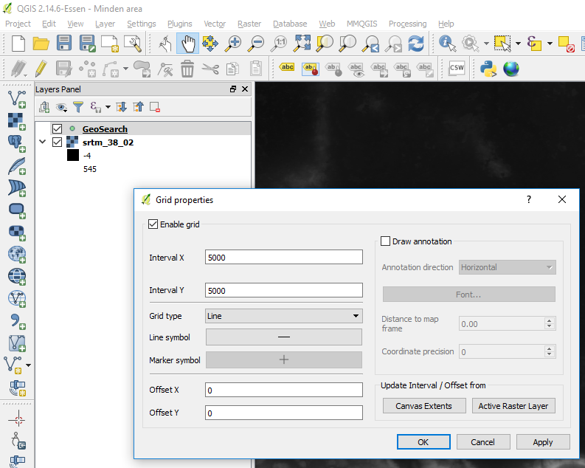

Figure 18 Enabling a decorative 5km grid

## Creating an Area Box

To pick and plan our map area, we are going to create a map area box. The typical map size for FCSS is 46×30 hexes, which at 500m hex corresponds to approximately 20 x 15 km (the hexes overlap a bit in the horizontal direction, and consume 433m width, not 500m).

**WARNING:** QGis will let you create larger or smaller maps just as easily. My experience is that beyond 35km, the earth's round shape will cause bending of the UTM based hex grid (which we'll create later), so lines and shapes drawn on this QGis hex grid tend to deviate from the grid assumed by FCSS, and "leak" into neighboring hexes. The large 90x60 hex "Eiterfeld" northern Fulda corridor map in Flashpoint Campaigns: Germany Reforged was a challenge because of this. For a first map, I suggest starting small with a 20x15km area.

Now, let's create a new layer for our new map area (and future ones), and then draw the area box.

Use the "Layer" menu, "Create Layer", "New Shapefile layer" to define a new layer. In the dialog box, select Type "Polygon", and check that the CRS used is our WGS 84 UTM one.

Under "New field", type "area", set the type to "Text data", and press "Add to fields list". This will add a field for the area's name.

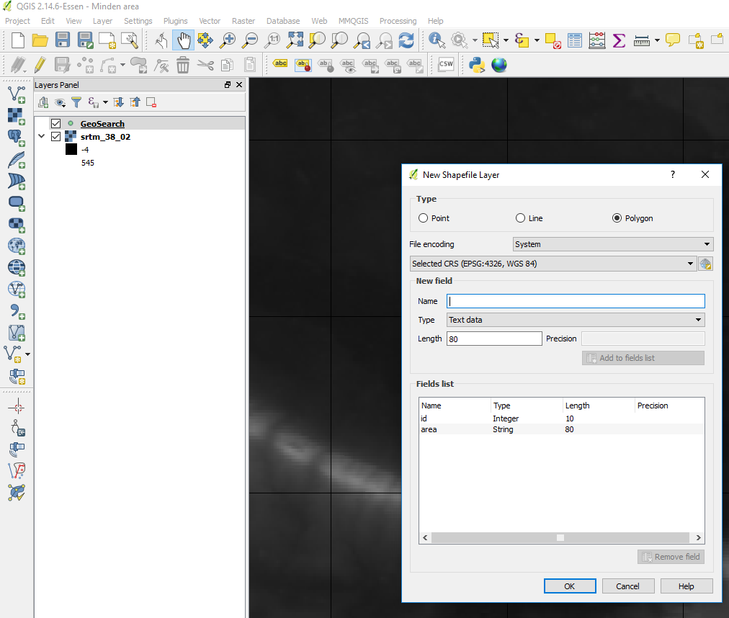

Figure 19 Creating a new layer to contain the area box(es)

Next, press OK to create the layer. Name the layer "area_boxes" and save it insider our project folder.

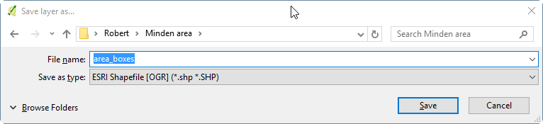

Figure 20 Saving the area boxes layer as "area_boxes" inside our project folder

Now we select the newly created "area_boxes" layer in the Layers Panel, and toggle editing to "on" (using the Pencil icon, or the Layer menu, Toggle editing).

Next, we draw a rectangle of 4 grid squares wide (4×5km = 20km) and 3 grid squares high. It doesn't have to be pixel perfect, and its location doesn't matter too much. Under "Edit" menu, choose Add feature. Draw the polygon by clicking the four corners of a 4×3 grid square rectangle, then use the right mouse button to indicate we are done and show the dialog.

Enter "Minden" as the area name. You can leave the id blank. And press OK. (Or, if you are not happy, press cancel, so the polygon is discarded, and you can create a new one).

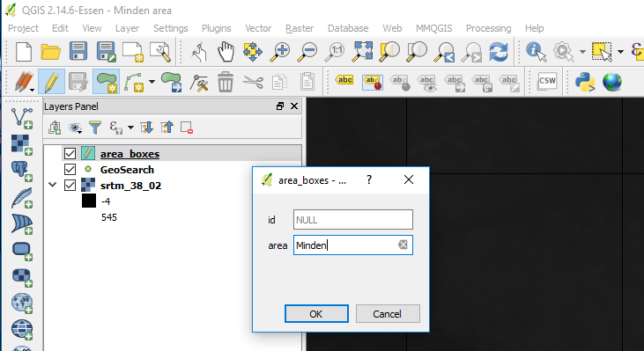

Figure 21 The pop-up dialog when we're done drawing the area box rectangle

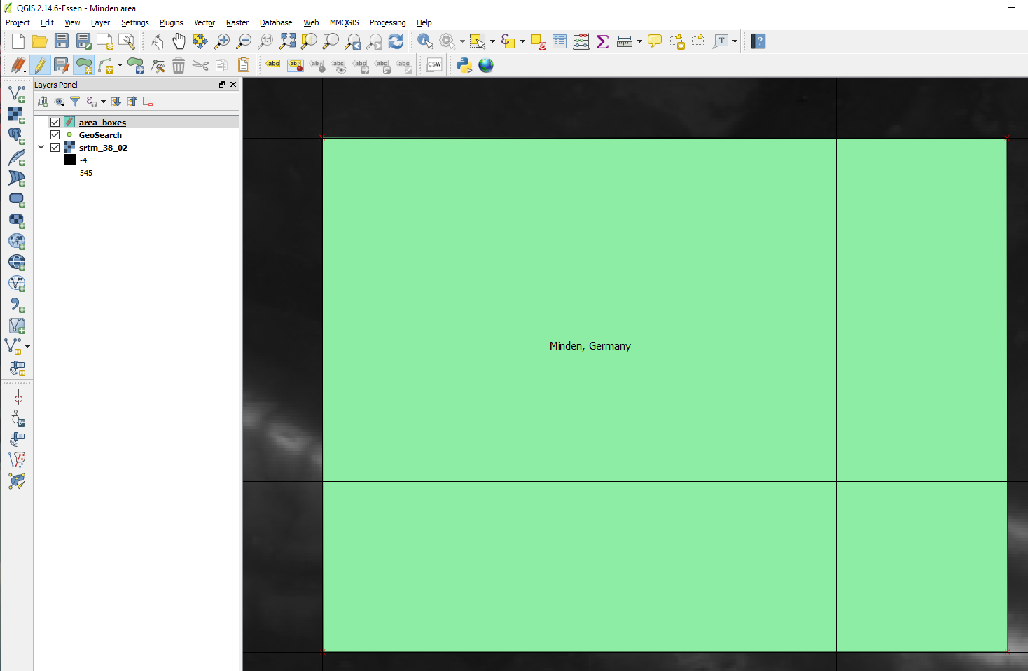

Figure 22 Our 4×3 5km square box for the Minden area

Make sure to save the edit to the area_boxes layer, using "Layer" menu, "Save Layer Edits".

## Styling and Positioning the Area Box

QGis gave the area_boxes layer a default style (green uniform fill). We are only interested in the box's only, so let's change the style. In the Layers panels, select the area_boxes layer. Use right mouse button, select Properties, then select the Style tab. Using the "Style" button at the bottom, Load Style, and select the "editing_style_areabox.qml" style from the presets we installed previously in our project folder.

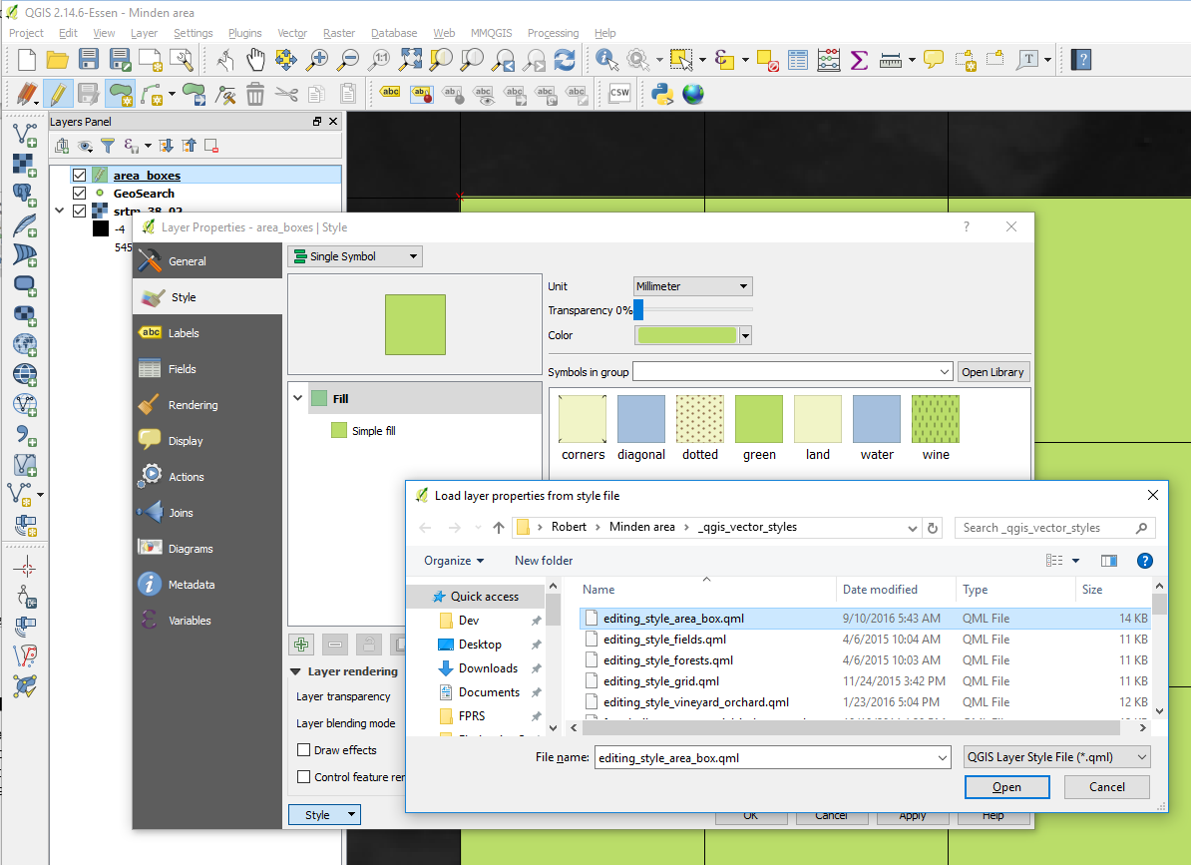

Figure 23 Loading a style pre-set for the area box layer

In the file selection dialog, press Open. Next, press Apply and OK.

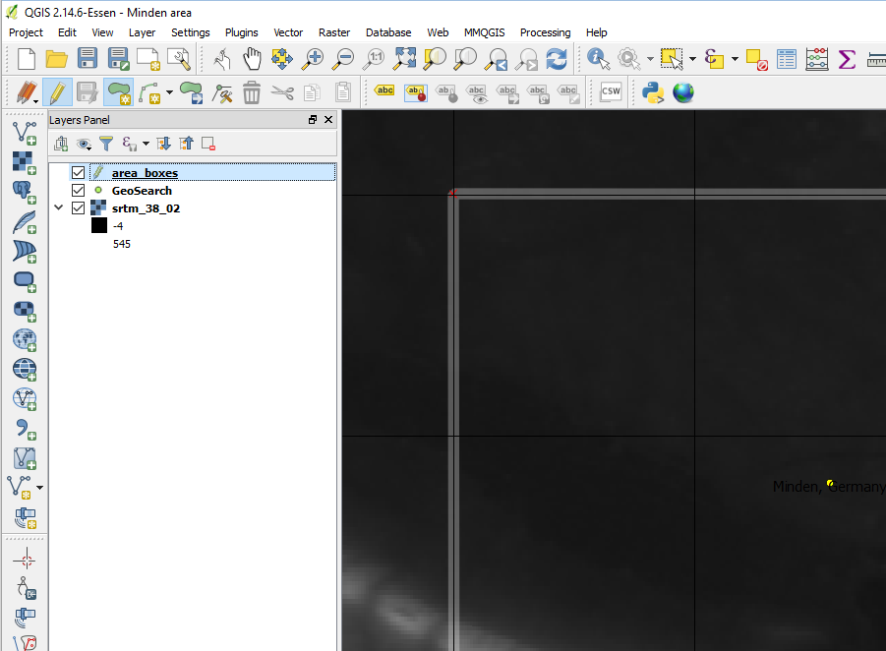

Figure 24 Area box with new style

We are still looking an at elevation only map of the Minden area, making it hard to position our map box. If we add a "Google maps" style road map with some elevation shading underneath, it becomes much easier to positioning the box to capture interesting terrain.

**NOTE:** My experience with Bing (satellite) maps in QGis has been better than with Google maps. With Google maps, occasionally the layer didn't refresh properly when zooming in and zooming out, and occasionally the maps layer shifted a few hundred meters. I don't have a clue what the cause of this problem is (me, QGis, the OpenLayers plug-in or Google), but when the Bing maps are good enough, I use these.

Use "Web" menu, "OpenLayers plug-in" and add a layer. Here, the OpenStreetMap/OCM Landscape is a good option since it displays roads and elevation.

After a brief pause (due to retrieval of map tiles from the Internet), a new layer OCM Landscape is shown on top.

Use the Layers Panel, select the area_boxes layer, and drag it upwards so it sits above the OCM Landscape layer, and the area box is shown on top of the OCM Landscape layer.

Also disable the 5km Decorative Grid, since QGis, under the hood, has switched to a different projection and coordinate system, to use map tiles from Internet sources. As a result, the 5km decorative grid is no longer accurate; actually, it is more than 30% off! (View, Decorations, Grid, and untick the grid lines option).

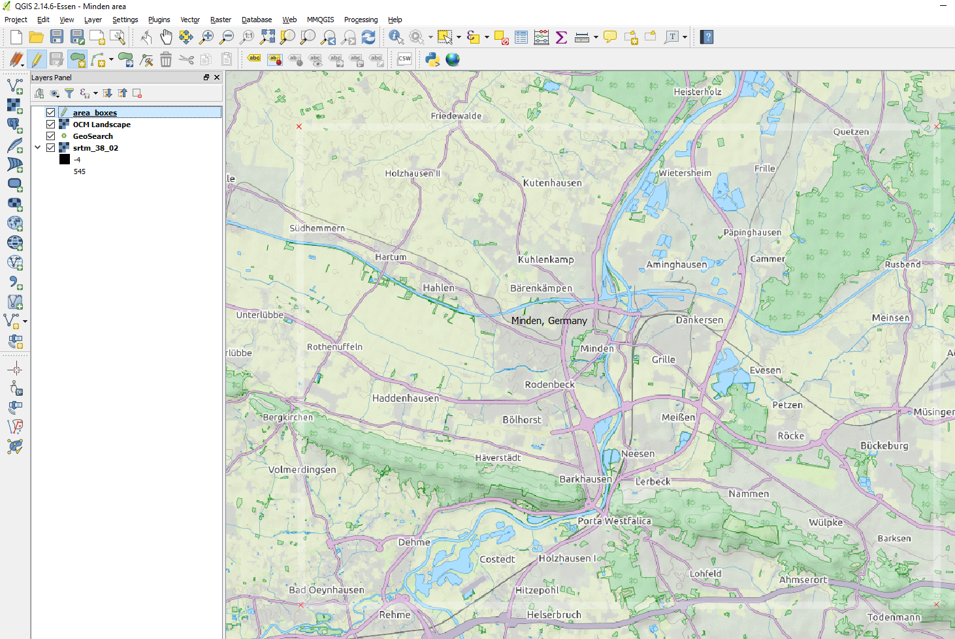

Figure 25 White area box outline shown on top of OCM Landscape map

QGis shows us which terrain can be covered by a 20x15km map. Let's move it south a bit, so it covers the bridge at Oeyenhausen (a critical bridge in the "Red Army" cold war novel by Ralph Peters), but still features the Mittellandkanal running east-west just north of Minden.

Ensure the area_boxes layer is selected. Use the "View" menu, Select, Select Feature(s), then click inside the Minden area box to select it. Next, use "Edit" menu, Move Feature(s) to switch to a move mode, and move the area box south. Finally, deselect the box (so we can see through it) using "View" menu, Select, Deselect all selections.

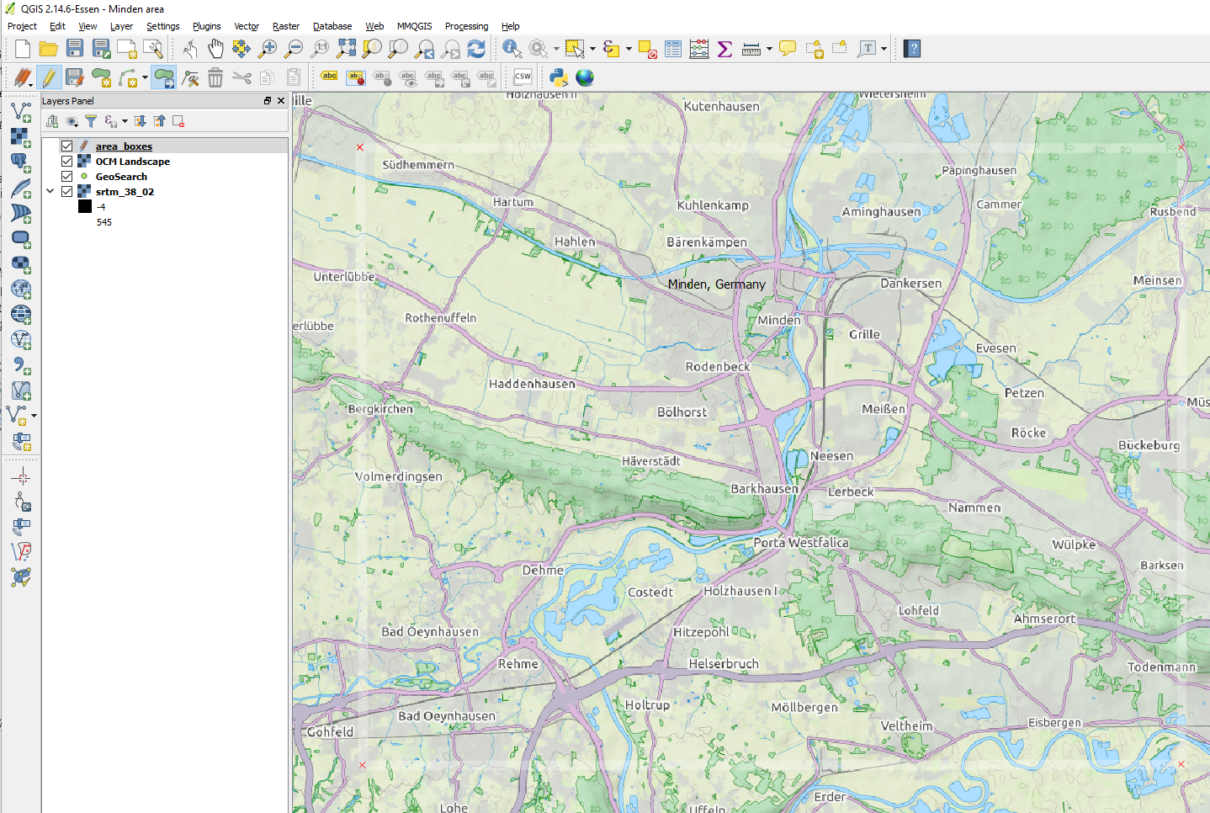

Figure 26 Improved position for our area box

## Positioning Our 500m Hex Grid

Finally, it is hex time! However, before you can create a hex layer, be sure to force QGis to use the WGS 84 UTM coordinate system again (using Project, Properties, CRS, or the shortcut in the right bottom corner of QGis).

Next, center the Minden area box in the center of the window, with a few kilometers of margin to the window borders.

Create the hex grid layer using the "MMQGis" menu, Create, Create Grid. In the "Grid" dialog, change the Shape Type to Hexagons. Change the output Shapefile to save the grid as "grid_500_minden" in our project folder (via the Browse button). Use Project Units (should be metric). Choose Extent "Current Window". Set Y-spacing to 500 (X-spacing will automatically adjust to 433). Press OK to create the hex grid layer.

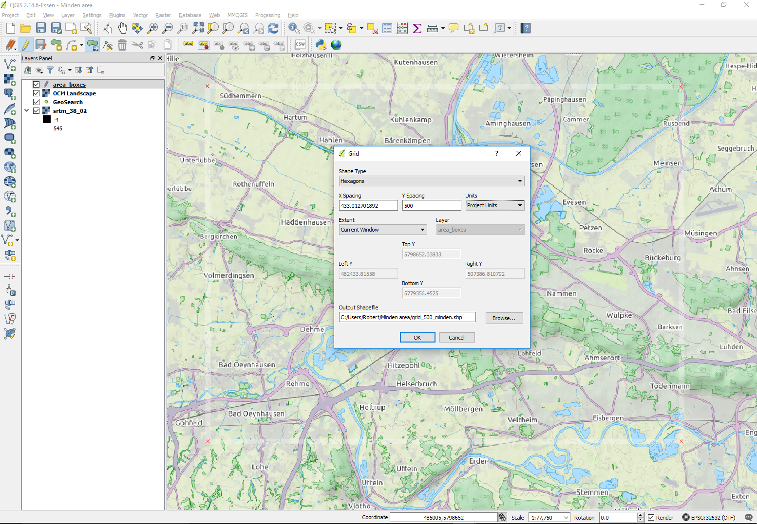

Figure 27 Minden area centered in window with margin, and MMQGis hex grid dialog

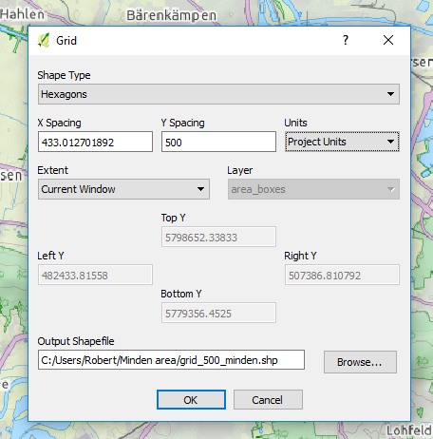

Figure 28 MMQGis hex grid dialog settings

Select the grid_500_minden layer and change its style to a transparent grid using right mouse button, Properties, Style, Load Style, and load the _qgis_vector_styles\editing_style_grid.qml style.

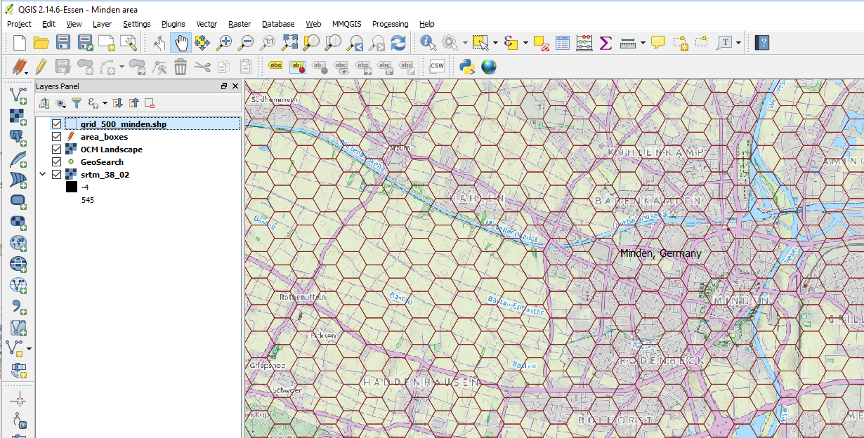

Figure 29 Zoomed in our new hex grid layer

Finally, we try to tweak the position of the hex grid such that the major river Weser and the Mittellandkanal runs through the center of the hex (especially where their roads and rail roads near). This to minimize the shifting of roads when we represent those wide rivers and canals as full 500m hexes. Obviously, achieving a perfect placement isn't possible since nature (outside beehives) doesn't conform to hexagons.

The easiest way to move all the hexagons of the grid_500_minden is deselect all elements of the layer, then invert the selection. So, select the grid layer, toggle layer editing. Next, use View, Select, Deselect features from all Layers. Then, use View, Select, Invert Feature Selection. Finally, use Edit, Move Features to tweak the grid position. After tweaking, make sure to save the layer edits.

## Rendering the Elevation in FC's Color Palette

With the area selected and a hex grid in place, we can start building our game map. The first step is to render the elevation data in the Flashpoint Campaigns' elevation color palette, from elevation 1 upwards, for our map area.

We do so by using QGis to tell us about the actual elevation in the Minden area, and select the most appropriate style from the preset styles.

In the Layers Panel, deselect the OCM Landscape overlay, so we can see the underlying elevation data.

Select the area_boxes layer, then select the Minden area box in the layer. Next, use View menu, "Zoom to Selection" to focus on the map area.

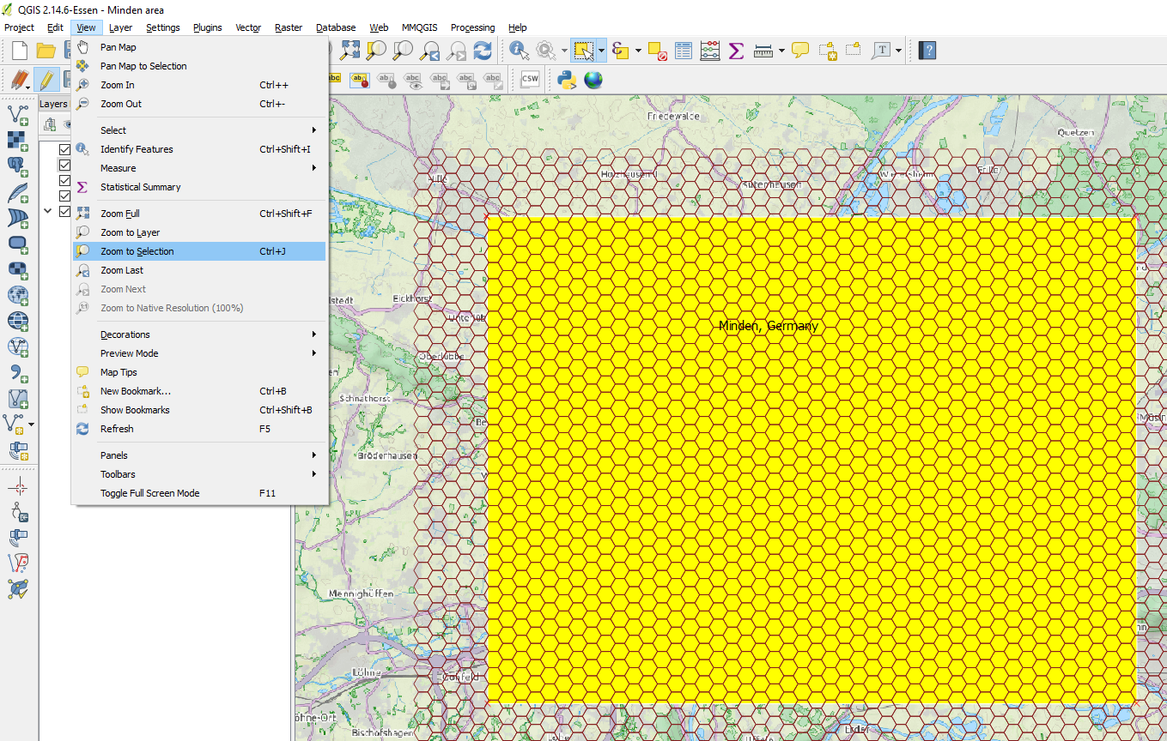

Figure 30 Zooming to the Minden area box

Next, select the srtm elevation layer. Use right mouse button and duplicate it. (It won't duplicate the 70MB data file on disk, just the layer entry in our project's layers).

Rename the new duplicate elevation data layer to srtm_38_02_Minden. Deselect the srtm_38_02 layer in the project (so it isn't rendered), and select the new srtm_38_02_Minden so it will be rendered. (The purpose is of this is to capture this area's elevation setting separately from perhaps a next map area 30km south and 100m higher that uses the same elevation data).

With srtm_38_02_Minden select, use right mouse button, Properties. The properties dialog allows you to do two things: (1) inspect the actual elevation in the area in view, and (2) apply a style.

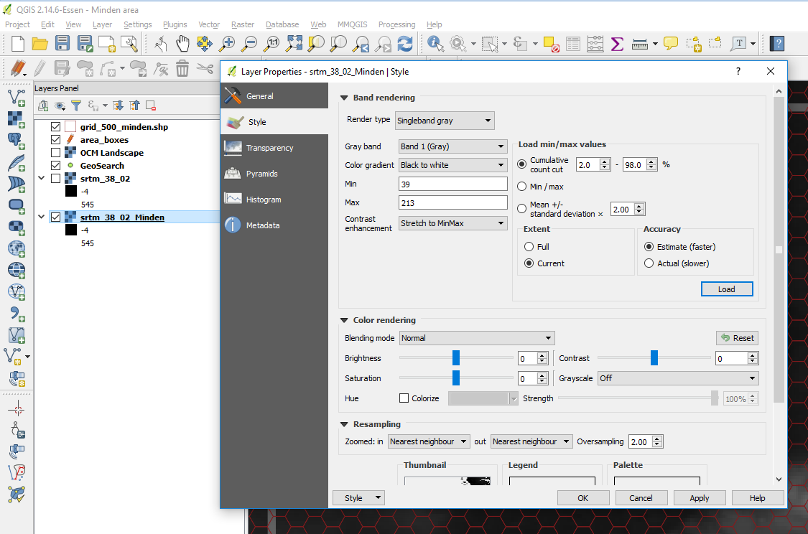

Figure 31 Inspecting Minden area's elevation and applying the corresponding elevation style

To inspect the elevation in Minden's area, select as "Extent" "Current", then press the Load button. It will show you a minimum elevation of around 39m and maximum elevation of around 213m.

As a rule of thumb, round up from the minimum elevation to the next multiple of 25m, and pick an elevation style starting with that number (so 50m, in this case).

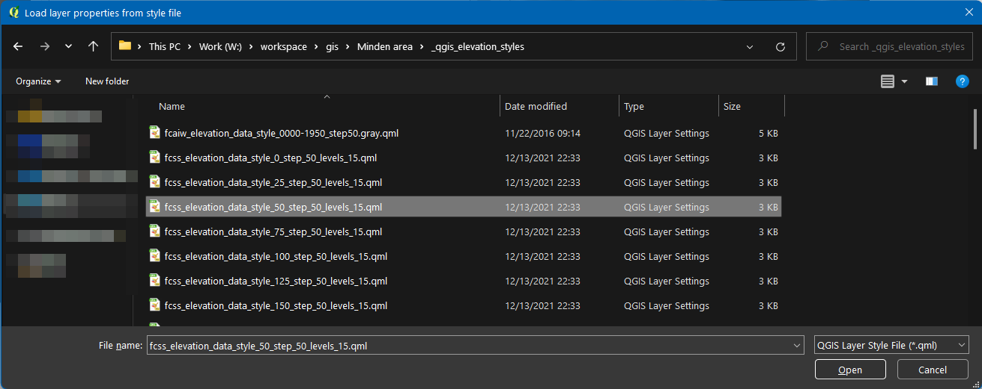

Figure 32 Loading the 50m step elevation style starting at 050m

To load the elevation style, press the Style button, "Load Style", load the 50_step50 file from _qgis_elevation_styles folder, and press Apply.

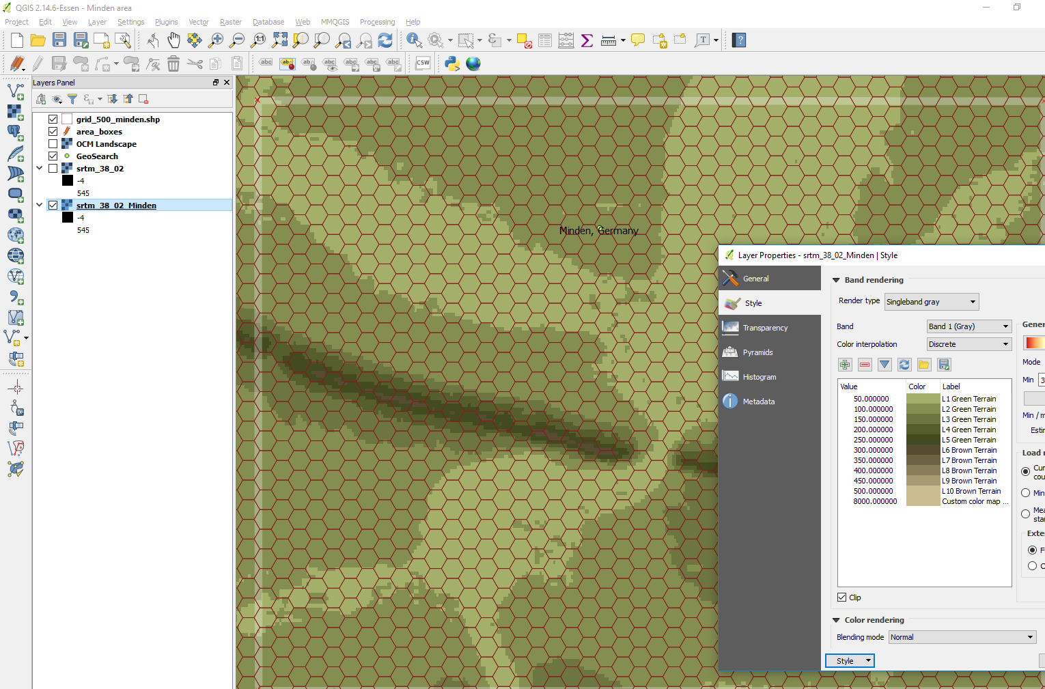

Figure 33 Minden area elevation rendered in Flashpoint Campaigns colors

Feel free to check what the elevation looks like when choosing a floor of 25m (so the 025_step50 style) or of 75m. My subjective feeling is that the 50m floor represents the terrain the best. The benefit of QGis is that we can change the elevation (colors) easily, and at any time.

# Exporting Our 'Elevation Only' Map for Map Values Scanning

The next step is to export our new map for first time to a bitmap, for the Flashpoint Map Values Scanner to scan it.

In typical QGis fashion, the first export will involve a bit of a hassle to set things up, but from then on exporting the bitmap will be trivial, without requiring any resizing or cropping in MS Paint or a Photoshop clone.

In QGis, we export a selected area of the map by making a Print Composer for this area, which captures the required scale and dimensions. Afterward, we just open the Print Composer and use it to export a bitmap.

To create the Print Composer for our 46×30 hex map, do the following. Use the "Project" menu, "Composers Manager", select a "specific" New from template, and press the "..." button to load the 46×30 print composer template.

**WARNING:** If you are creating your second map, or are using the example project to start from, do not modify the existing fcrs_500_Minden print composer but make sure to create a new one.

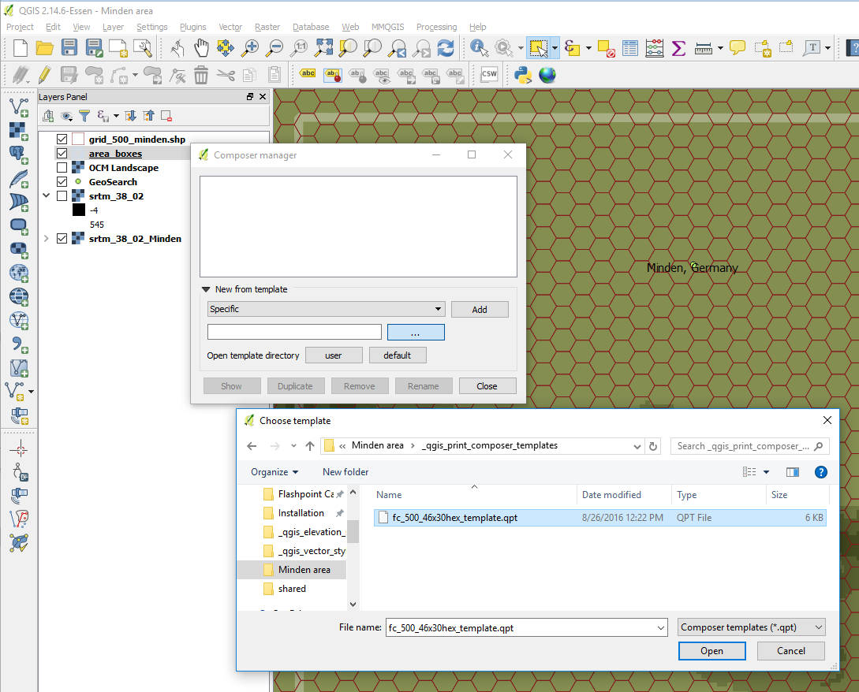

Figure 34 Creating a new Print Composer from the 46×30 hex template

With the template selected in the Composer Manager dialog, select Add. A new dialog will pop up to name the new Print Composer. Let's name it fcrs_500_Minden.

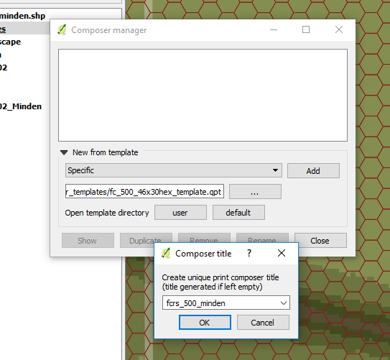

Figure 35 Naming our new Print Composer

The new fcrs_500_minden Print Composer will appear, with its own (blank) window.

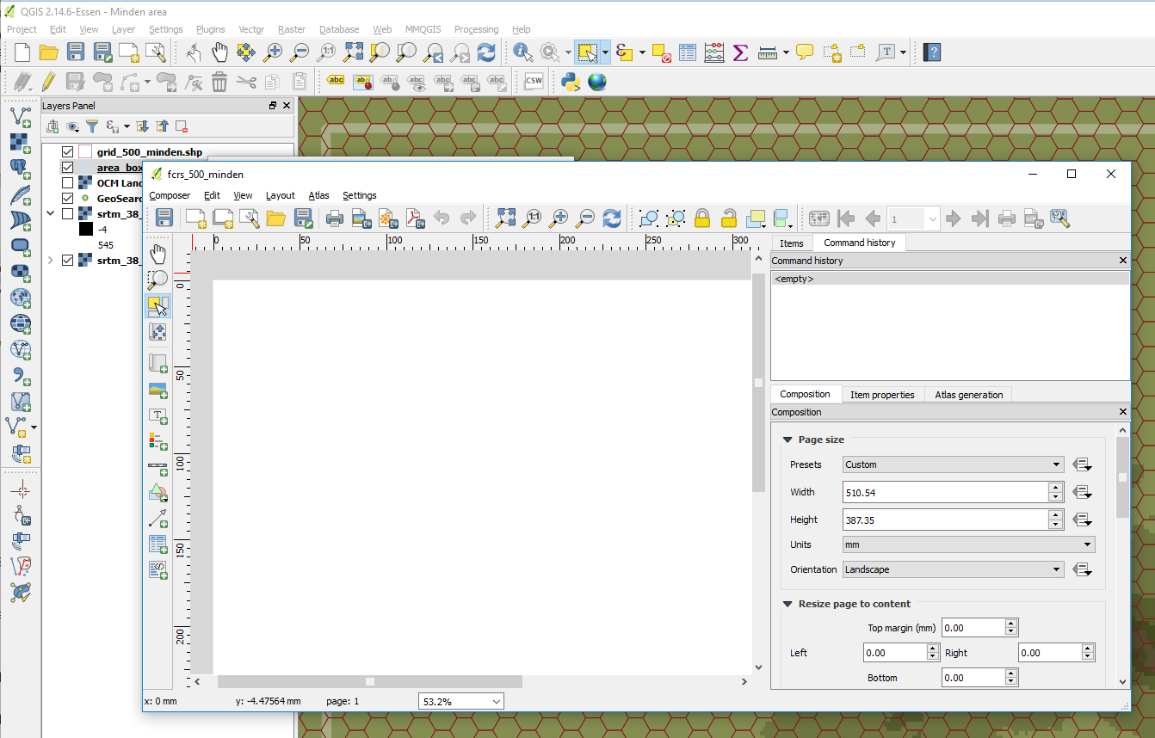

Figure 36 The Minden Print Composer in a new window

Start with closing the 'Command List' Panel and 'Items' Panel, since we don't need it. Select the Item Properties tab, then select the blank area in the main view. (The area is blank because it focused on an area of the map in Southern Germany for which we don't have elevation).

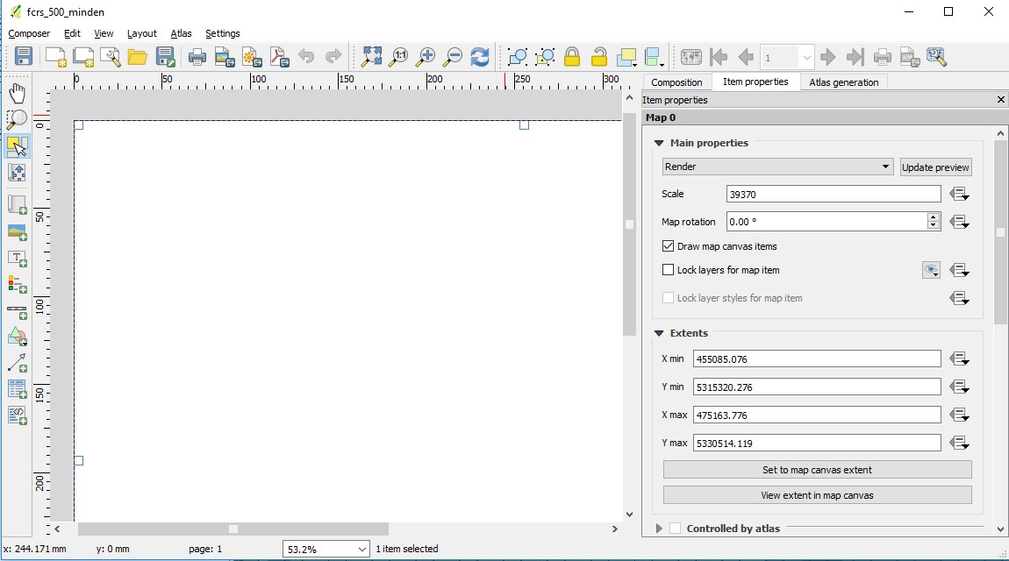

Figure 37 Default Scale and Map Extents of the Print Composer

To make this Print Composer print/export our Minden area, we need to change the extents in the Item Properties to match our map box but not change the scale (39370).

**NOTE:** the scale 39370 comes from 1000m / 1 inch since we're exporting a bitmap at 64 pixels per 500m hex or 128 per 1000m = 128 dots per inch).

Alt-tab to the QGis main window, select the area box layer, select our area box, and use View, Center on Selection to center the window on the area box. Alt-tab back to the print composer and press the "Set to map canvas extent" button.

The Print Composer will update to the following (zoom out to 25% using the control in the bottom row of the Print Composer):

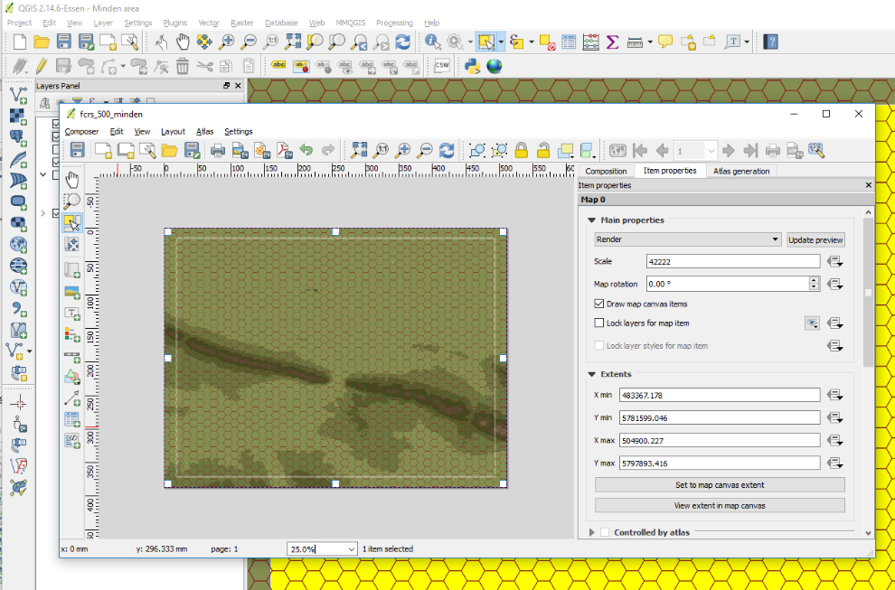

Figure 38 Focusing the Print Composer on the Minden area (but incorrect scale)

Next, correct the scale back to 39370, so the hexes are the 64-pixel height Flashpoint Campaigns: Cold War expects:

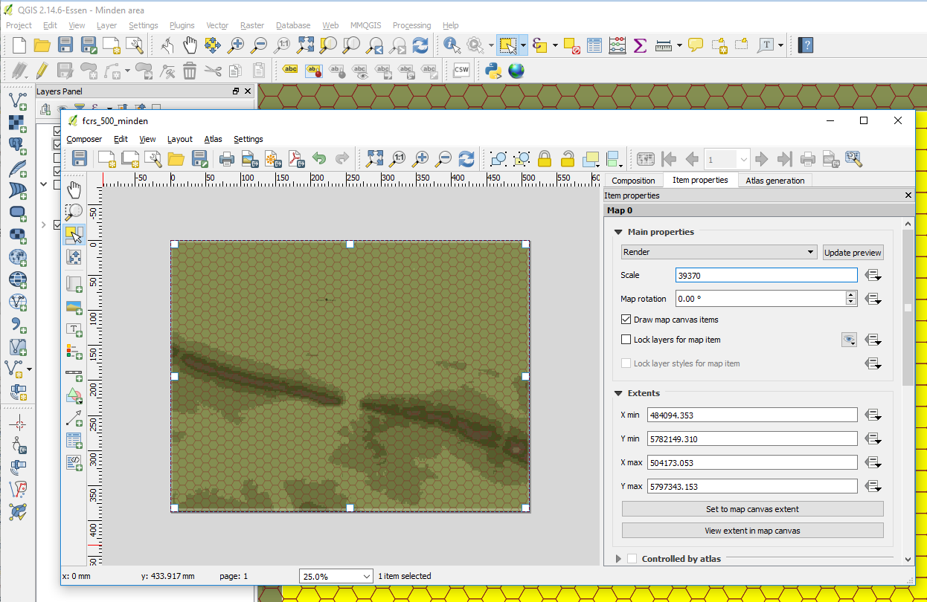

Figure 39 Minden area, at correct scale 39370 (but not perfectly aligned with the game’s hexes)

Next, we need to tweak the extents such that the hex grid perfectly aligns with the grid assumed by Flashpoint Campaigns. I don't know of a good way to solve this QGis, and just resort to a trial-and-error cycle of exporting to Flashpoint Campaigns and tweaking the Print Composer extents. As follows:

**Step 1**. Export to the map for scanning by Flashpoint Campaigns using the current extents. In the Print Composer, use "Composer" Menu, Export as Image, and save the image, for example, to our project folder:

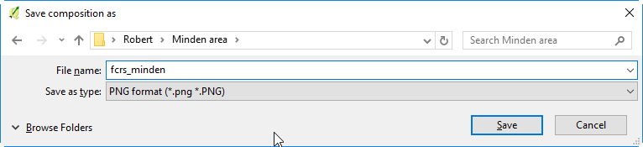

Figure 40 xporting our map for scanning by the Flashpoint Campaigns Map Values Scanner as fcrs_minden.png

In the next dialog, you should see the following settings (128dpi, width of approximately 2572 pixels). Just press Save for QGis to export the .png file.

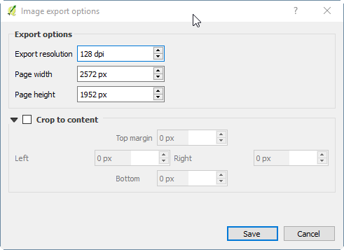

Figure 41 QGis automatically exports the image with the correct width and resolution

**Step 2**. Load the exported bitmap in the Flashpoint Map Values Scanner and check the hex grid alignment with yellow hex cursor.

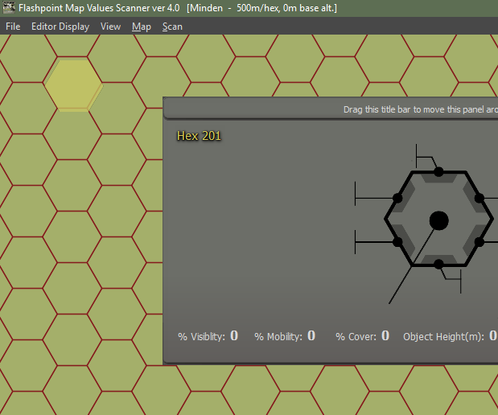

Figure 42 Flashpoint Campaigns Map Values editor with the exported QGis map, and the grid not aligning perfectly with the map cursor (yellow hexagon, top left)

Compare the hex shape with the grid in the exported QGis bitmap. Typically, the two will not line up perfectly, and we need to fix this in QGis.

The offset in this case seems about 1/20th of a hex horizontally to the left and 1/50th of a hex vertically (down). For a 500m hex, the offset thus corresponds to approximately 25m horizontally, and 10m vertically.

Switch back to QGis and our Print Composer. First fix the horizontal offset, subtracting 25m to the extents Xmin and Xmax:

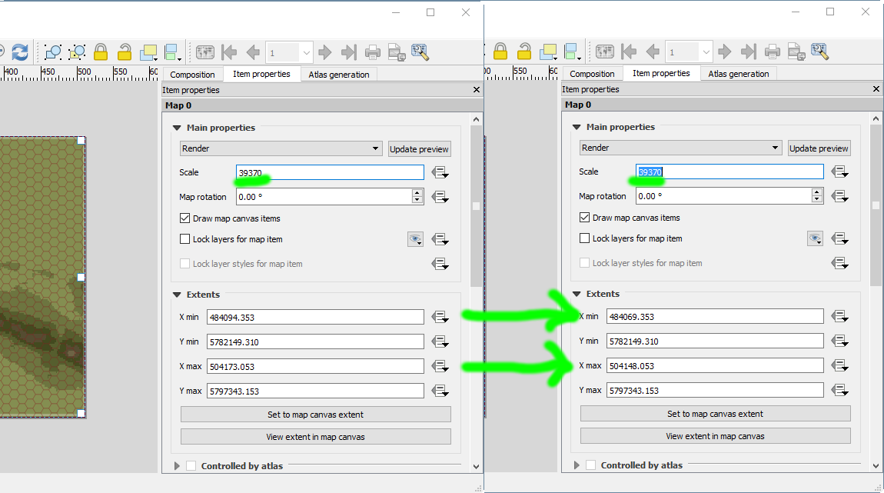

Figure 43 Tweaking the Print Composer extents to align with the game’s grid

With these extents, update the Print Composer (press Update preview), Repeat steps 1 and 2, also adjusting for vertical offset in Ymax and Ymin.

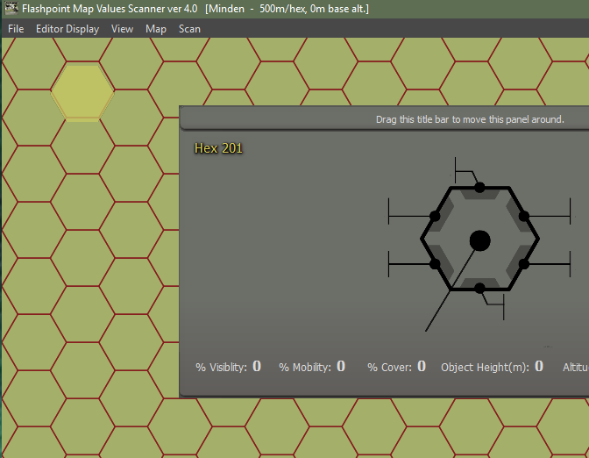

Figure 44 Offset reduced horizontally, but still requiring vertical tweaks...

Rinse and repeat until you get it spot on. This takes me typically 3 to 8 tries. However, these retries are less work than later trying to adjust polygons and polylines because they cross hex grid borders in FCSS.

Here is the result:

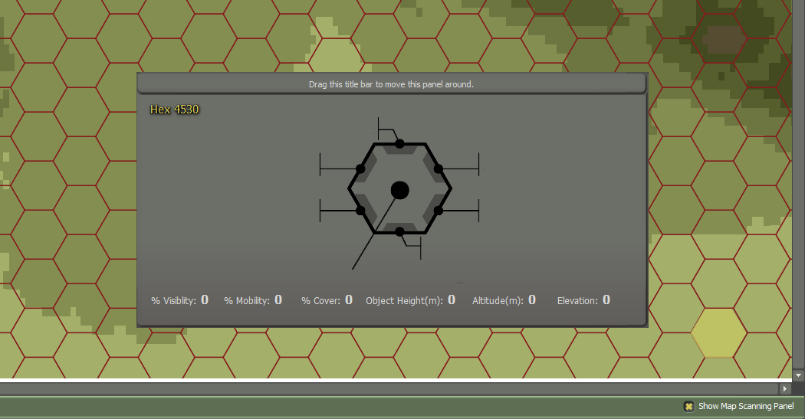

Figure 45 Well aligned Print Composer settings and Flashpoint Campaign game hex grid

**NOTE:** especially for larger maps, be sure to check both the top left corner (hex 101) and bottom right corner of the map for alignment.

Now, let's save everything we have done. In the Print Composer, explicitly save the Minden Print Composer, using Composer menu, save as template (name fcrs_500_Minden).

In the QGis main window, in the Layers Panel, toggle off all the editing flags from any layer (and save the result, when prompted). Also save the project.

Add some organization to the Layers Panel, by introducing the following groups (using, in the Layers Panel, right mouse button, Add Layer Group):

* Helpers
* Manual Annotations
* Elevation

Next, drag and drop the layer such that the elevation items are under elevation, and the area boxes are under helpers, as follows:

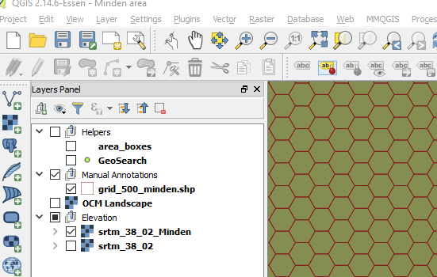

Figure 46 Some housekeeping done to our layers (ignore the GeoSearch layer; that layer and corresponding plug-in are no longer functional in QGis 2.x)

Finally, use the Print Composer again export the map as we should, with the area boxes and GeoSearch layers disabled.

Load the map into the Flashpoint Map Values Scanner again. This time, let’s fill out the map meta information, consisting of author information, map name, and altitude information. Under ‘Editor Display’, choose Author Details… to launch the following dialog:

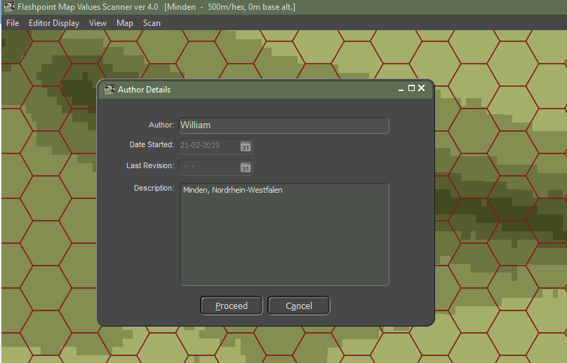

Figure 47 Map meta information: author information and map description

Press ‘Proceed’ to close this dialog. Next, and open, again under ‘Editor Display’, the Map Scale and Base Altitude dialog. The map scale cannot be changed (and is fixed to 500m hexes). For altitude, fill out the base level we have chosen for our elevation style in QGis (75m).

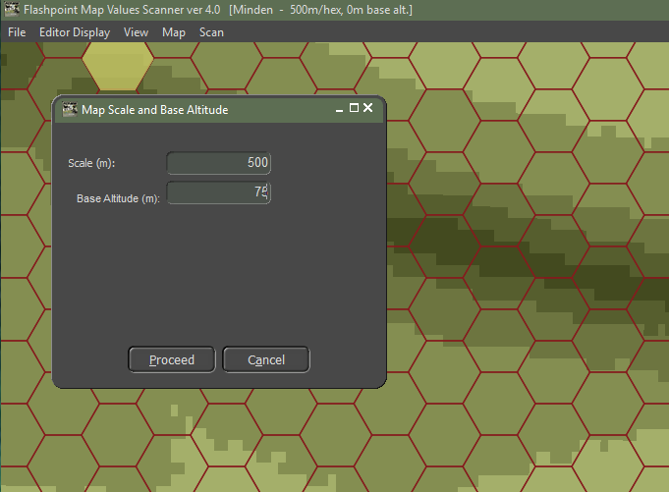

Figure 48 Map meta information: base altitude of 75m

Now, we can scan the bitmap for terrain properties (mainly elevation data, as that is all we have now). Choose, from the menu ‘Scan’, then ‘Scan Map’. (Or, alternatively, press the big ‘Scan for Map Values’ button in the bottom right corner).

After approximately one minute (longer for larger maps and slower computers), the map will have been scanned. A popup dialog appears, showing a summary of the findings:

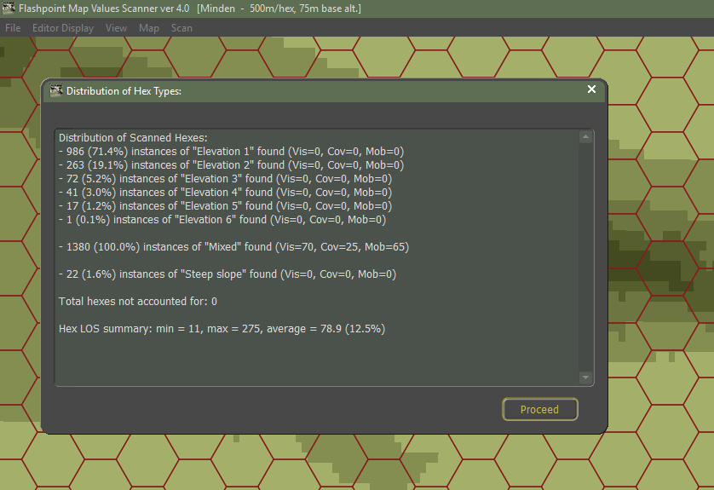

Figure 49 Map scanning results: six elevation levels, and twenty-two steep slopes

Press ‘Proceed’ to close the dialog. We can now inspect the scanning result. From the ‘View’ menu, choose ‘Elevation Values’ to have the elevation (from 0 to the maximum elevation) displayed.

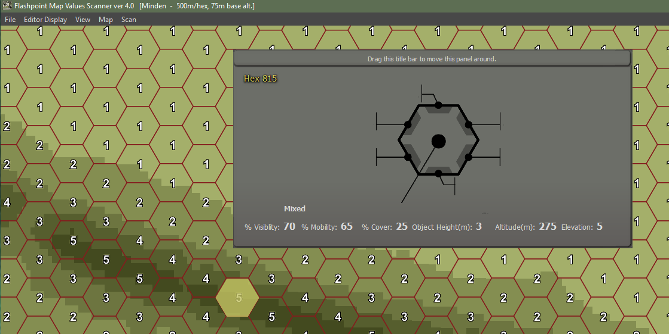

Figure 50 Elevation values after map scanning

Note that the selected hex also has its altitude defined (275m, being 4 elevation steps of 50m higher than the base altitude). Also, the object height in the hex is 3m (given its ‘Mixed’ terrain), which plays a role in line-of-sight computations.

From the View menu, you can inspect other attributes. % Visibility, %Cover, and %Mobility indicates the terrain impact on line-of-sight, on offering cover, and on impact vehicle mobility.

Altitude indicates per hex altitude value. Feature height (or object height) indicates the height of the obstacles / features in the hex, which impacts the ability of helicopters to fly low.

Hex identifier is the hex number identification the location, typically running from 101 to 4630 for 20x15km maps. The Hex Side Obstacles indicates hex side obstacles and steep hill sides:

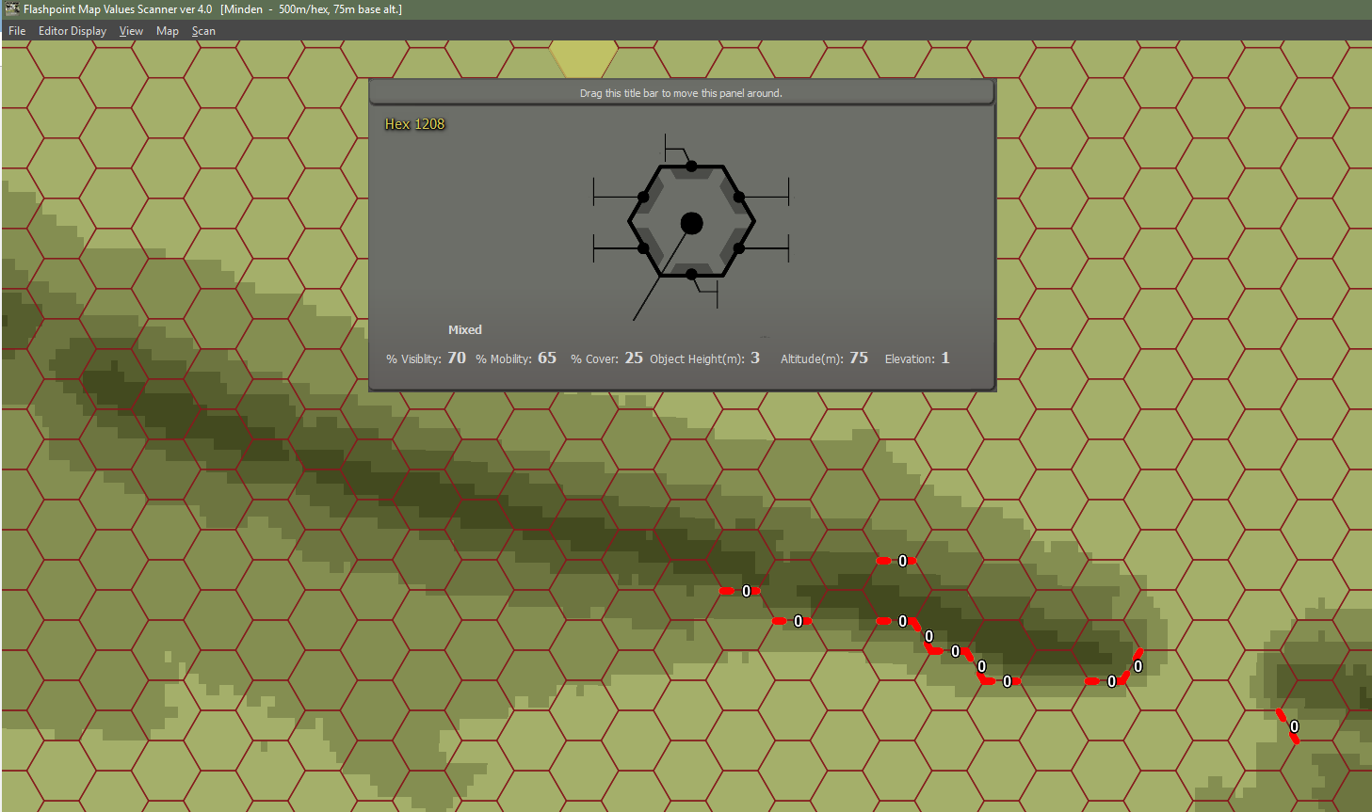

Figure 51 Steep hill sides indicated by the Hex Side Obstacles view

‘Road net’ displays the road net (we haven’t defined any) and ‘Surface type’ indicates dry of wet surface.

Save the result as fcss_minden.fp10.

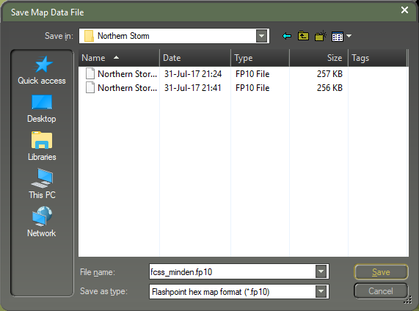

Figure 52 Save our scanned map as fcss_minden.fp10

# Intermezzo: The Terrain per OTS Render Tool

Sadly, we haven't yet figured out how to make pretty maps with QGis. At OTS HQ, we run a complex, clumsy and secret tool that reads the .fp10 and .png bitmap, and renders it as elevation layers.

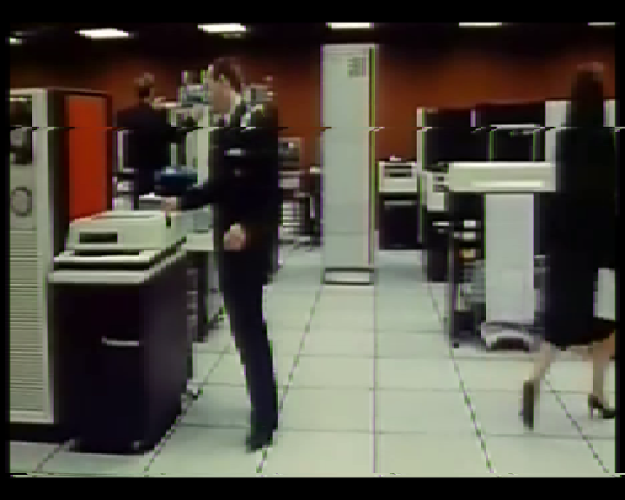

Figure 53 The render tool at OTS HQ?

Just to demonstrate what we have accomplished in the preceding steps in QGis, here is the result per OTS map render tool:

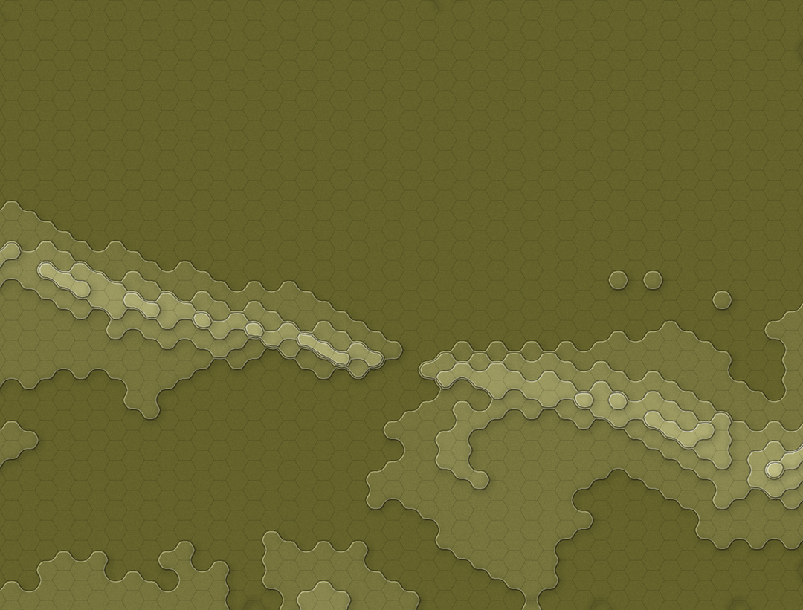

Figure 54 Intermezzo: the terrain per OTS's render tool interpreting the .fp10 file

# Drawing Our Map: Water and Roads

With the elevation in place, let’s organize our project so we can draw water (full hex major rivers and lakes, and hex side minor rivers and streams), roads (highways, primary roads, secondary roads, rail roads), built up areas (rural, industrial/commercial, high rise), forests (and vineyards/orchard) and fields.

## Creating Layers for Our Manual Annotations

Please create the following layers, as explained below the table, and arrange them in this order in the “Manual Annotations” group:

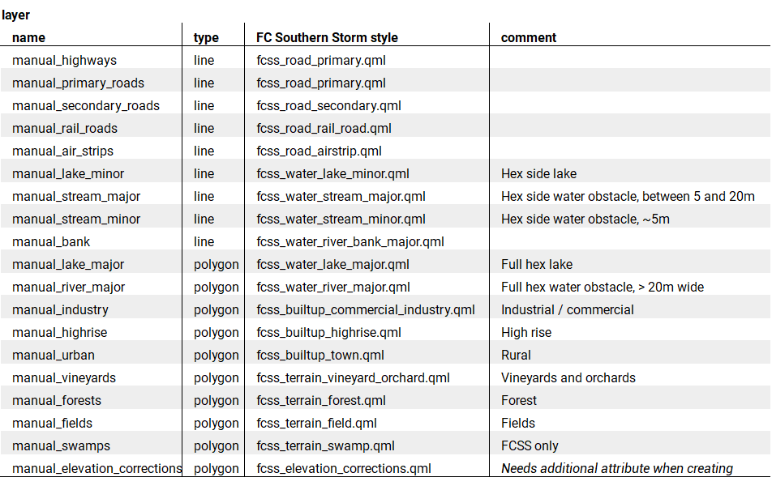

Table 1 Layers to add to QGis to capture our manual drawing

To create a line type layer, such as ‘manual_highways’, use the Layer menu, “Create Layer”, “New Shapefile layer”. In the “New Shapefile Layer”, choose “Line” for “Type”. Leave file encoding to “system”. Set CRS to Project CRS (your WGS UTM). Next, press the OK button.

When prompted to the “Save Layer as...” save the layer in our project folder using the layer’s name (‘manual_highways’).

Repeat this for all the line layers in the table.

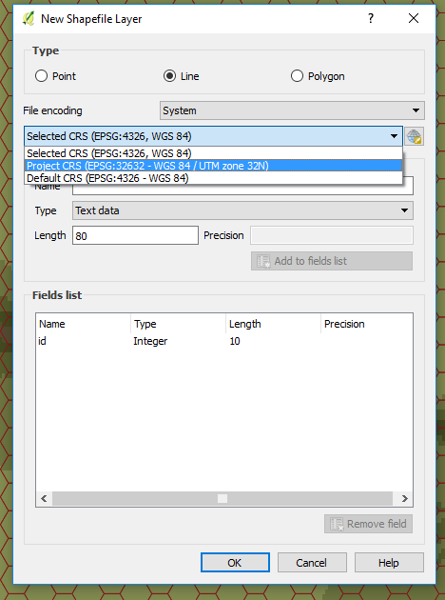

Figure 55 Creating a new "Line" ShapeFile layer

To create a polygon type layer, such as ‘manual_lake_major’, use the Layer menu, and create a “New Shapefile layer”, this time with “Polygon” for “Type”. Again, ensure the CRS is the Project CRS (WGS UTM). Press OK and save the layer.

The final polygon layer (manual_elevation_corrections) is special in that it needs an additional field (to capture the elevation). Fill the “New Field” name with “elevation”, type “Whole number”, and press “Add to fields list”. Next, press OK and save the layer.

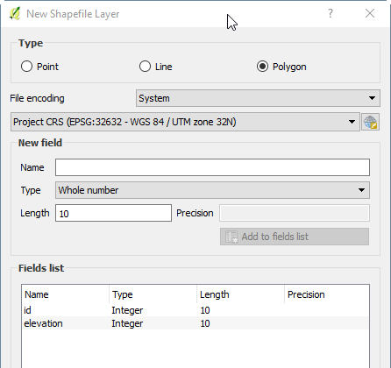

Figure 56 An additional "elevation" field defined for the manual_elevation_corrections_layer

Repeat this for all polygon layers in the table.

When all layers have been created, and arranged, the Layers Panel should look like this:

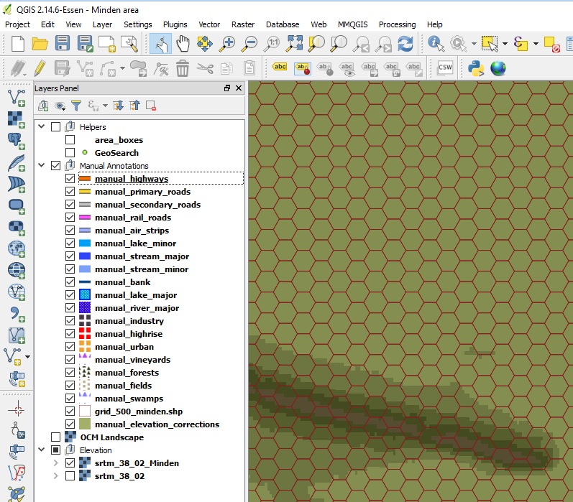

Figure 57 All line and polygon layers defined and ordered, in Flashpoint Campaign styles

Save the project.

## Defining Short-Cuts for Quickly Selecting and Moving Features

For quick creation of water and urban hexes, I prefer to draw a hexagon shape slightly smaller than a hex, select it, copy it, and repeatedly paste and move it to cover a river / urban area.

QGis comes standard with keyboard short-cuts for copy and paste, but not for “Select Feature” and “Move Feature”. Use the “Settings” menu, Configure Shortcuts. In the dialog box, scroll to “Move Feature(s)”, press “Change”, and assign it with a key combination, for example, Ctrl+G.

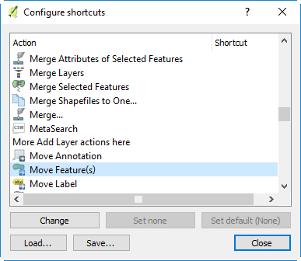

Figure 58 Assign a short-cut to Move Feature(s)

Next, scroll to “Select Feature(s)”, press “Change”, and assign it a key combination, for example, Ctrl+T.

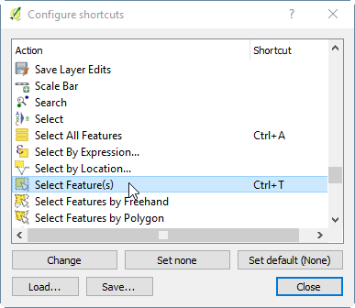

Figure 59 Assign a short-cut to Select Feature(s)

## Adding a Satellite Layer to Drawn On

We will be drawing the “full hex” major rivers on top of a satellite imagery; satellite images will tell us both the location and the size (width) of the waterways.

In the Layers Panel, click (but don’t tick) the OCM Landscape layer, then use the Web menu, OpenLayers plug in, Bing Maps, Bing Aerial with Labels. Next, select the “area boxes” layer and tick it, so we see our map area’s boundaries.

Zoom the map in to scale 1:25,000, which is a good scale to draw our first polygon.

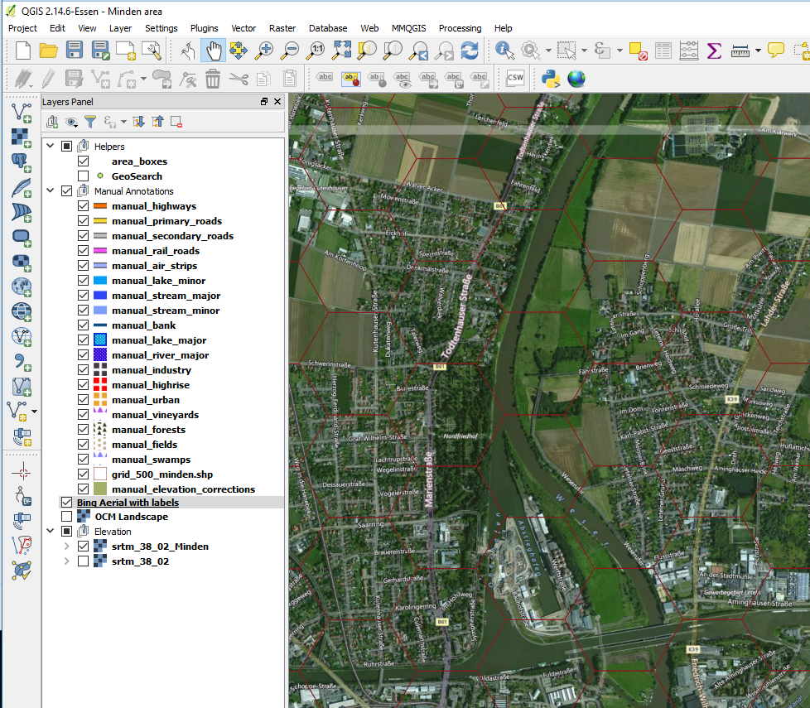

Figure 60 Finally time to draw our first polygon

Near Minden, the Weser River (running north-south) and also the Weser-Elbe canal (running east-west) are too wide (greater than 20m) for a hex side stream and need to be represented as a full hex. You can see this for yourself on the satellite image. All the other water obstacles are smaller and can be represented as a hex side water obstacle.

See Appendix D for guidelines on how to represent water obstacles.

## Drawing Rivers, Highways, Primary Roads, and Air Strips

To draw our first river hex, select the manual_river_major layer. Next, toggle the layer to enable editing (right mouse button, Toggle Editing). Select the Edit menu, “Add Feature”. Draw a hex shape inside one the hexes through which the Weser River runs, keeping a good amount of margin between the hex shape and the hex grid. That margin makes it easier for us to position copies of the hex shape in other positions in the hex grid, without accidentally running over a hex grid boundary and “leaking” into an adjacent hex.

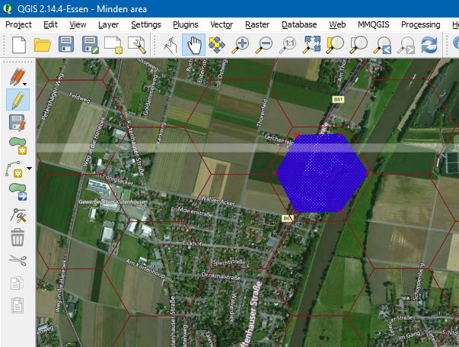

Figure 61 A first major river hex shape drawn on the major_river layer

With the hex shape available, we can change to a paste and move process. Select the shape (use your newly assigned keyboard short-cut, Ctrl+T). The selected shape is shown in solid yellow. Ctrl+C, Ctrl+V to copy and paste. Use new keyboard short-cut Ctrl+G to change to move mode and move the shape to the next river hex. Ctrl+V to paste a new shape and move it. Repeat until the whole Weser River and the Weser-Elbe / Mittelandkanal are covered.

Approximately 100 new hex shapes later, the Weser and the Kanal are covered, but not without running into the occasional dilemma of where to place the hex shape, trying to balance representing the flow the river / canal, not covering key roads, and not covering key hills. Don’t deliberate too long; QGis makes it relatively easy to revisit your current decision later, when you have more information (about the position of roads, etc.).

Do make sure you place hex shapes also just outside the borders of the area box, to cover the (half) hexes on the border of our game map.

Save your layer edits using the Layers menu, Current Edits, Save for Selected Layer(s).

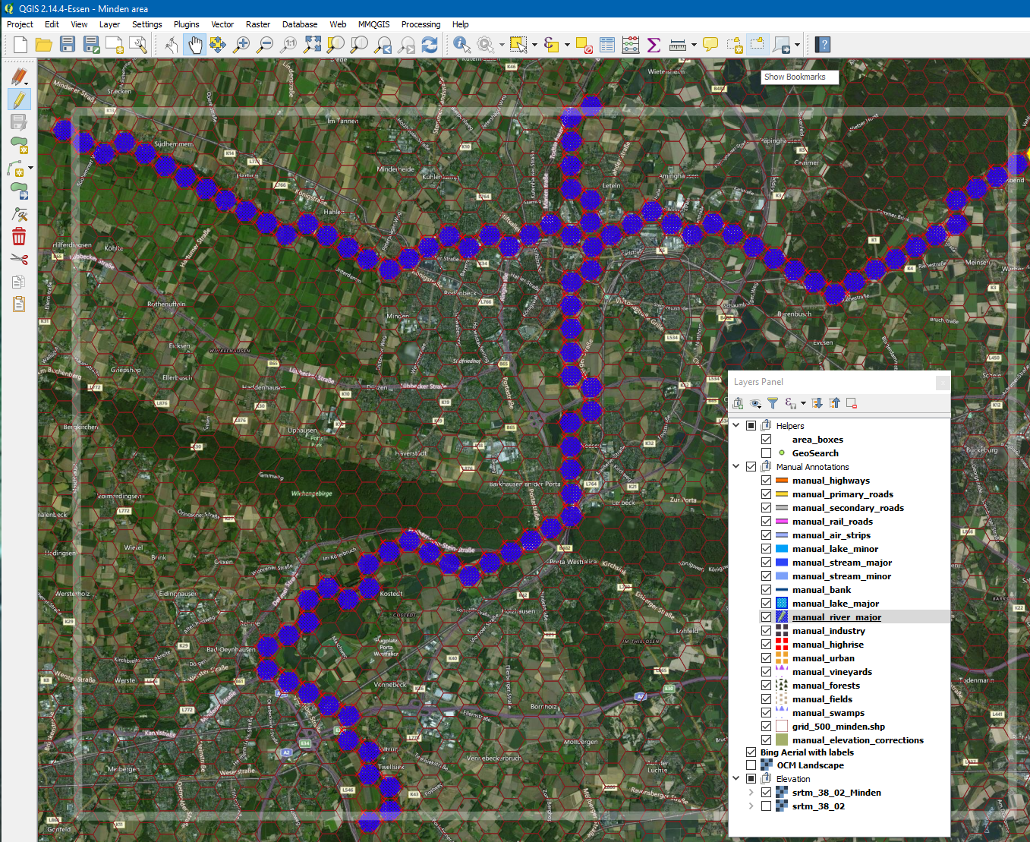

Figure 62 The Minden area with the Weser river and Mittellandkanal defined

Next, we draw the highways (Autobahn A2 (E30), and Autobahn A30 (E34)). Select the manual_highways layer, toggle the editing to on. Roads are drawn as polylines. For the Flashpoint Map Values Scanner to reliably detect roads and not get confused, run the roads from hex center to hex center, crossing near the middle of the hex side.

Start by Edit menu, “Add Feature”, click a series of points, and end by using the right mouse button, OK; there is no need to enter an “id”. When drawing, the Backspace key allows you to undo the last point drawn. While drawing, you can switch to the Pan Map mode (in the View menu), pan the map left or right, then press right mouse button and continue with drawing a road.

**NOTE:** If you have a Wacom Tablet and Pen (“digitizer”), QGis has excellent support for it. Using a pen works great for me, and feels faster than using a mouse for drawing lines and polygons.

Keep in mind that the A30 highway is incomplete here, transitioning to a Bundesstrasse B61 major road for several kilometers. (This was the case already in 1989).

Don’t forget to save your layer edits.

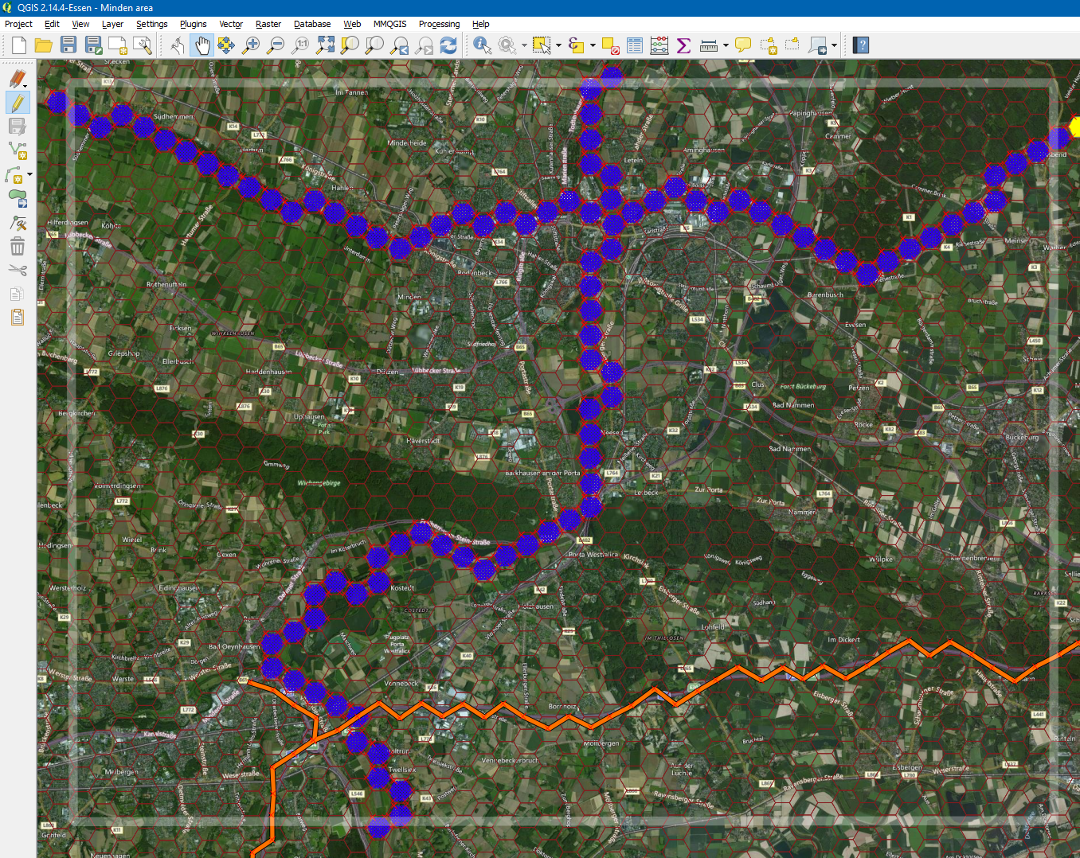

Figure 63 Minden, with the A2 highway and the tail of the A30 highway added

Adding the major roads (B61, B514, B482, B65) is similar, using the manual_primary_roads layer. Using the Bing Road layer (instead of the Bing Aerial with Roads layer) might make it easier to see the major roads. Use the “Web” menu, OpenLayers plug-in, Bing, Bing Roads to add the layer.

Some creativity will be required to run road B61 west of the Weser through the Porta Westfalica gap, since the real road position is covered by the river hexes.

Also add the airfield (Flugplatz Porta Westfalica, former British occupation forces airstrip) in layer manual_air_strips.

And save your edits.

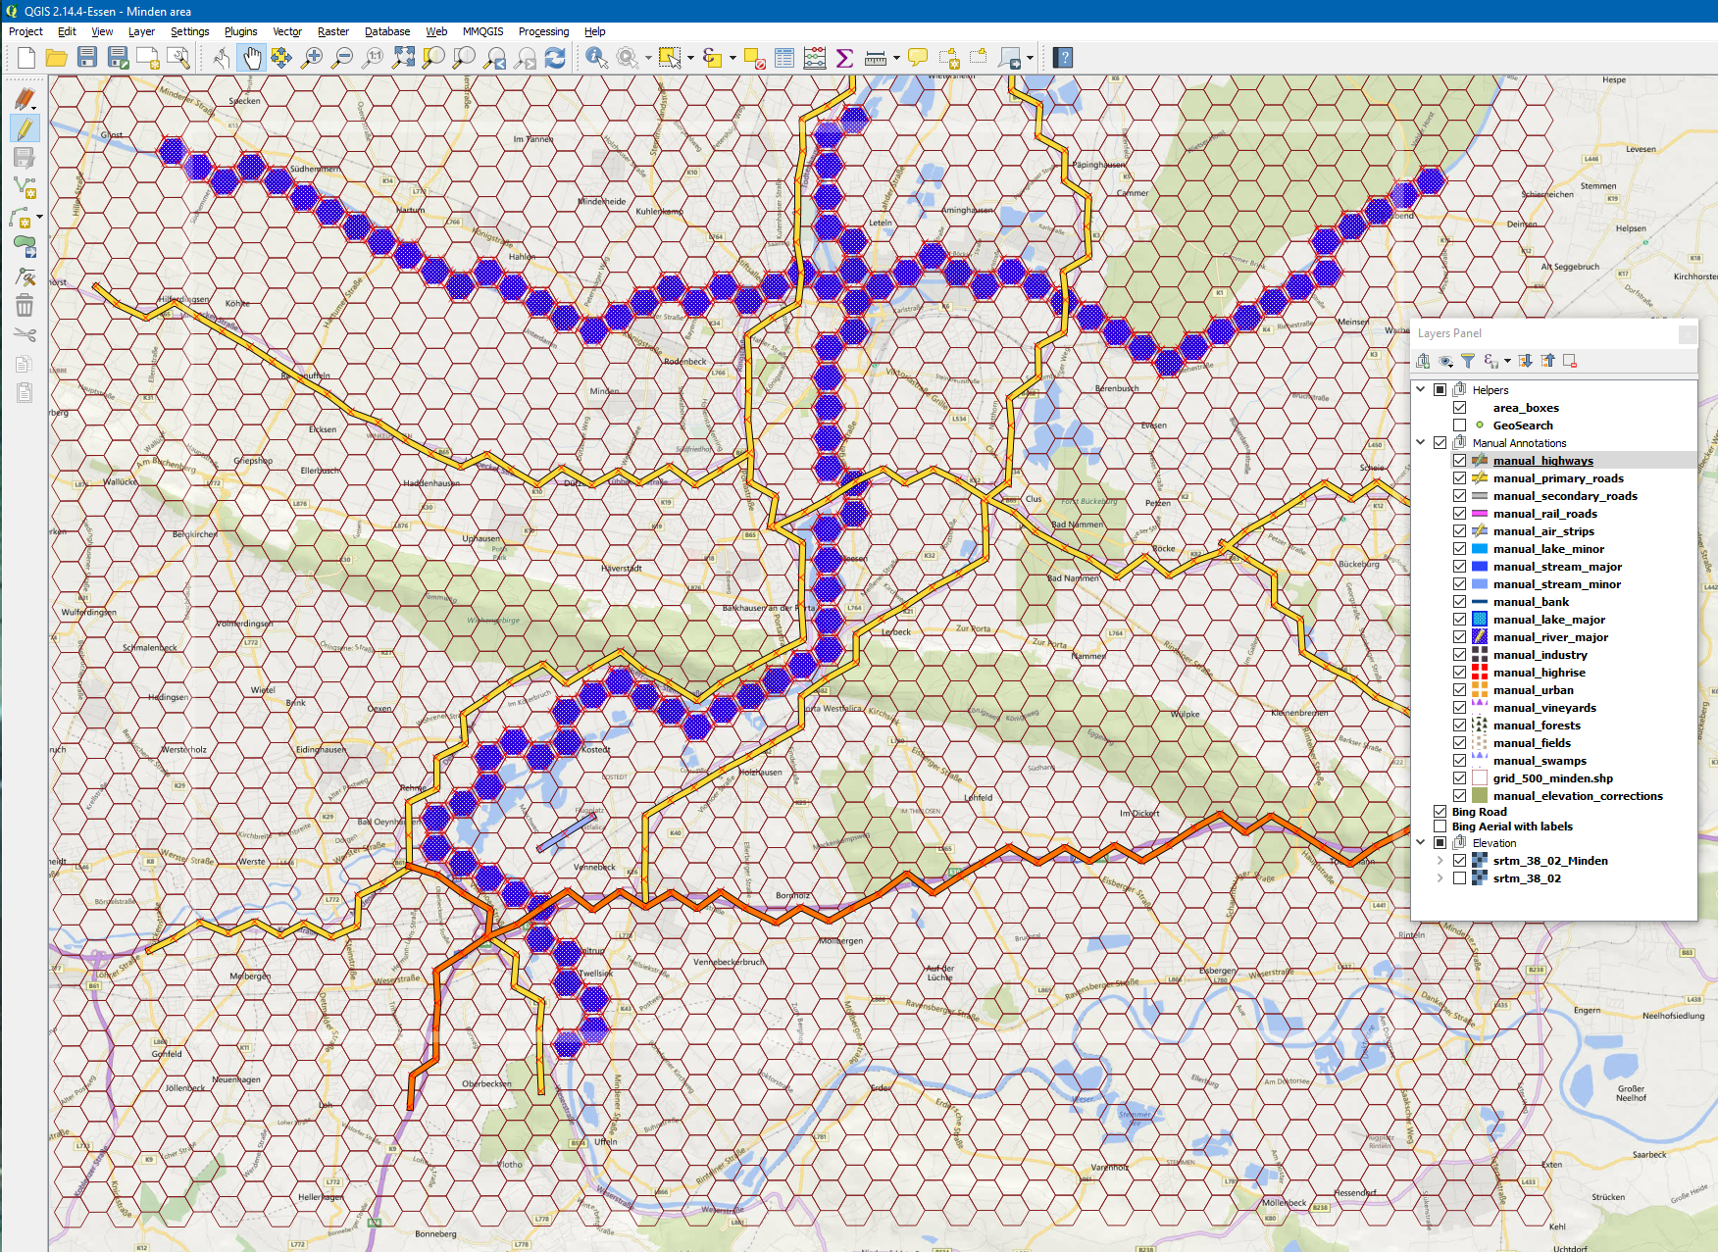

Figure 64 Minden with primary roads and air strips added, using Bing Roads as backdrop

## Intermezzo: OTS Render

If we were hide the Bing layers, change coordinate system back to WGS 84 UTM, export the bitmap, parse the bitmap anew and save it as an .fp10 map file, and send the results to OTS’s secret lab, they might return an intermediate result as shown below. We’re doing great!

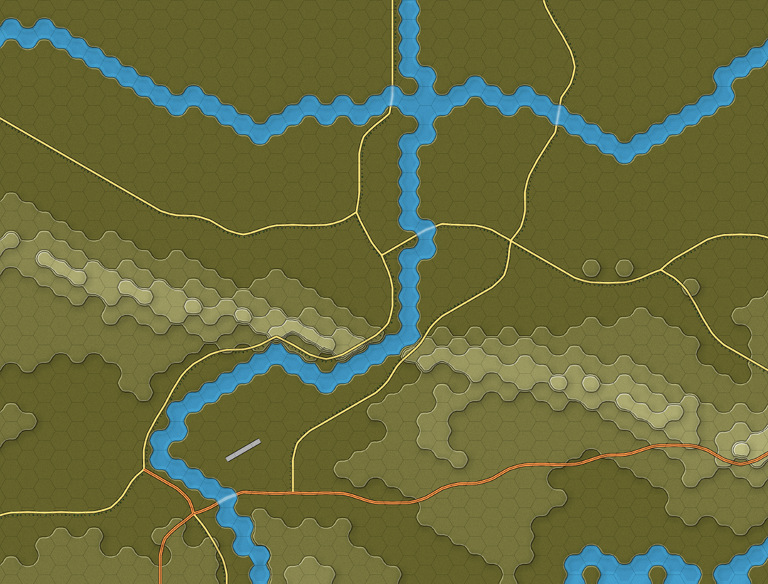

Figure 65 Our works-in-progress Minden rendered at OTS HQ

# Drawing on Our Map: Towns, Minor Roads, and Railroads

We will further dress up our map by adding full hex rural, high rise and industrial areas.

## Built-up Areas and Crisp, Clear Maps

Although QGis and the Flashpoint Map Values Scanner do not impose a style on you, I do recommend staying with a crisp and clear style, introduced with Flashpoint Campaigns: Red Storm. Since built-up terrain is, in terms of game tactics, very different from other terrain, built-up terrain is not to be mixed with other terrain in the same hex. This clear style makes the map straightforward to read.

As a rule-of-thumb, do not turn a hex into a built-up hex unless the satellite map shows that most of the hex is filled with built-up terrain. When in doubt about the extents of the village, trim the outskirts of the villages.

When in doubt where to position the built-up hex (amidst terrain all partially covered by buildings), pick the location where it makes most sense on the game map, such as road crossings or riverbanks.

## Drawing Built-up Areas

We draw the built-up areas in the same way we’ve drawn the major river, by copying, pasting, and moving a hex shape polygon. Select the manual_river_major layer, select a hex shape on that layer, and copy (Ctrl+C). Next, select the manual_urban_layer, enable it for editing, and paste the hex shape. It will show up in urban style (not as a major river).

**NOTE:** In QGis you can easily copy (or cut) shapes from one layer into another layer. This way, you can quickly change the hex contents from urban to high rise, or a road from highway to primary road.

Below, you can see the result, with urban, high-rise (red) and (hard to see) industrial zones (dark greyish).

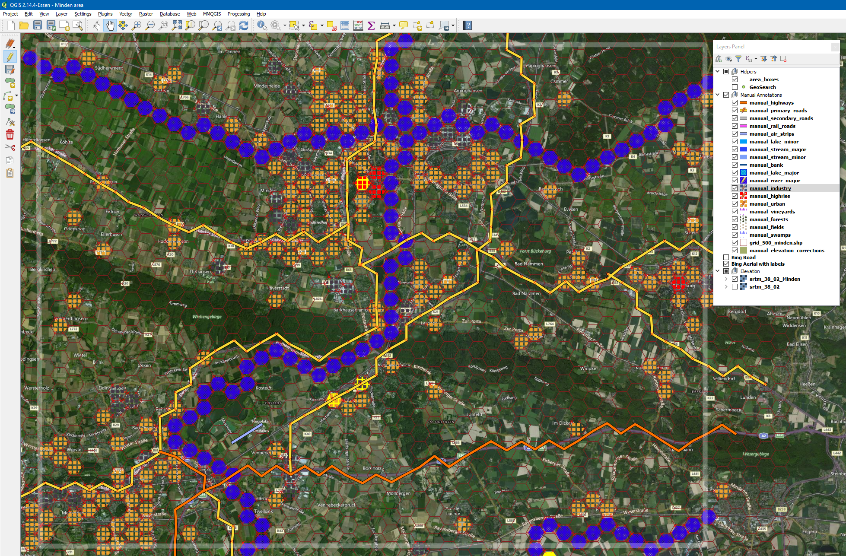

Figure 66 Minden covered with manually placed full-hex built-up area annotations

## Drawing Railroads

Perhaps a pet peeve of mine, but I do like to have rail roads drawn on the map. If a railroad bridge can carry a diesel locomotive, it can carry armored vehicles… FCSS supports rail roads and railroad bridges.

Railroads are a lot easier to spot on the Bing roads “underlay”, so disable the Bing satellite map and activate the Bing roads “underlay”. Draw the railroads in the same way as the highways and primary roads have been drawn. Personally, I like to recreate the original alignment (left or right of the road) when drawing railroads in the same hex as roads.

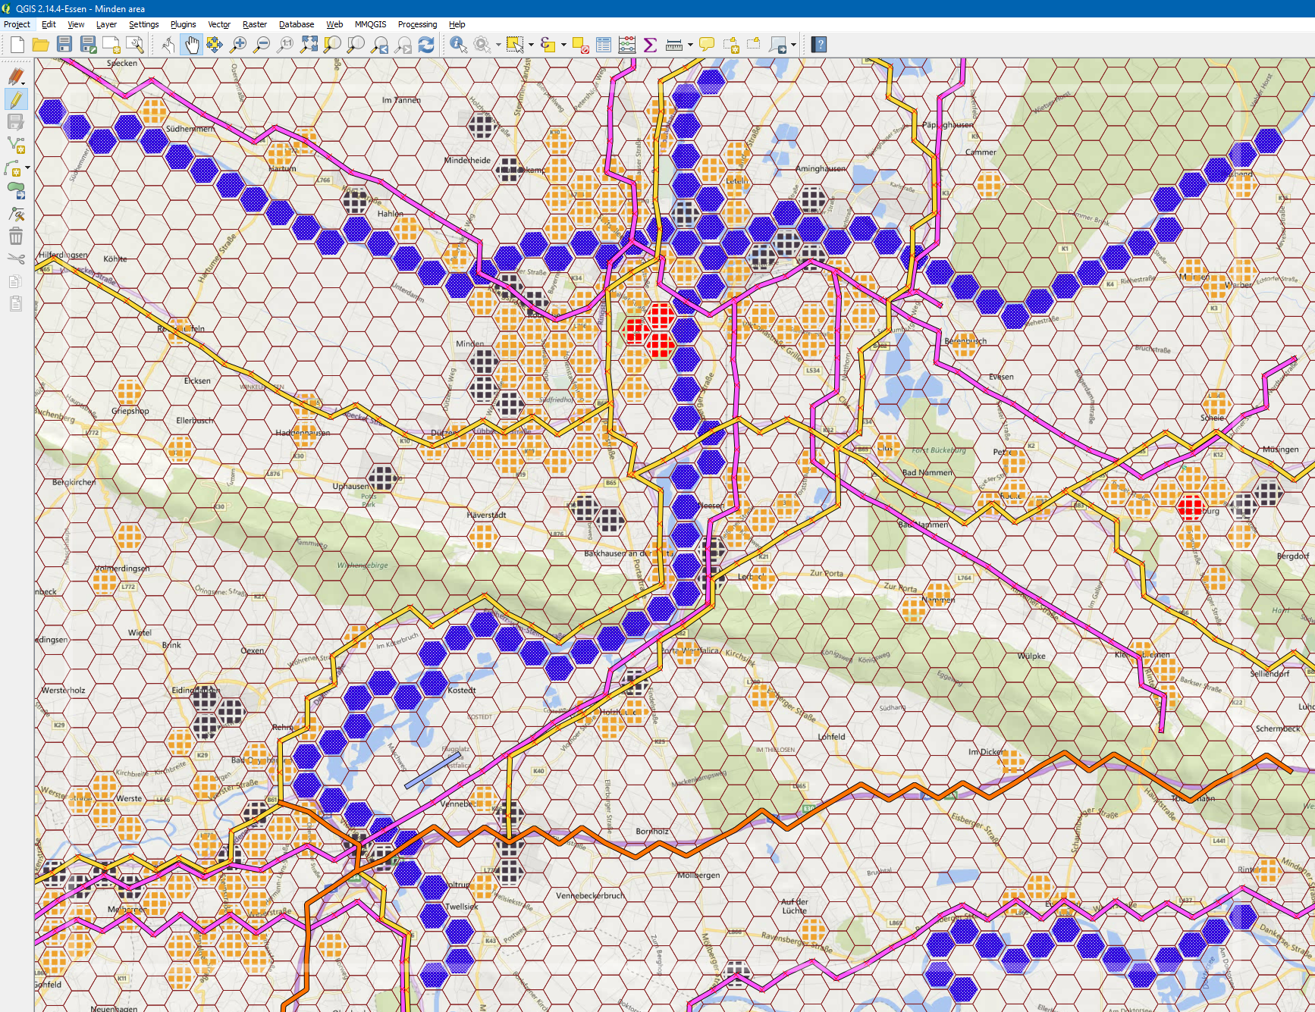

Figure 67 Railroads drawn on the map, using the Bing Roads "underlay"

## Drawing Secondary Roads

Next, draw the secondary roads on the map. Use the color coding and road size on the Bing map to identify the secondary roads. Germany makes identifying its secondary roads a bit easier, by issuing road designations to significant secondary roads: the “L” roads are Landesstraße, provincial roads, and the “K” roads are Kreisstraße, maintained by the county. There are a few exceptions to this rule:

* Bayern/Bavaria not using the “K” designation for its Kreisstraße, but using a two or three letter county abbreviation instead; and
* Saarland, Hamburg, Bremen and Berlin not having Kreisstraße

One thing to keep in mind is that built-up terrain is given high mobility values, almost as high as road hexes, so there is no need to draw a dense road network in built-up areas.

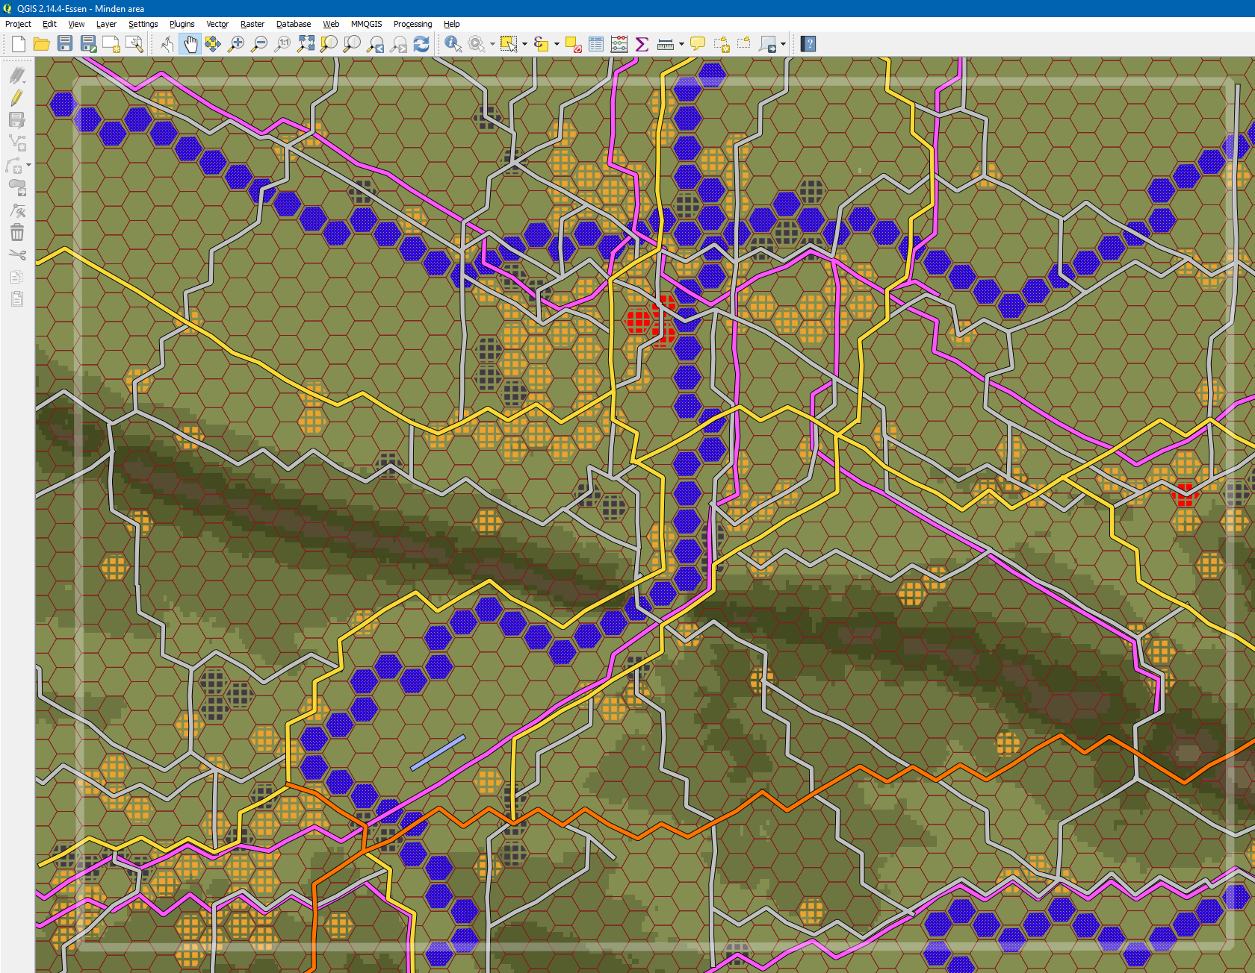

Figure 68 Secondary roads added to the Minden map

## A Critical Review of Our Results and a Few Fixes

In the above map, some details do not make much sense. In two river hexes, we can see (rail) road bifurcations, suggesting an unrealistic bridge construction. This can easily be fixed by editing the road poly lines, shifting the bifurcation out of the full-size river hex in a way that most closely reflects the real-world.

With a layer selected for editing, use Edit menu, “Node Tool” to move around individual nodes of a polyline.

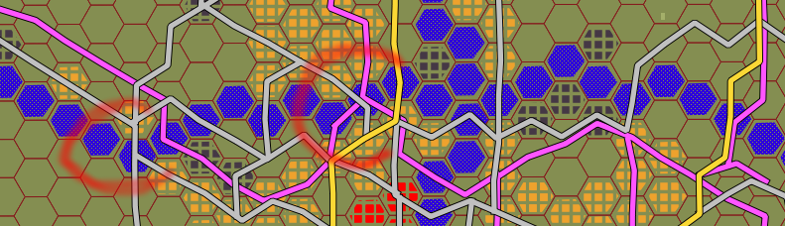

Figure 69 Two unrealistic (rail) road junctions inside a major river hex

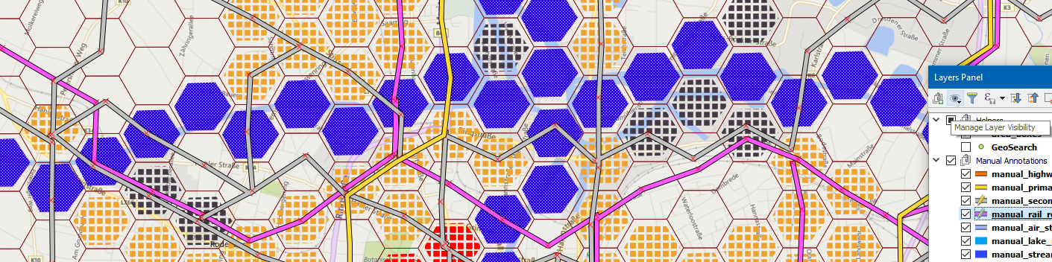

Figure 70 Roads and rail-roads trajectories reworked to avoid junctions in full river hexes

## Intermezzo: OTS Render of Our Works-in-progress

After another trip to OTS HQ, we receive the following render of our works-in-progress map in return.

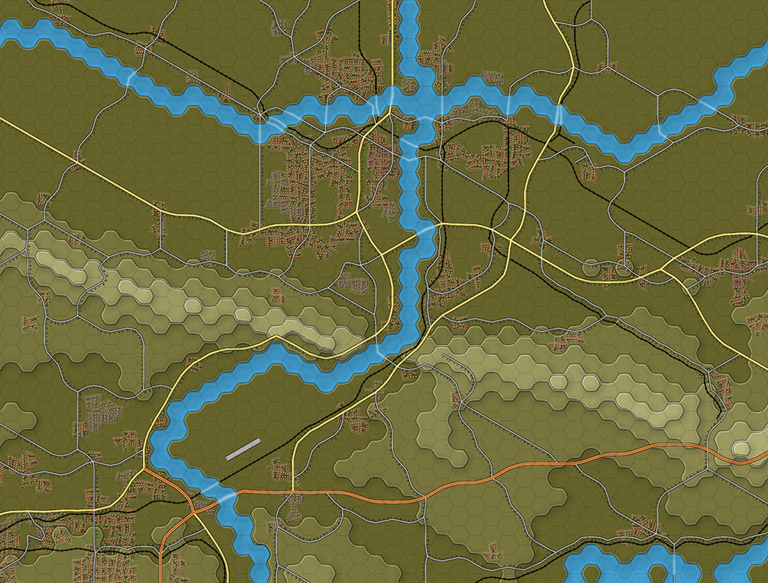

Figure 71 OTS render of our works-in-progress

# Drawing on Our Map: Minor Rivers, Streams, Forests and Fields

## Identifying Minor Rivers and Streams

The hardest part of drawing minor rivers and streams is identifying the ones that represent real water obstacles, and ignoring the ones which are too small to represent much of an obstacle. Sadly, map data such as OpenStreetMap often is not reliable in displaying minor rivers and streams: sometimes the blue lines on the map represent 10m wide streams (true obstacles), other times the blue lines represent narrow ditches (no obstacle), and worst of all, sometimes true streams are not drawn on the map.

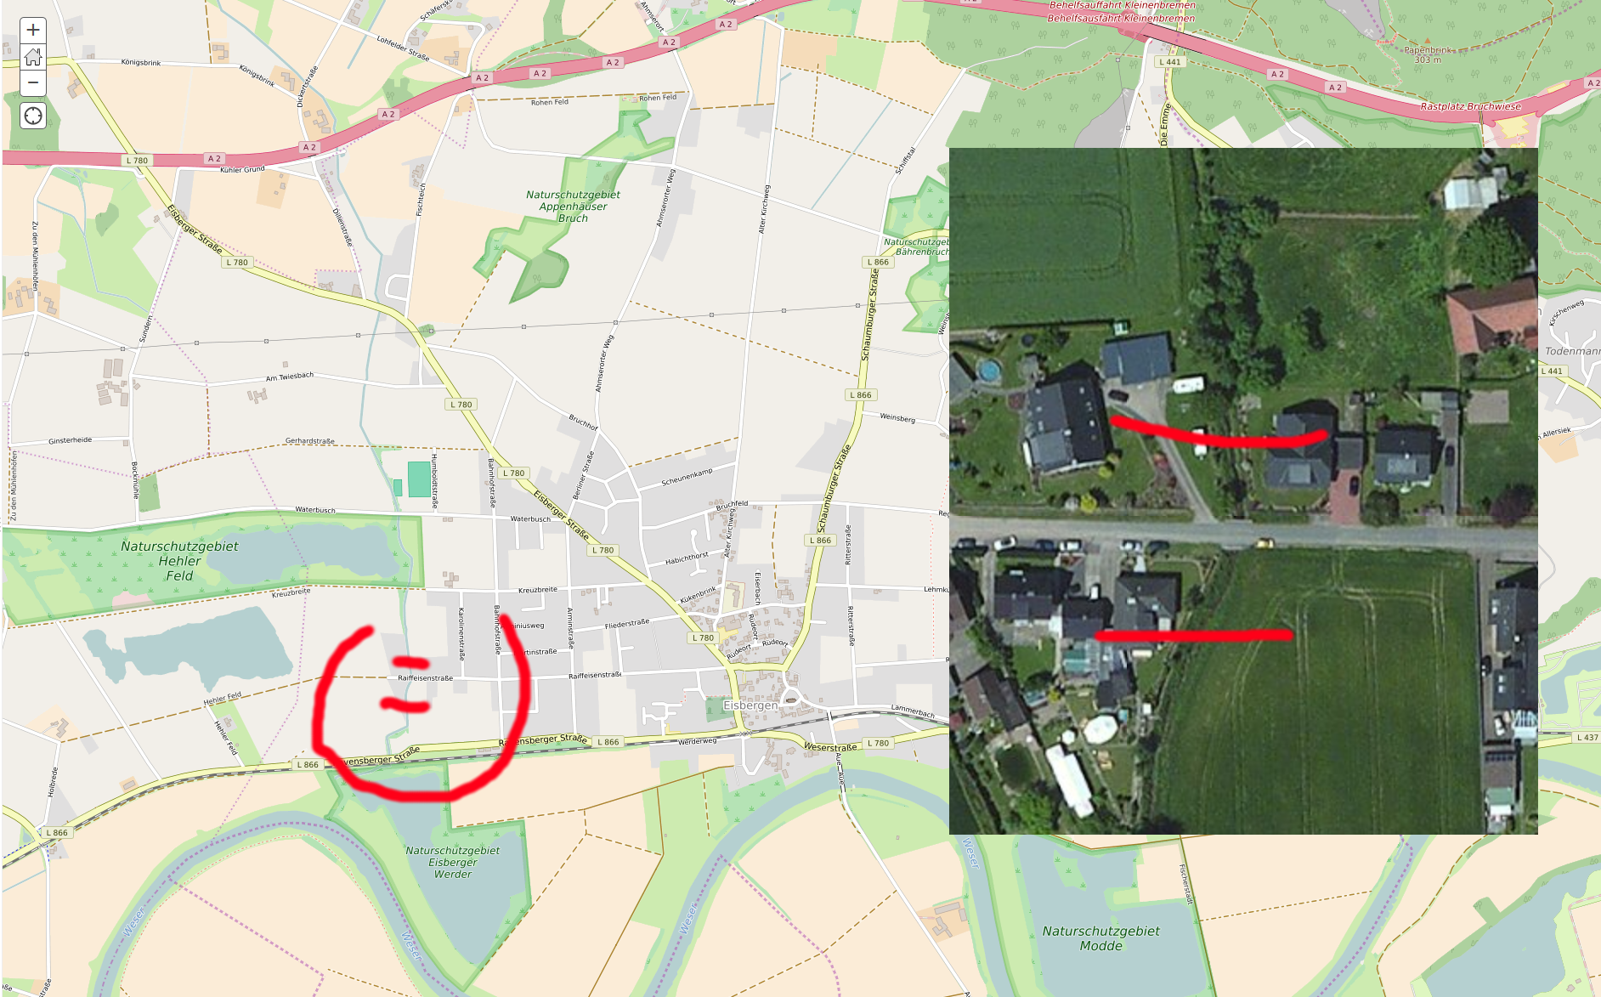

Figure 72 OpenStreetMap view and a zoomed-in satellite view of the (bridge across) water obstacle

What works best for me is to use OpenStreetMap to identify potential water obstacles. For each potential obstacle, I try to find a bridge across the obstacle, and use the satellite view to assess the size of the obstacle / bridge. (Narrow streams typically run amidst trees, so their size is hard to judge unless they cross a road). Another way is to study the elevation; valleys typically feature a stream.

For me, looking for streams and switching back and forth between OpenStreetMap and satellite view often is done quicker outside QGis, using my web browser and ArcGIS’s web site http://www.arcgis.com/home/webmap/viewer.html

The illustration above shows a nameless stream that is wide enough to be an obstacle and runs from the Weser River north towards the highway, then tunnels below the highway and appears as a tiny ditch north of the highway. In other words, it only presents an obstacle between the highway and the Weser.

## Enabling Snap to Grid for Drawing Tight Polylines and Polygons

For the minor rivers and streams, and for the forest and field polygons, we can draw more quickly and more precise by having our lines / point snap to the hex grid.

To snap to the hex grid when drawing, use “Settings” menu, Snapping Options. Change Snapping mode to “Advanced”. Then scroll down to our grid_500_minden. Tick the checkbox, and change the tolerance to 25, units to “pixels”. Next, press “Apply” and “OK”.

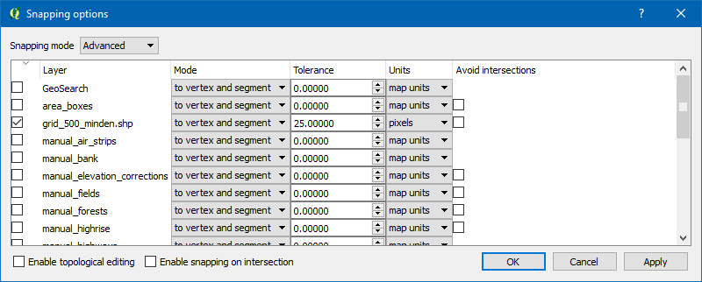

Figure 73 Enabling/disabling snapping to our hex grid

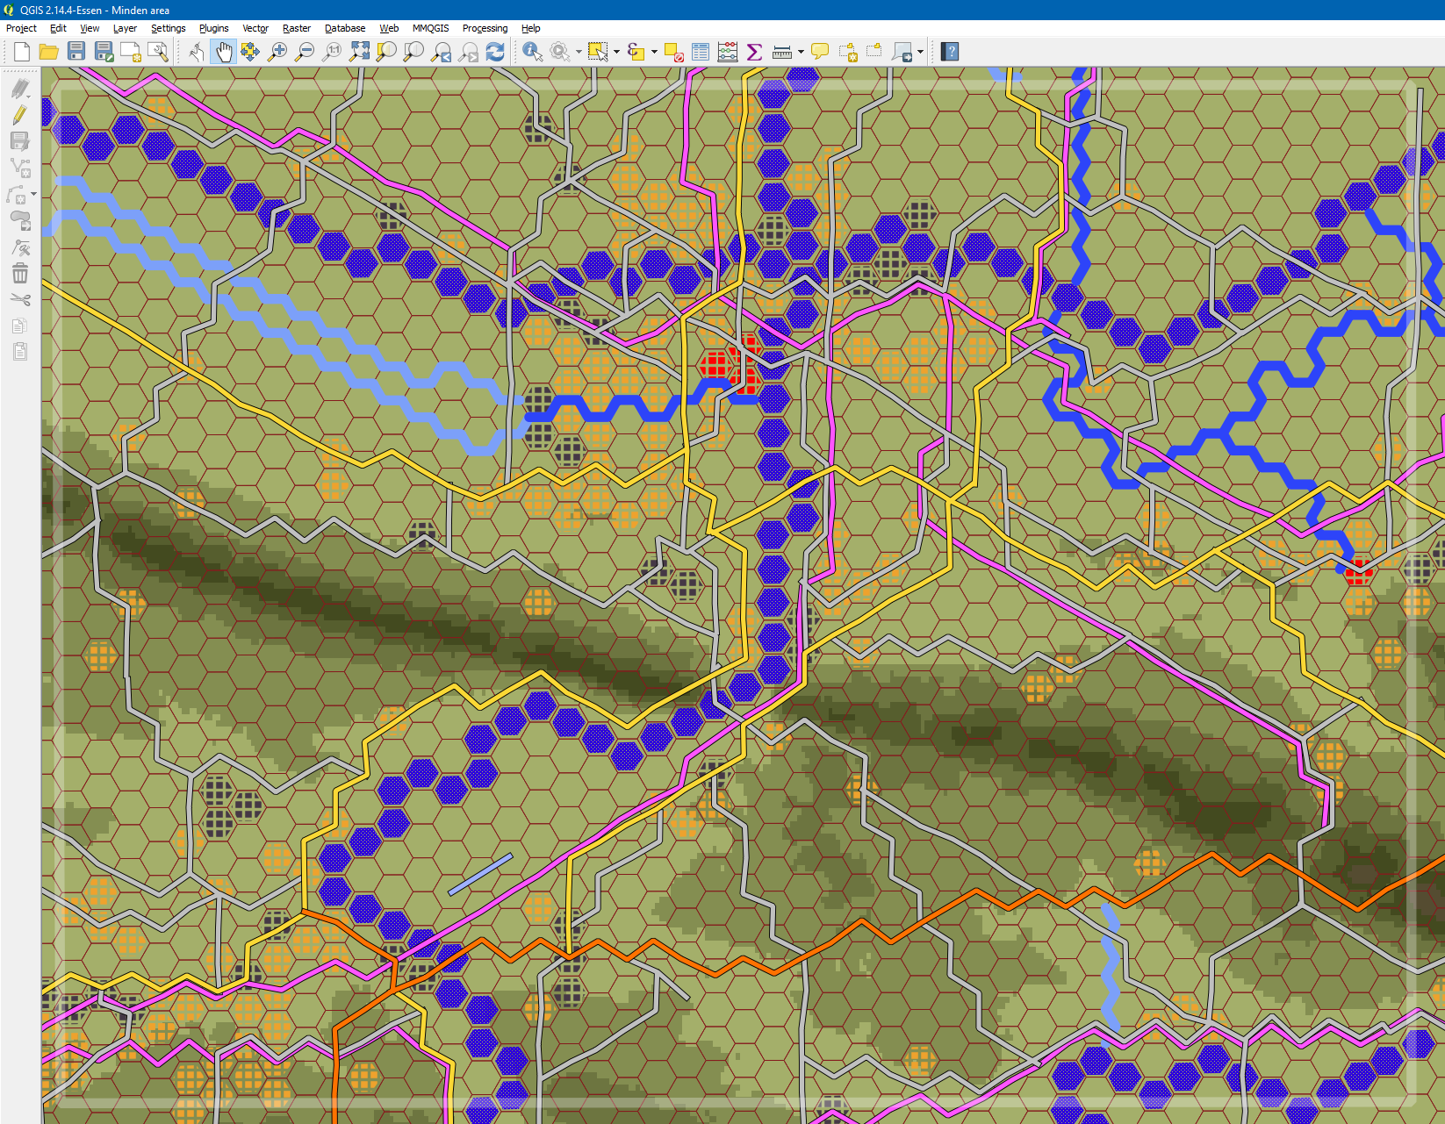

Figure 74 Streams (light blue hex side lines) and minor rivers (medium blue hex side lines) added to the map

In contrast to the earlier game (Flashpoint Campaigns: Red Storm), there is no longer a need to manually tag the hex sides of an obstacle with obstacle ids. The Flashpoint Map Values Scanner automatically detects and tags obstacles.

The next render from OTS HQ shows the minor rivers and streams on the map.

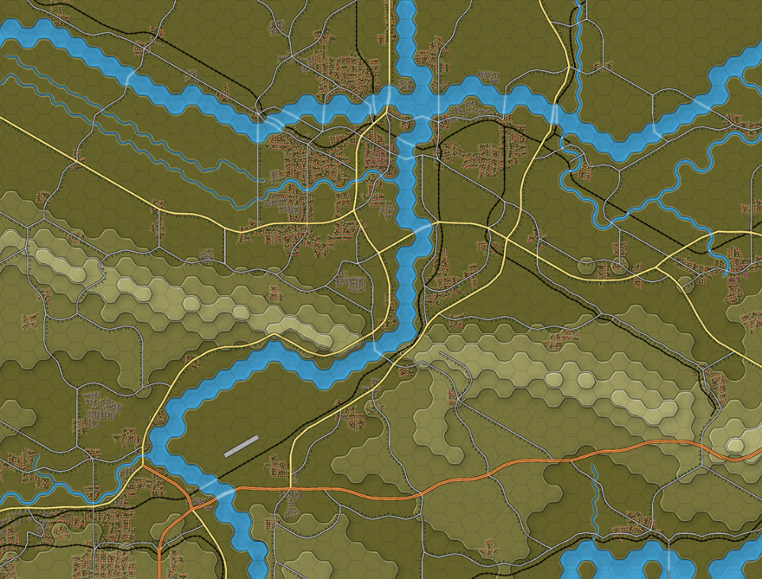

Figure 75 OTS render of our works-in-progress with minor rivers / streams added

## Drawing Forests and Vineyards/Orchards

Whereas we drew the towns and rivers using hex shapes, we’ll be drawing the forests as polygons. That way, we will need less effort to cover larger areas, and can better approximate the actual shapes of the forests.

Personally, I approximate the forest shape using one or more (out of six) pizza slices in the hex.

Before drawing the forests, make sure snapping to the hex grid is enabled. Choose a satellite map to draw on top of. Since the default style (dark green triangles) is hard so see on top of the satellite map, change the style of the manual_forest layer to editing_style_forests. This will display the forest polygons in easy to see, semi-transparent solid red.

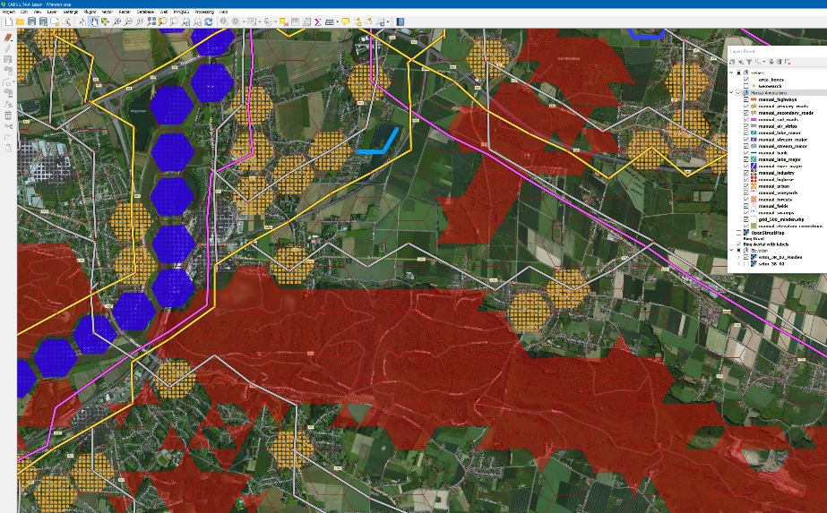**NOTE:** the process of going over all the satellite map, spotting and drawing the forests is also a great opportunity to spot other missed features. In my case, I spotted and added a minor river, several “full hex” lakes, some “hex side” minor lakes, a missed secondary road, etc.

Figure 76 Drawing forest polygon (using a temporary high-contrast "editing" style)

## Drawing Fields

Drawing fields is next. Draw any flat area, without too many buildings or trees, as a field. Fill a complete hex or fill up a partial forest hex with field. Leave any hex with many buildings or trees blank; Flashpoint Campaigns will see this as “Mixed”, with slightly higher visibility hindrance and mobility hindrance than a clear field.

Drawing fields into partial forests goes easier when we are also snapping to the forest layer. So, use “Settings” menu, “Snapping Options”, and enable snapping to manual_forests, with tolerance set to 25 pixels (as units), and Mode set ‘to vertex’.

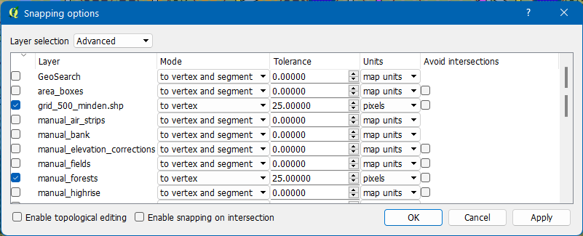

Figure 77 Snapping to the hex grid and the manual_forests layer

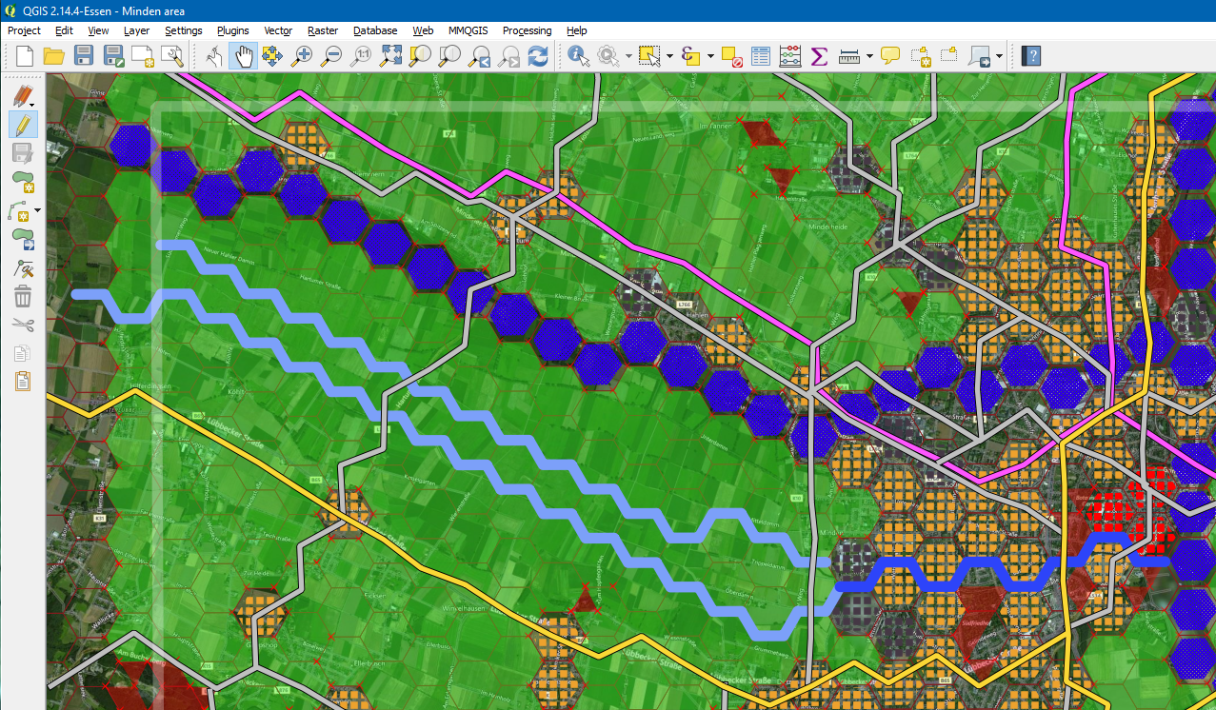

Figure 78 Fields drawn on the map, using the editing_style_fields for better visibility

## Drawing Banks

For Flashpoint Campaigns, riverbanks and major lake banks need to be drawn explicitly, as lines on the inside (water side) of the land-water hexside boundary. If we were to use snapping to the hex grid, the bank lines would up on the hexside and into both hexes, which is not what we want.

Instead, we’ll just use the manual_lake_major and manual_river_major polygons to snap to and deselect snapping to any other layers.

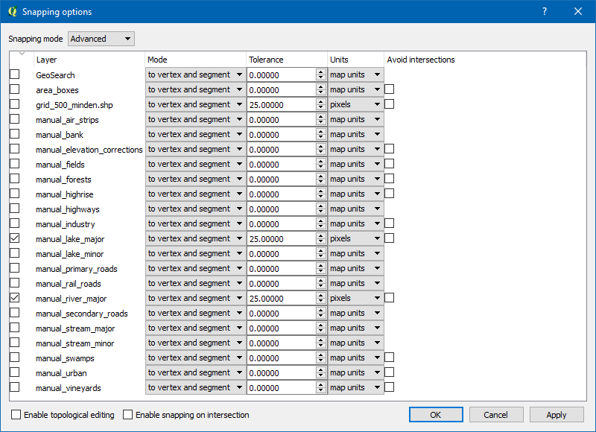

Figure 79 Snapping only to layers manual_lake_major and manual_river_major

With snapping set-up correctly, enable layer manual_bank for editing, and draw lines along the river and lake shapes near hex sides with land hexes, as illustrated below:

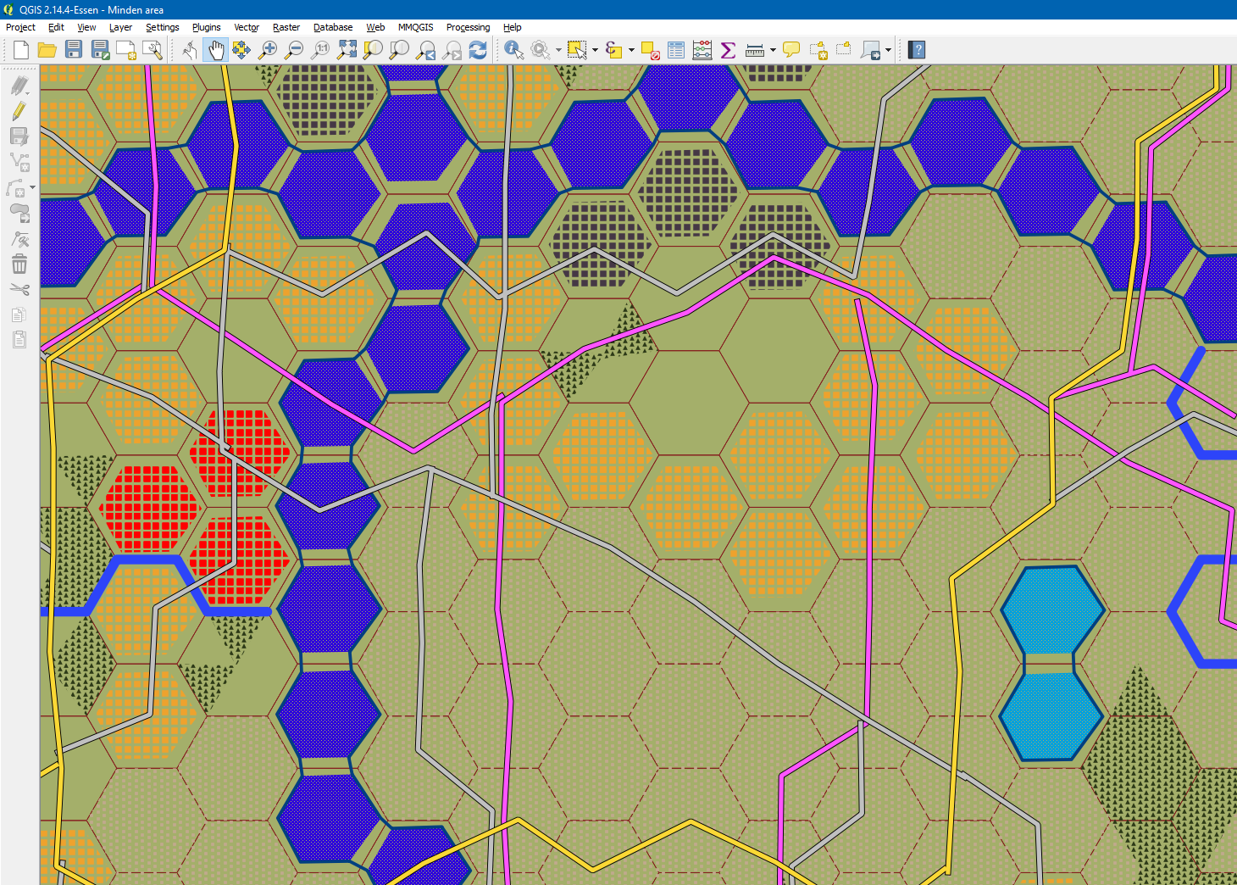

Figure 80 Banks drawn along the sides of major rivers and major lakes

## Inspection Time: Fixing Road Flow and Elevation

We are done doing the bulk drawing. This is a good time to take a critical look at our results and correct those spots that don’t seem quite right.

The things to look for are:

* Hill shapes which aren’t correctly represented in the hex elevation values, for example because a narrow hill shape is split across two hexes, and doesn’t have a back impact on elevation of these hexes
* Awkward or unrealistic roads running uphill or downhill for no good reason

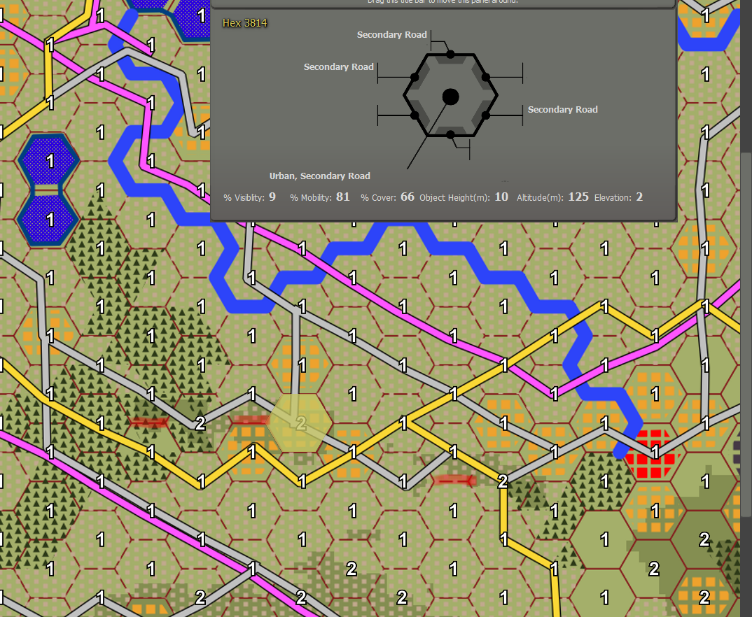

Figure 81 Two ridges (red markings) not interpreted as higher elevations along their full lengths

Our map has a few locations where the elevation values do not correctly reflect the ridge’s elevation. We are going to correct this in QGis, by placing hex shaped polygons in those locations where we want to correct elevation and set the correct elevation value for them. The layer’s style is set-up such that it will display a polygon with the right color for the elevation set.

Enable manual_elevation_corrections layer for editing. Select a hex shape on the manual_urban layer, copy it, switch to the manual_elevation_corrections layer, and paste it at the location where you want to correct the elevation. Next, with the shape still selected, use the Layer menu, Open Attribute Table. For the newly created shape, enter in the “elevation” column the intended elevation, then press the Save Edits button.

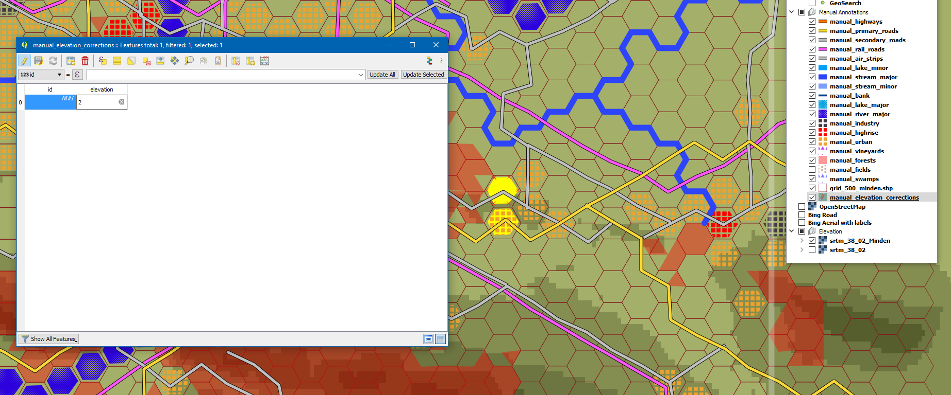

Figure 82 Setting the elevation for a shape in the elevation_corrections_layer

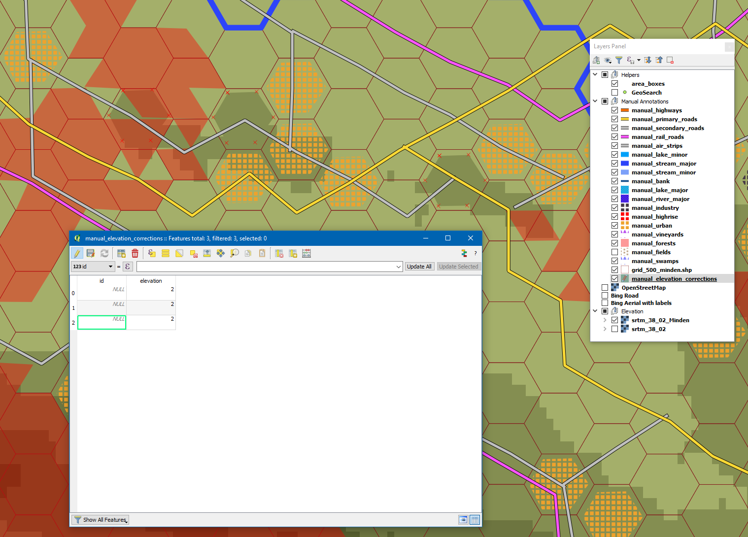

Figure 83 Three corrections, shown in the table and on the map

# Prettying up Our Map with Labels

QGis served us well to turn real-world terrain into a map values bitmap for Flashpoint Campaigns. For humans, however, the map becomes easier to interpret when locations, key highways and roads, and major rivers have been labeled.

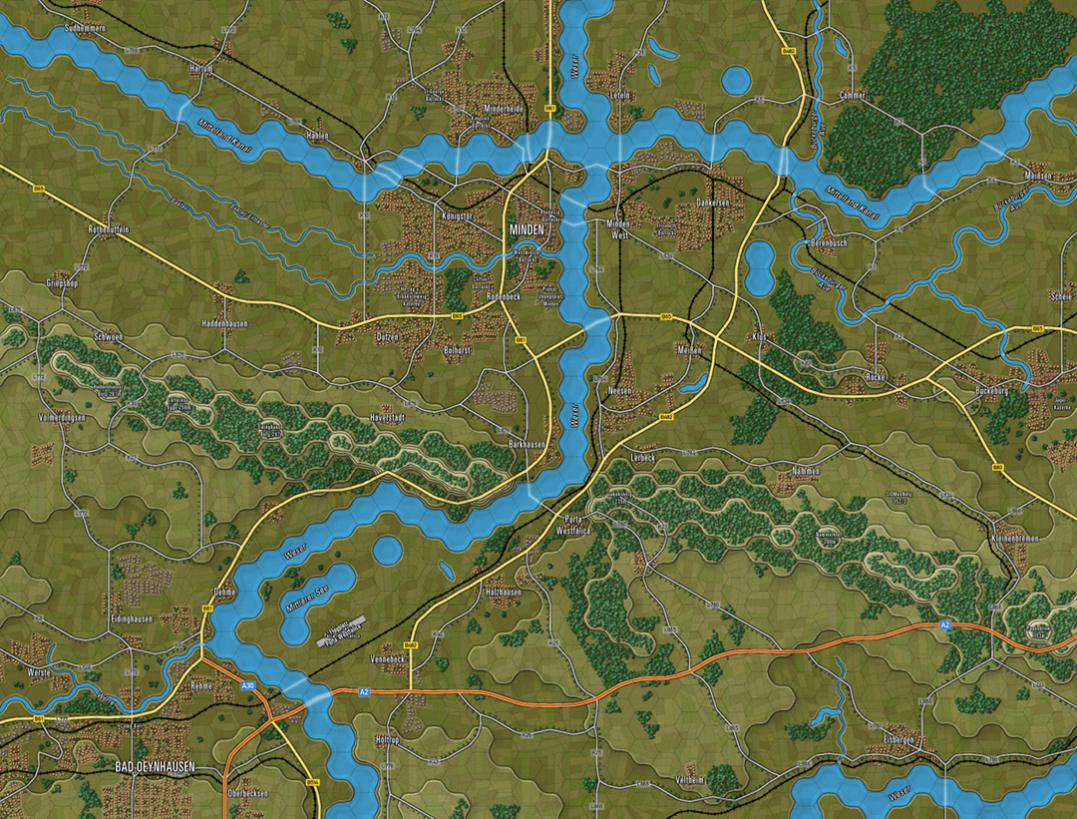

Figure 84 OTS render with labels added

This can be done using a bitmap editor.

# Creating Our Second Map

With all layers already set-up, and elevation data imported, creating a second map inside this project is a lot easier and less effort than starting a project from scratch.

I will try to reuse a project for several maps, if possible. The trick is to not wipe or remove, but to add:

* Add a new area box (edit the area_boxes layer)
* Add a new elevation layer, with a style / elevation coloring specific to the new area, by duplicating the srtm_38_02 layer, rename it to srtm_38_02_<area name>, and setting the style to match the minmum elevation for the area. Disable the elevation layer for areas you aren’t working on.
* Add a new hex grid layer covering the new area box
* Create a new Print Composer and set it cover the area box and line up with the hex grid
* Add new polylines and polygons to the “manual” layers

**NOTE:** If your next area is adjacent or partially overlapping with an existing area, make sure to line up the new hex grid perfectly with the existing hex grid. This enables you to reuse any work you’ve done beyond the area boxes edge, and create larger combinations of your maps.

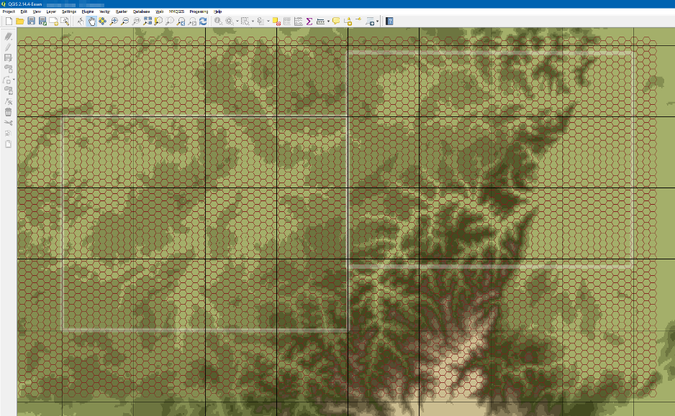

Figure 85 A second area box, with a hex grid aligned with the first

# Appendix A. Example Project

This manual comes with an example project, which can be used to start your own. The example project also allows you to see in more detail how the example map described in this manual has been created.

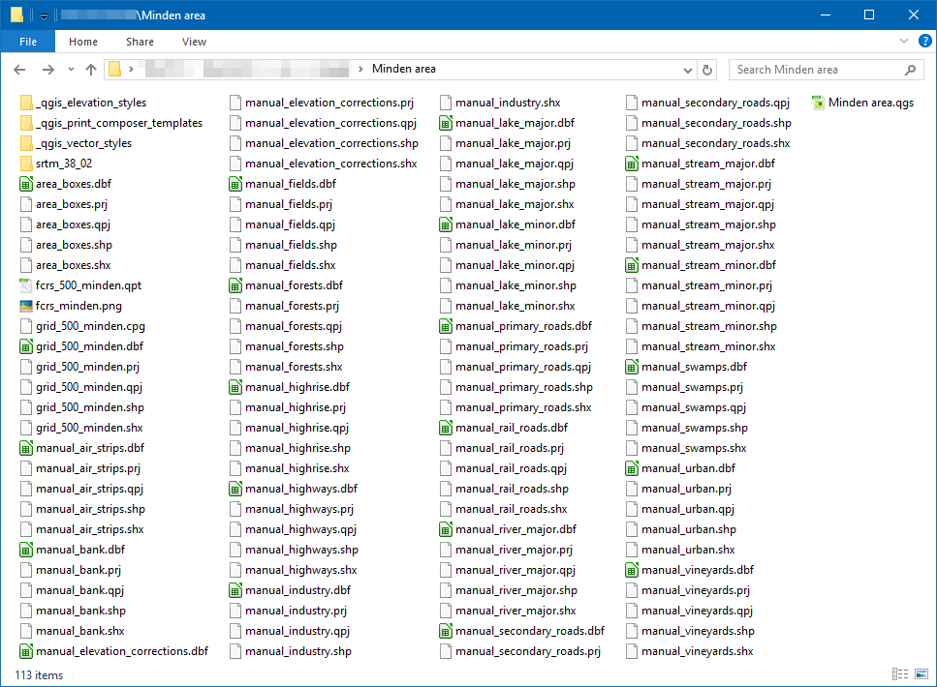

Figure 86 The “Minden area” QGis project folder, with the project file top left

The project folder contains:

* A single project file (Minden area.qgs),
* A single print composer (fcrs_500_minden.qpt),
* A folder with elevation data (srtm_38_02),
* A folder with styles for the elevation layer (_qgis_elevation_styles),
* A folder with styles for the vector layers (_qgis_vector_styles),
* A folder with a 20x15km (46x30 hex) print composer template (_qgis_print_composer_templates),
* Per vector layer, five files together containing the vector data in shapefile format for the layer

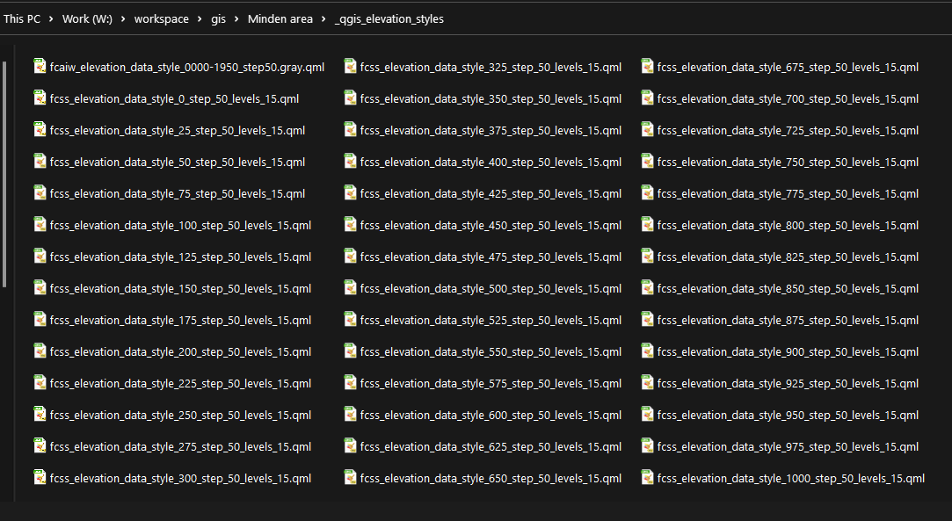

Figure 87 The elevation styles to style a raster layer with FC's fifteen elevation colors

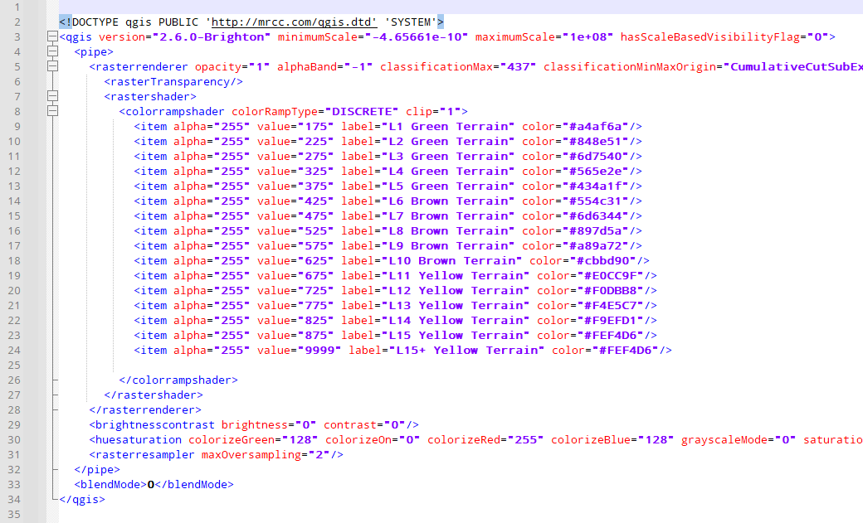

Figure 88 Elevation style file contents (for elevation 175m and up, in steps of 50m)

# Appendix B. Default FCSS Map Data Types

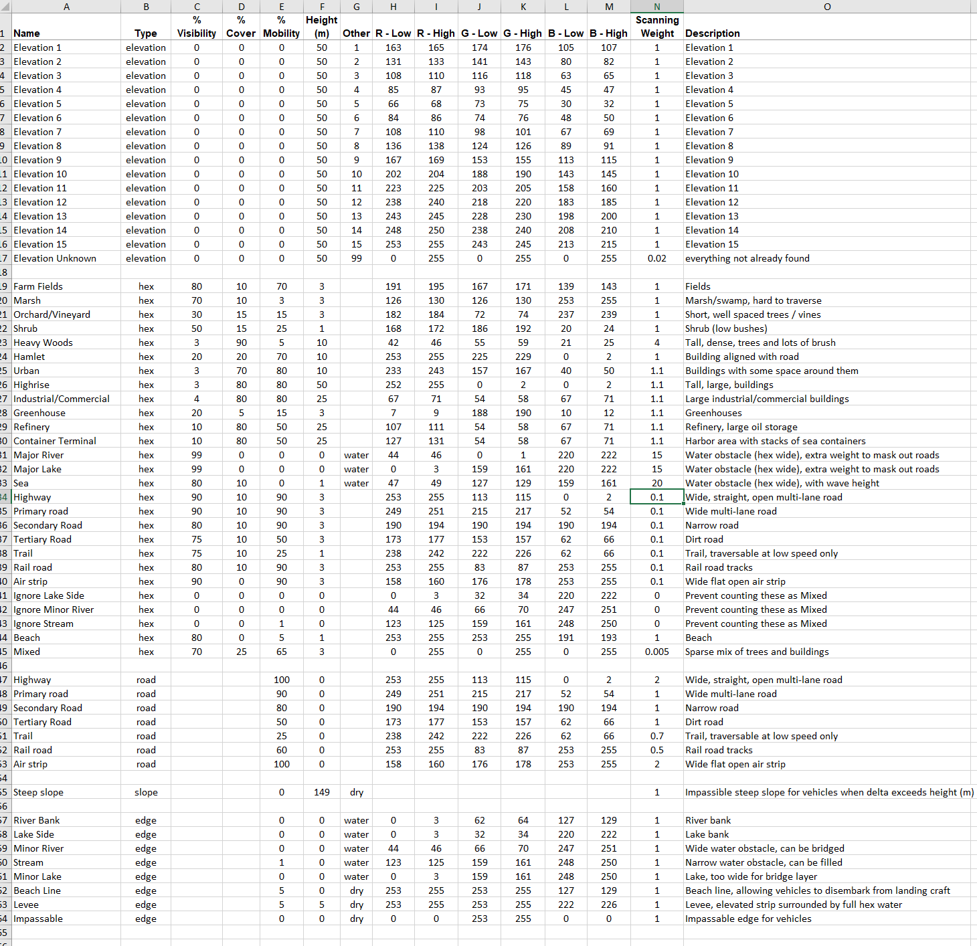

Figure 89 Default Map Data Types for FCSS (MapDataTypes_FCSS.xls)

The map data types file defines how the Flashpoint Map Values Scanner interprets the terrain bitmap and sets values for the game terrain hexes and hex sides.

The map data types file is an ordinary spreadsheet that can be edited with Microsoft Office or the free LibreOffice software.

The map data types file consists of five sections:

* Elevations (column ‘B’ has type ‘elevation’)
* Hex visibility / cover / mobility (column ‘B’ has type ‘hex’)
* Road connections (column ‘B’ has type ‘road’)
* Steep slope height (column ‘B’ has type ‘slope’, typically 1 entry only)
* Hex edges (column ‘B’ has type ‘edge’)

## Elevation

The elevation section defines the colors for each of the elevations. Although it does not impose a hard limit on the number of elevation steps, 15 steps are a good practical limit since it (a) is hard to discern more than 15 background colors on the map, and (b) 15 steps of 50m covering 750m of elevation difference suffices for the terrain surrounding Europe’s major road systems.

The fifteen elevation colors list corresponds to the ‘fcss_elevation_data_style_XXX_step50_levels15.qml’ styles files for QGis, in the example project, subfolder ‘_qgis_elevation_styles’.

For a more mountainous region (think Golan Heights, from the Jordan river valley up to the Mt. Hermon foothills), we would need 20+ steps of 50m. We can define these colors as gray values, in the 83 - 180 range as follows:

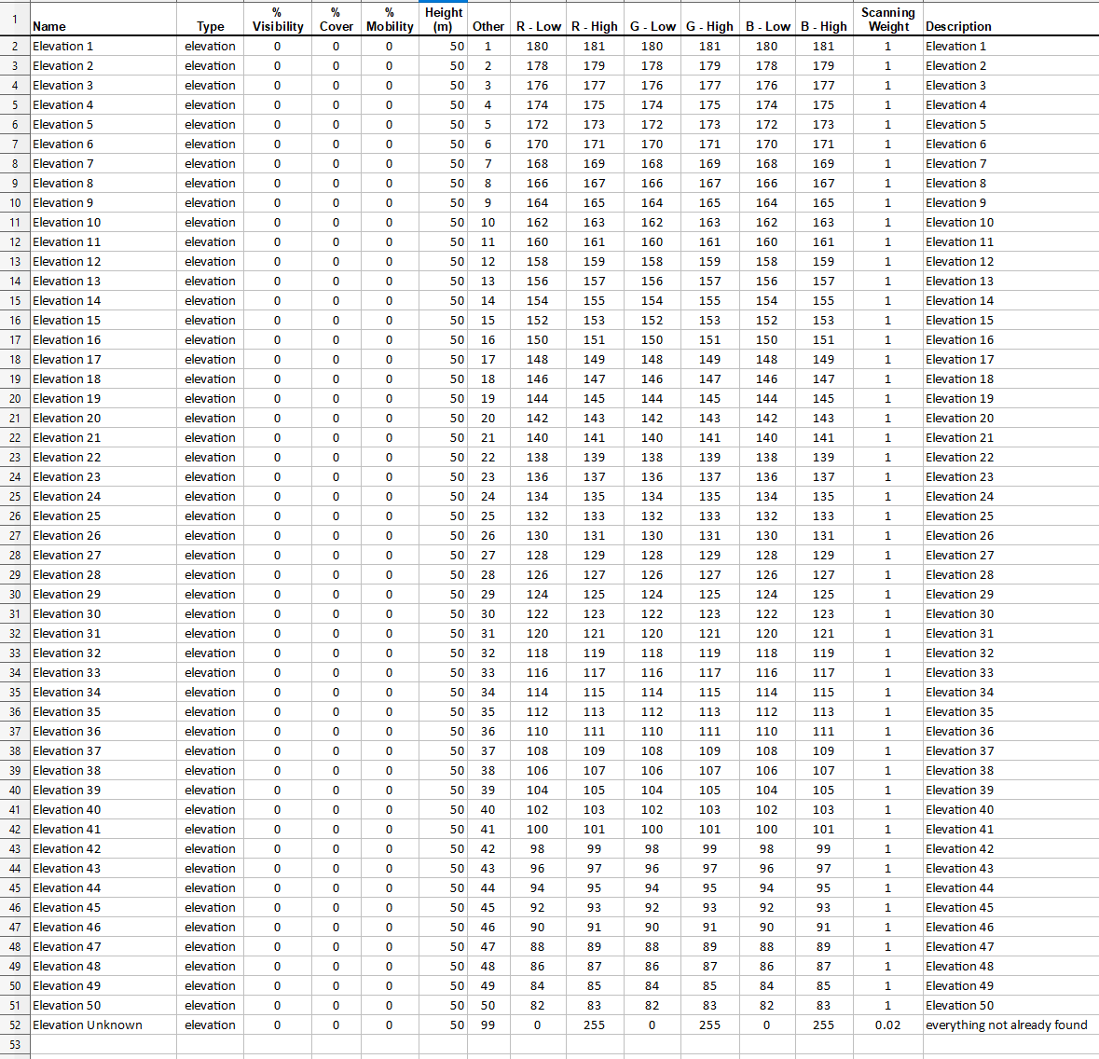

Figure 90 Elevation color definitions for up to 50 elevation steps

Use the Qgis style file fcaiw_elevation_data_style_0000-1950_step50.gray.qml to format the elevation data in the right colors for the above elevation definitions.

**NOTE:** When scanning the hex and spotting different elevation colors, the most frequently occurring elevation color (the statistical ‘modus’ or ‘mode’) will be chosen as the hex’s elevation color.

## Hex Visibility / Cover / Mobility

This section defines several types of built-up areas, forests/agriculture, roads (and their influence on mobility, visibility), and several entries to ignore hex effects for hex side obstacles.

## Road Connections

This section defines mobility properties for road types in hexes and across hex sides.

## Slope Hex Sides

A single row defines the minimum elevation step (in meters) for which the hex side will be automatically labeled 'impassable' for vehicles.

## Edges (Hex Sides)

This section defines edge properties for hex sides. Mobility '0' edges cannot be traversed unless a bridge is placed. Mobility > 0 edges can be passed, albeit leading to a delay. Column 'G' indicates whether the obstacle is a wet or dry one. Amphibious vehicles may cross a wet obstacle without requiring a bridge, but do not have an advantage in dealing with dry obstacles (think ‘anti-tank’ ditches).

## How to Define an Additional Type of Terrain?

For example, to represent green house filled areas, we can define a new ‘hex’ entry that reflects moderate to poor visibility (hard to see through greenhouses), moderate mobility (entry can be forced), and poor cover:



Figure 91 Defining an additional type of terrain: green house covered hexes

The color RGB = 190,193,160 is chose to detect green house pixels in the map bitmap.

To pick a color, pick a unique triplet of RGB values (each in range 0, 255). For each of those color channels, take a low value up to 2 lower (but not lower than 0), and a high value up to 2 higher (but not higher than 255).

# Appendix C. UTM zones

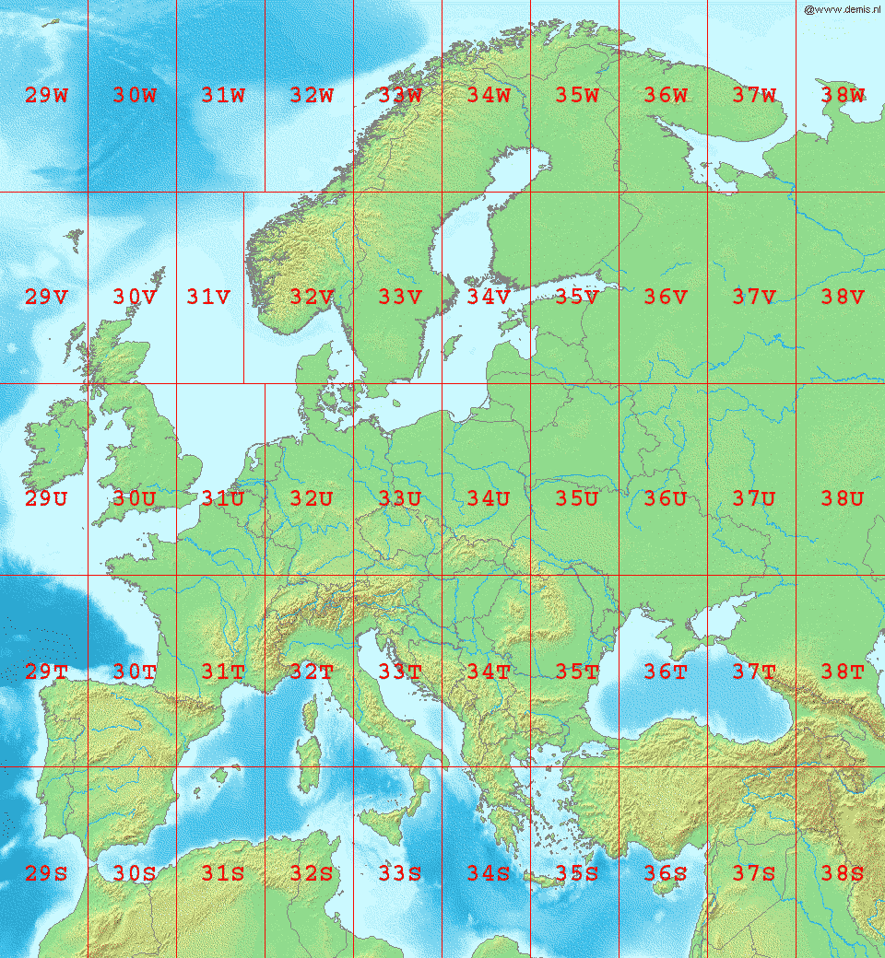

Figure 92 UTM zones for Europesource: <https://upload.wikimedia.org/wikipedia/commons/9/9e/LA2-Europe-UTM-zones.png>

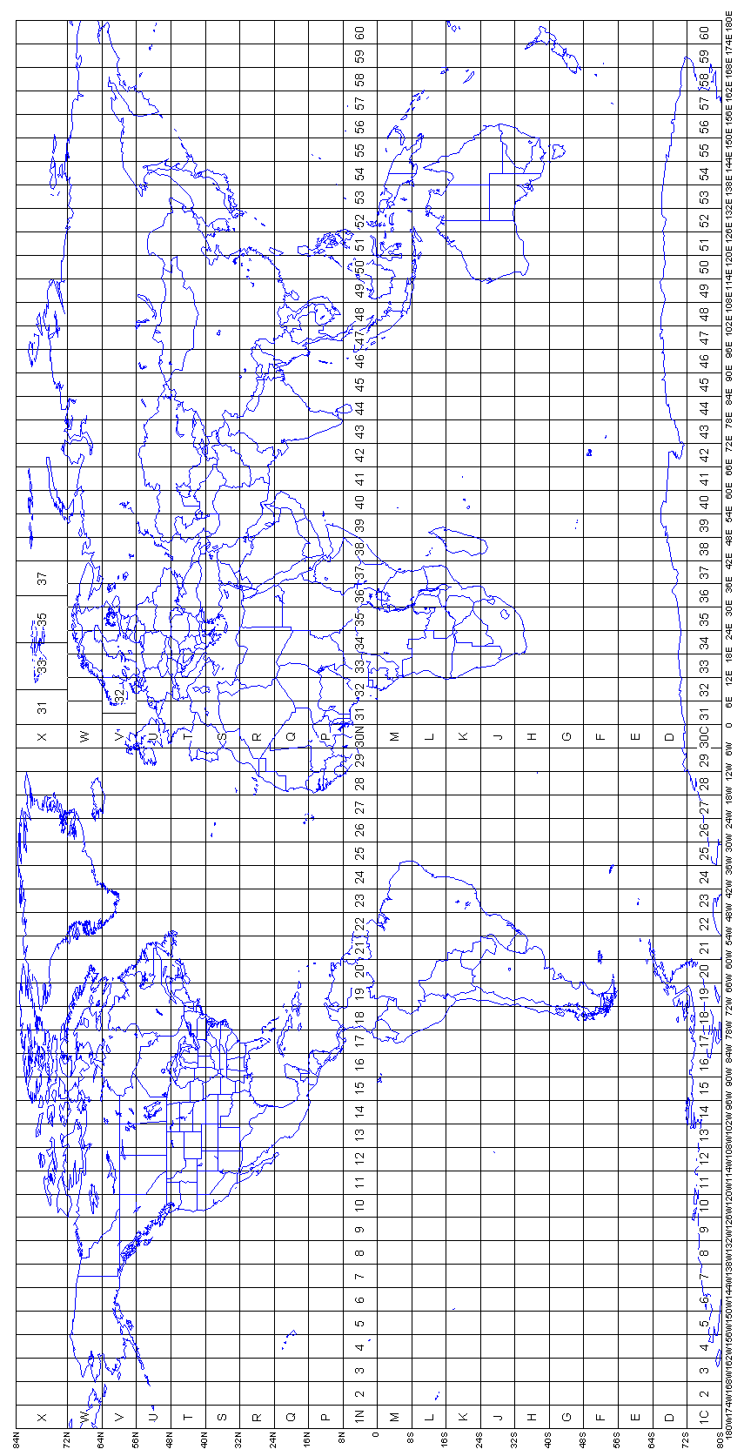

Figure 93 UTM zones for the world  
source: <http://www.dmap.co.uk/utmworld.htm>

# Appendix D. Representing Water Obstacles

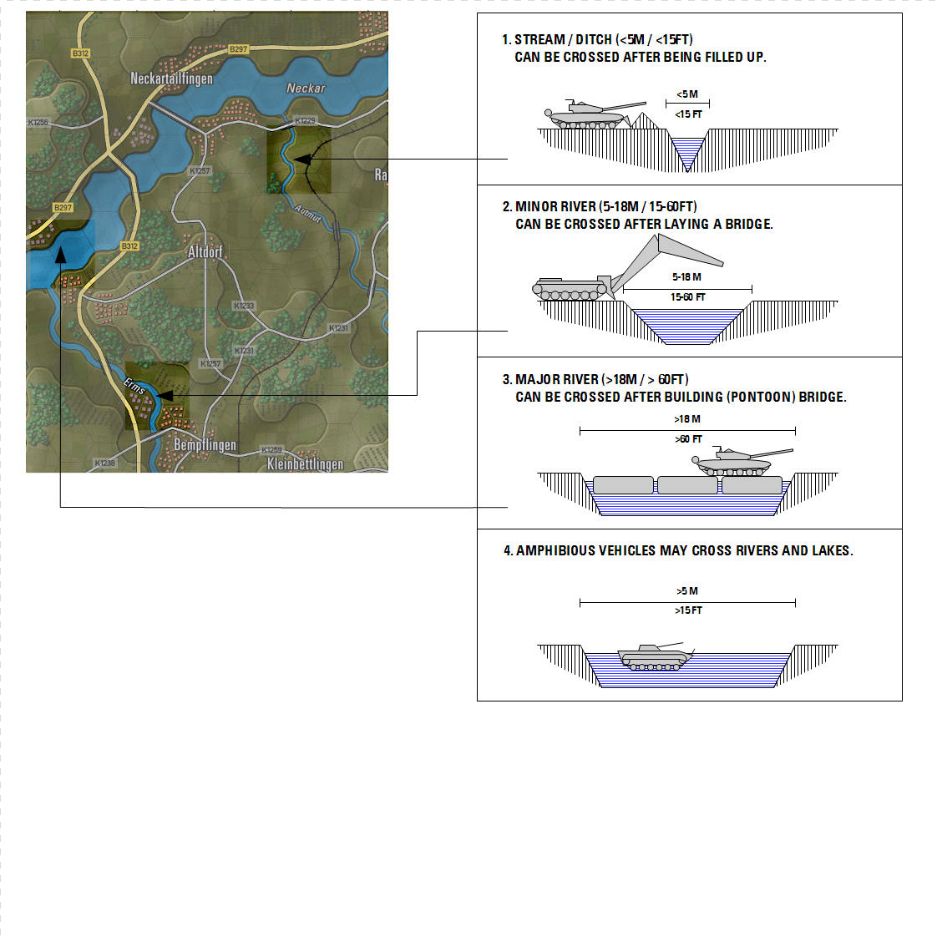

Figure 94 Recommended representation of water obstacles

# Appendix E. Creating a New Elevation Correction Layer

To create a new Elevation Correction layer, to contain corrections specific to a single area, do the following:

* Use Layer menu, New Shapefile Layer
* Choose Type Polygon
* Define a new field (to hold the elevation): by filling out the New Field area with name Elevation, type Whole Number. The default length (10) suffices.
* Press ‘Add to Fields List’ button to add the field
* Press OK, and make sure to save the new layer inside your project folder
* After creation, select the new layer, right mouse button, Properties dialog, Style tab, then load the fcss_elevation_corrections.qml style

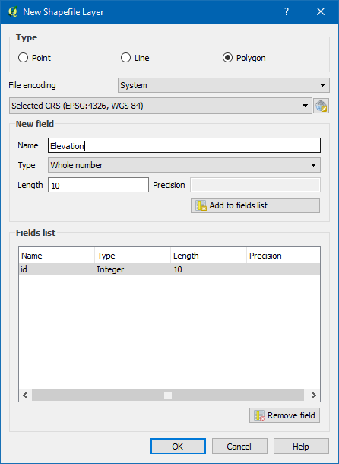

Figure 95 Defining the additional Elevation field for the Elevation Correction Layer

# 

# Flashpoint Campaigns Credits

## On Target Simulations

* Lead Programmer and Head Honcho: **Robert "Ironman" Crandall**
* Data, Programming, Graphics, and Sound: **Jim "Cap’n Darwin” Snyder**
* Programming, Data, Models, and Research: **Jeff “Iron Mike” Sugden**
* Map Master, Programmer, AI, and Graphics: **William van der Sterren**
* Quality Czar and Testing Lead: **Charles “The Whip” Belva**
* Programming: **Kevin “SgtZDog” Zemon, Will Jackson, Alex Kriesel**
* Testing: **Tomasz Niedzinski**

## On Target Simulations Content Team

* Alexander “Stimpak” Schwarz, David “22sec” Whitt, Mike “MikeJ19” Johnstone, Joao Lima, Jurrie van der Zwaan, John “JohnO” Osborne, Jorgen “Jotte” Torgersson, Jo van der Pluym, Scott “WABAC” Gibbs and Steve “Mad Russian” Overton

## Cold War Beta Testers

* Names to be added before release

## Matrix Production Support

* **Erik Rutins, Maxim Klose-Ivanov**

# OTS on the Web

Matrix Games Forum: <https://www.matrixgames.com/forums/viewforum.php?f=10149>

Check Us Out on Discord: <https://discord.com/channels/911711314051739659/911711314257248331>

Check Us Out on Steam: *“Pending a page URL*”

**© 2025 On Target Simulations (OTS), LTD. All Rights Reserved. The images used and OTS Logo are property of On Target Simulations, LTD. All other marks and trademarks are the property of their respective owners.**